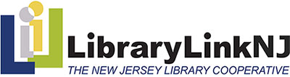
44 Stelton Road, Suite 330 TEL: 732-752-7720 or 866-505-5465 librarylinknj.org
Piscataway, NJ 08854 FAX: 732-752-7785 or 800-793-8007
Kathy Schalk-Greene, Executive Director kathy@librarylinknk.org

EXECUTIVE BOARD MEETING
Thursday, July 21, 2016 – 2:30

In Person at LLNJ Office

Mission: LibraryLinkNJ empowers libraries to serve their clientele more effectively
and enhances the value of member libraries to their communities.

Motto: Moving Forward Together

AGENDA

CALL TO ORDER
Statement of Compliance with Open Public Meetings Act
Welcome and Introductions

REORGANIZATION
Reorganization Committee Recommendation – Board Officers & Committees [action]

MINUTES
Minutes of June 16, 2016 Meeting [action]

REPORTS
Treasurer's Report – Investment Report only [action]
State Library Report
Executive Director's Report [action]

CORRESPONDENCE
DRAFT Position Statement on The Role of Effective School Library Programs
In The Every Student Succeeds Act of 2015 [action]
Email from James Lonergan regarding
Regional Library Cooperative Regulations

UNFINISHED BUSINESS

NEW BUSINESS

AGENDA ITEMS FOR NEXT MEETING (online, September 22, 2016)

ADJOURNMENT

