PROJECT MANAGEMENT TRAINING

2-Day Workshop

6th Edition

INTRODUCTION 3
How to use the Course Materials 4
1. How to start a project 5
PM CONCEPTS 5
Definition of a Project 5
Identify the customer and the goals 5
Identifying what you'll deliver 5
Definition of Success vs. Failure 6
Defining the Project Scope 6
Project Risks 7
Documenting Assumptions and Constraints 7
What is the right level of project management 7
Obtaining Signoff 8
The Project Charter: Putting it all together 8
KEY LESSON TAKEAWAY 9
2. Getting Organized 10
PM CONCEPTS 10
Collaborating 10
The Triple Constraint 10
Identifying the work 10
Estimating time and cost 11
Building your team 12
Scheduling work 13
Making sure the schedule works 14
Organizing your project files 15
Timely and Accurate communication 16
Managing risk 17
KEY LESSON TAKEAWAY 17
3. Performing Work 18
PM CONCEPTS 18
Kicking-off work 18
Handing out assignments 18
Keeping things moving 19
Working through problems 19
KEY LESSON TAKEAWAY 20
4. Monitoring Progress 21
PM CONCEPTS 21
Getting status updates 21
Evaluating how the project is going 21
Handling changes 22
KEY LESSON TAKEAWAY 22
5. Wrapping Up 23
PM CONCEPTS 23
Finishing a project, phase or milestone 23
Getting sign-off 23
Tying up loose ends 24
Lessons Learned 24
KEY LESSON TAKEAWAY 25
6. Conclusion 26
PM CONCEPTS 26
Workshop Summary 26
Next Steps: Your next project 26
Next Steps: Learning more 26
KEY LESSON TAKEAWAY 27

INTRODUCTION
Welcome to the Sixth Edition of the PM101 Training Course. This course was developed over many years of training across several continents. The PM101 Course has been used in Corporate and Government audiences; in after-work programmes and in non profits too.

Our goal in developing this courseware was to make the concepts of Project Management much more accessible to most audiences. That’s because Project Management has such a wide applicability that the concepts we talk about can be used in almost any context, from launching a new software application, to planning a birthday party!

We hope that you enjoy this experience and don’t forget to leave us feedback at: comments@samsena.com

Sam Sena, PMP
2018

How to use the Course Materials
Ideally, you have attended our in-person classroom lessons or enrolled in the online course.

If you haven’t done so, no fear!

There are 6 knowledge areas in total and each chapter is organized into the following sections:

PM CONCEPTS
Project Management Concepts explained in greater depth that are used by the examples covered in class.

KEY TAKEAWAYS
How the concepts should be used to improve the quality of your project

1. How to start a project

PM CONCEPTS
How do we ask the right questions and collect all the relevant information up front? In this section we go through several concepts that can help us to understand what the project is about and what we need to do to achieve project success.

Definition of a Project
It is very important for the Project Organization, the Project Manager and Team, as well as Customers to come to a mutual agreement on the definition of a project. According to the Project Management Institute, a project can be defined as having the following characteristics:
- Temporary in nature: A project does not go on indefinitely. It must end at some point.
- Has a unique Product, Service or Result: The entire purpose of having a project is to create something that is unique. Conversely, manufacturing identical items such as paper clips on an assembly like does not have a unique end result and is therefore not a project.
- Coordinated undertaking of interrelated activities

Identify the customer and the goals
One of the first things to do early on in a project is to identify the parties (also known as stakeholders) who will benefit from the completion of the project. Stakeholders have the ability to influence the outcome of a project, such as by having control over the budget (how much we can spend), the deadlines (when the work has to be completed by) and resources (who is available to do the work).

It is also very important to identify early on what benefits we expect to enjoy at the completion of the project. For example, if we had a project to create a hydroelectric dam, the benefits would be the generation of electricity that can power thousands of households and factories alike with clean, renewable energy.

Identifying what you'll deliver
A Deliverable is a tangible thing that results from the completion of the project. Given how broadly a Project can be defined, I’ve listed several examples to illustrate various projects:

Category | Definition | Examples
A Product | This can be an item, a component that goes into an item, or even an enhancement to an item. | Construction Projects; Launching a Smartphone App
A Service | This could involve implementing a new business process or a service satisfying an economic need | Building a new cash reconciliation process; Staging a rock concert at a single venue; Moving house
An improvement initiative | An improvement to a product or service | Product Redesign; Kaizen or Operational improvement
A result or decision | Research findings or data that can be used to assist in making decisions or concrete outcome such as passing a new law. | Environmental impact assessment, Market Research,

Definition of Success vs. Failure
It is also important to understand what factors constitute the success or failure of a project. Often referred to as metrics or Key Performance Indicators (KPIs), the success or failure criteria of a project should be documented clearly such that all stakeholders are aware of its significance.

“So what if we end up spending more money that we should have? At least we finished the project” David, PM.

By reviewing the statement above, we realize that the element of time is a critical factor in measuring the success of the project.

Defining the Project Scope
Scope refers to all the work that you have to do in order to achieve the goals of the project. Scope is one of the first things you determine on a project. Logically, you first need to figure out the quantity of work needed to complete a project before you can calculate how long the project will take and also how expensive the project will be.

A key aspect of defining scope is by first performing a needs analysis and some initial data gathering. Some of the activities performed to facilitate understanding the scope of a project include:

- Performing an Initial Risk assessment.
- Conducting Focus Groups and workshops with stakeholders
- Analyzing feedback from Questionnaires and Surveys
- Evaluating Prototypes and alternative ways of getting work done.

Project Risks
Risk can be thought of as an uncertain event such that if it occurs, this will have a positive or negative effect on the project. Notice how a risk can have a positive or negative effect on the project, which relates to what we said about how a risk can be an opportunity as well.

Because risks can have such a huge impact on a project, it’s important for us to conduct a risk assessment early on in a project, so identify if there’s any potential issues that could derail our project. We can also identify strategies to manage these risks.

In the table below, we list out a few key risks that a project team faces and also if there are any possible responses to the risks available to the team:

Risk | Response
Deadline is moved forward | Focus on the most critical or important deliverables for the project first.
The technical solution doesn’t work | Rely on expertise outside of the project team. Build a prototype to test the design
Insufficient materials | Use project budget to procure materials

Documenting Assumptions and Constraints
Assumptions are factors that for planning purposes might be considered to be true, real or certain. This can be considered to be a risk. Assumptions should always be evaluated for accuracy later on! For example, we assume that there are sufficient materials and resources for a project team to complete the project.

Constraints are factors that might restrict a team’s options and typically are imposed externally on the project or team. For example, constraints can come in the order of Contract fixed costs, or deadlines..

What is the right level of project management
Project Management almost always results in more work on a project. If you think about it, proper project management means that at the very least, the Project Manager is fully aware at all times of what tasks are being worked on, by whom and so on. This invariably adds a level of overhead, in terms of project status meetings, updates and reporting.

For very large or critical projects, it is very important to have that level of management, since if anything goes wrong, the Project Manager is quickly made aware and management can make rapid decisions to correct or fix problems. However for smaller projects that involve fewer people or resources, full on project management may take too much time and end up delaying or hindering progress.

The project team needs to determine early on what level of project management is required for a project. The table below lists some sample criteria that could be used to determine the level of Project Management attention required on a project:

PM Overhead | Budget | Duration
No Project Manager | Less than $9k | Less than 2 weeks
Shared Project Manager | $10k to $49k | Between 2 weeks to 7 weeks
Dedicated Project Manager | Over $50k | Over 8 weeks

Obtaining Signoff
An important characteristic of the project is that there is an assigned Sponsor. The sponsor is typically a member of Senior Management or the Executive Team that has a solid understanding of the project and is responsible ultimately for the completion of the project.

The Project Charter: Putting it all together
If you’ve followed the exercises, you would have had an opportunity to create your first project charter. The key aspect of the charter is that it is typically the first formal project document to be created that has the Project Sponsor’s signature and authority.

The key components of the Project Charter are as follows:

- Project Title and Description
- Project Manager Assigned and Authority Level
- Business Need
- Project Justification
- Resource Pre-Assigned
- Product Description/Deliverables
- Stakeholders
- Constraints
- Assumptions

KEY LESSON TAKEAWAY
It is quite common to have a dire or urgent circumstance driving the creation of a project. Nevertheless, we find ourselves as part of a project team, trying to get organized in order to figure out what tasks need to be accomplished. The purpose of a Project Charter is to document as much relevant information as possible early on in a project. The Charter can then be used to drive useful discussions and activities that help add even more detail to a project.

2. Getting Organized

PM CONCEPTS
In this section we look at a systematic approach for building a strong structure around the project that ensures that people involved in the project know what to do and when to do it. We also learn how to anticipate when circumstances or events that are out of our control change.

Collaborating
Project Planning is a highly collaborative process. This is particularly important when we are building out individual task lists and dependencies, as we cannot assume that the project planning team knows the best way of getting the work done. Experts and consultants may be needed to provide advice or sample plans used from similar projects conducted in the past can be used. Therefore a project must be set up early on to facilitate the sharing of information between team members.

Stakeholders could include the following groups of people:
- Customers
- Management
- Team
- Project Sponsor
- People doing the work (Employees or Contractors)

The Triple Constraint
The triple constraint states that there are three fundamental forces that are imposed on a project, namely Time (Schedule), Cost (Resources) and Scope (Requirements). These three forces work in tandem to influence how a project can progress. Typically when one of the triple constraints changes, it will impact the other two constraints and a project manager should be aware of this.

Identifying the work
There are several tools that can be used to help define the scope of a project in great detail.

Project Scope Statement
The Scope Statement is an extension of the Project Charter. It adds a lot of detail to the project that isn’t included in the Charter. A Scope statement should have the following components:
- Project Scope Description
- Acceptance Criteria: What must be completed in order for the project to be considered a success
- Deliverables: The end result of the project
- Exclusions: Identifies what is out of scope for the project
- Constraints: Externally imposed restrictions on the project, such as deadlines, budgets and limited resources
- Assumptions: Relating to the scope of the project and the potential impact of these assumptions if they are not valid.

Work Breakdown Structure (WBS)
The WBS is Product oriented family tree of activity according to PMI. The WBS lists out all of the work that has to be performed on the project. The diagram below depicts a sample WBS for building a ship and sailing it off an island.

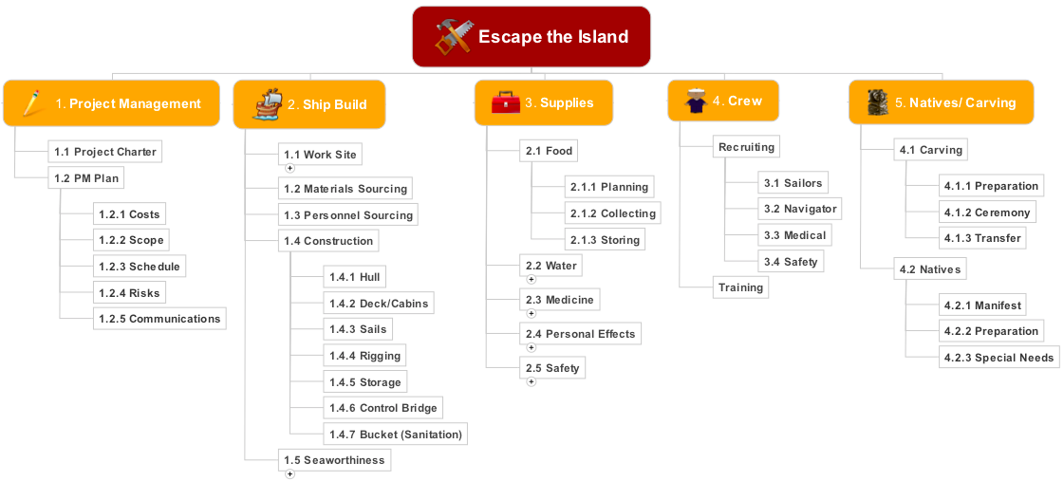

By way of analogy, think of preparing a grand Christmas Dinner for your friends and family. Your WBS will contain various components of the dinner, including the Ingredients required for the various dishes you plan to cook, the accompanying beverages and snacks, as well as the invitations, preparation of seating arrangements, cooking equipment, cutlery and so on. If there is something that needs to be done in order to make the Christmas Dinner a success, then it needs to be included in the WBS. The WBS is depicted graphically and is a common output from a series of brainstorming activities.

Decomposition and the 100% rule
Decomposition is the process of breaking down project deliverables into smaller, more manageable components, from the upper levels down to the lowest levels of the WBS, also known as the work package level. The 100% rule states that the WBS should capture all of the deliverables, both internal and external to the project.

Estimating time and cost
The WBS or Scope Baseline provides us with a good sense of all the work that needs to be accomplished on the project. However, we do not yet know how the work will be performed, who will perform it, and what sequence the work must be performed. We need to go through a further process of decomposition.

Activity Definition
At this point in the project, the scope baseline or WBS has been created and we are further breaking down the WBS into the activities that need to be completed in order for the total project to be considered complete. This is commonly accomplished by looking at a component of the WBS and trying to define what tasks must be performed in order to complete the WBS component.

Activity Duration Estimates
There are several techniques that can be used to help estimate how long an activity takes. PERT is a common technique used to derive reliable duration estimates. PERT or Program Evaluation and Review Technique, is a Probabilistic Time Estimate.

There are 3 Time Estimates used in our calculations:
- Pessimistic: Worst Case Scenario, the activity will take this amount of time to complete
- Most Likely: Based on prior experience, the activity should take this amount of time
- Optimistic: If everything goes well, the activity will take this amount of time

The calculations related to PERT are as follows:

(A) Most Likely Time Estimate (PERT Mean):
{Pessimistic Estimate + (4 x Most Likely) + Optimistic Estimate} /6

(B) PERT Standard Deviation:
(Pessimistic Estimate – Optimistic Estimate) /6

Building your team
The Project team is expected to grow as the project takes on momentum. Contractors or experts join the project to perform specialized work. It becomes increasingly important that each person is aware of what they are supposed to do, when they are supposed to do it, as well as what other members of the team are doing too.

- Human Resource Plan: At this point in the project, we have identified the work that needs to be performed as well as the right way of performing the work. We now need to begin the process of identifying; documenting and assigning project roles and responsibilities and reporting relationships, as well as creating a staffing management plan.
- Acquire Project Team:This is the process of getting the right people to do the job. Actually going out and tracking these people and bringing them on board the project team. Take note that it is not necessarily the project manager’s responsibility and that it is actually done by Human Resources in support of the Project Manager who provides guidance on who they need for their staff in many instances.
- Develop Project Team: We need to develop our individual and group skills in order to enhance our overall team performance. We want to foster and improve their skills of each individual but ultimately the goal is to enhance team performance, thereby contributing to our overall project performance.
- Manage Project Team: This encompasses all of the necessary managerial actions necessary to ensuring project success, including tracking team member performance, providing feedback and resolving issues and conflicts that may arise during the course of a project.

Scheduling work
With a list of activities to be performed and a solid understanding of the required people and skills to perform the work, we can now begin to plan out the activities in the sequence they are supposed to be performed in.

Activity Sequencing
Activity Sequencing focuses on the correct sequence of performing activities now that they have been defined. At this time, the planning team will be asking questions such as how particular tasks should be performed and in which sequence should they be carried out and if the tasks can be performed serially, parallel or a combination of the two most likely? The sequence could be linear, one after the other, or in parallel or even with certain tasks that are overlapping each other. This largely depends on the nature of the work.

Dependencies
To correctly sequence a list of activities, we need to define any related dependencies. Dependencies can be classified as:

- Mandatory Dependency: Involves a physical or technological limitation of the work. For example, a prototype must be built before it can be tested. There is no overlap in there. You have to build a prototype before you can test it.
- Discretionary Dependency: Depends on how you would like to do something or how might have done something in the past or how your organization might dictate how a task is performed.

Network Diagrams
A network diagram is a way of depicting activities that depicts the relationship and dependencies between the activities. The diagram below illustrates an example of a Network Diagram that a project team has created to map out the sequence of tasks to be performed in constructing the ship. The activities are depicted in boxes or nodes and the arrows depict dependencies between the activities. This is called an Activity on Node (AON) diagram.

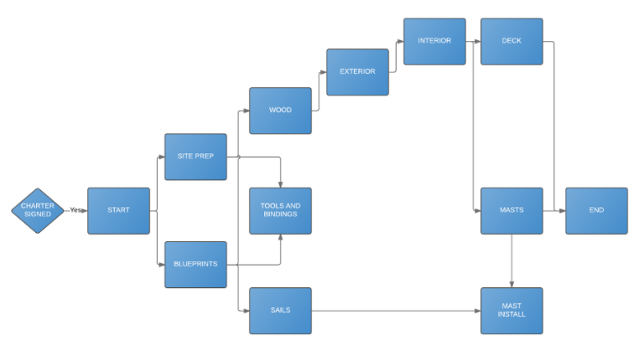
The network diagram typically moves from the left to the right (START to END) and includes forks or branches along the way.

Milestones:
A milestone is defined as an activity of zero duration. It exists as a particular juncture in time in which you have identified as being significant in the project and that you want to make known to stakeholders. I.e. it could be the end of a phase or task or the delivery of a work result or even the expenditure of a certain amount of money.

Milestones are very effective in communicating with Upper Management or the Customer. The reason is that these parties may not be interested in looking at the technical details that we can find in the Network Diagram or WBS.

Making sure the schedule works
A project schedule may not fit perfectly for a variety of reasons. For example, a particular resource (equipment or person) may be needed in the multiple places at the same time. There are several techniques that can be used to resolve some of these issues:

Resource Leveling
We want to ensure that we do not exhaust the resources that are working on our project. For example, if we try to crash a project or particular activity, a particular resource might end up working 18 hours straight, which is not a sustainable level of effort.

The objective of leveling is to establish a schedule where a resource is used in a pretty much consistent manner over time. A situation where there might be a bad allocation of resources is when a resource is utilized heavily in one period of time and not utilized at all in another period. Ideally, we want to find a way where the resource is used in a pretty much consistent manner over the duration of the project. By performing leveling, we reduce the over commitment of resources. We are trying to recognize that our resources might be overworked.

Leveling inherently lengthens the project schedule, however, if we have adequate slack, or the resource is involved in an activity that does not impact other activities if it is delayed, then we may not lengthen the schedule.

Schedule Conflicts
Conflicts can arise between the Project Team and the Client for a project due to scheduling issues such as tasks falling behind or delays elsewhere in the project that a current activity is dependent upon. The following tools can aid the Project Manager in the process of resolving these conflicts.

- Resource Histogram: A bar chart which displays what resources are being used and across what time they are utilized.
- Resource Gantt: A Gantt chart which displays the tasks and responsibilities of the individual resources. It shows the utilization of resources across a Gantt view. In the exam, you will be tested more for the definition of what this tool is than to create or work with one.
- Responsibility Matrix: A list of the tasks and activities together with the resources responsible for performing each particular task in the project.

Organizing your project files
It is imperative to have a clear and methodical way of organizing information and data. As the project progresses past planning and into execution, the amount of project management effort expended is expected to increase. The Project Management team is constantly obtaining updates on ongoing tasks and updating the plan. We’re communicating information to various stakeholders and also working with the team to solve obstacles and challenges that stand in our way.
Project Document Templates
Project document templates represent a standardized way of recording and transmitting information. This includes standard formats for Project Planning documents, including Charters, Scope Statements and other Supporting Documents. Project Monitoring and Execution documents such as Project Completion Checklists, Contract Procurement Templates and even Weekly Status Reports are other examples of documents that are frequently used in a project and can be standardized across the project.

Naming Format
File names should be consistent and self sorting. A common file naming convention is as follows:

YearMonthDay_ClientName_ProjectName_DocumentType_Version_EditorInitials.XXX

So for example, a Project Status Report for a project prepared by a PM looks like this:

20100704_LibraryProject_MakerFair_RAGReport_v1.0_DL.docx

File/Folder Structures
Shared folders should be labeled and organized carefully in a logical and easy to understand manner. A common folder structure is as follows:

Project Name (ID)
> 00 Contract, Proposals
> 01 Workstream 1
> 01 Research
> 02 Requirements
> 03 Other documents
> xx Old versions
> 10 Status Reporting
> 00 Document Templates
> 01 Weekly Status Reports
> 02 Client/Steering Committee Meetings
> 20 Logistics, HR

Timely and Accurate communication
All the planning in the world is of no use if the people who need the information are unable to access it in a timely manner. A project communications plan provides an excellent way to track the key communications that go out to the project team and when they need to go out.

Project Communications Plan
A project communications plan provides a systematic way of communicating information to various stakeholders of a project.
The sample communications plan below lists out the necessary items to be included in the list:
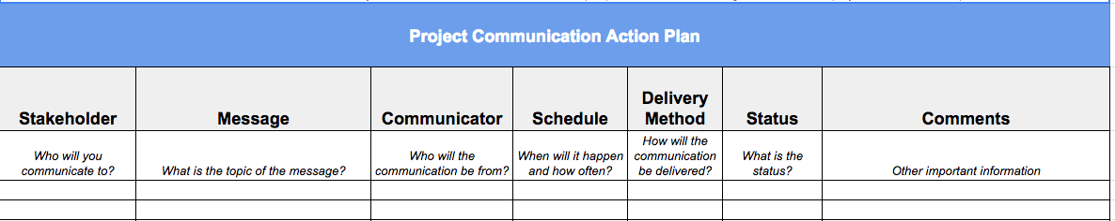

Managing risk
Risk management planning the process of trying to figure out how we’re going to manage the risk that arises from performing project activities. The risk management approach involves the following steps:

- Risk identification: This is the process of trying to spot as many of the risks as possible. We want to take a look at all of the risks that enhance our opportunities in a project as well and the risks, which might threaten the success of the project.
- Qualitative risk analysis: We are looking at the probability vs the impact of a risk event occurring and assigning a score to the risk event. We can then prioritize the risks according to different categories (High/Medium/Low). This allows us to make sure that we are focusing on all of the high risks first.
- Quantitative risk analysis: This is a more detailed activity and highly resource intensive. We use complex techniques like Monte Carlo Simulations to assess the likelihood of a risk occurring.
- Risk response planning: In this section, we try to identify the most appropriate response to a risk. This can be either mitigation (we find a way to reduce the impact of the risk when it occurs), avoidance (we find another way of doing things such that the risk is avoided entirely), acceptance (we realize there’s nothing we can do, so we accept the risk and move on), sharing (we spread out the risk among many options or solutions), or transference (we purchase insurance and in exchange for our premium, the insurance company takes on the risk).

KEY LESSON TAKEAWAY
Certainly one of the most critical aspects of the project is to have a good plan which includes aspects of Scope, Time and Cost (Triple Constraint); as well as aspects of Human Resources, Communications and Risks.

3. Performing Work

PM CONCEPTS
With a carefully laid out plan, our next priority is to execute! In this section, we explore the tasks a Project Manager can perform to help the team to perform the work needed to complete the project.

Kicking-off work
A Project Kickoff meeting is a formal meeting, with an agenda and attendees. The goal of the kickoff meeting is to review the Project Charter and introduce the various key stakeholders for the project, including the Project Manager.

A typical meeting Agenda includes the following:

- Introduction: A few words by the Project Sponsor, highlighting the goals or objectives and business case for the project
- Review of Project Charter: Run through of key elements of the Project Charter
- Establish PM Standards: Define project war rooms, status meeting cadence, time and cost reporting guidelines and other organizational procedures
- Introduce Project team members: This includes the Project Manager, workstream leads and key vendors/contractors
- Establish Project Communications Needs

The kickoff meeting is very much a team building activity. It allows team members to get to know each other. Furthermore, we have an understanding of our working relationships and our lines of communication. We can also reach a common agreement on the goals of our project. We can identify some problem areas and we are hoping to define the objectives of our project to our stakeholders.

The kickoff meeting is not intended to for discussions of any hard technical issues you may encounter into the project. It is not a status meeting of the project and we are not trying to explore alternatives to performing tasks in the project.

Handing out assignments
If planning was performed properly, the resources involved in the project should have individual tasks assigned to them already. At this point, the process of handing out work assignments can be performed by compiling a list of tasks assigned to each resource and making sure this is communicated to them.

Work Authorization System
The Work Authorization System is a formal process in which a person says ‘Okay, this work is supposed to be done and I release this.’ Key elements of a work authorization system include:
- Formal approval of the work by relevant authorities
- Formal approval of the vendor or individual performing the work
- Detailed description of task, including success requirements and required skills

Resource Assignment Matrix
A resource assignment matrix tracks the various resources in a project in relation to the activities or tasks being performed. Note that in addition to people, resources could include tools and equipment and rooms.

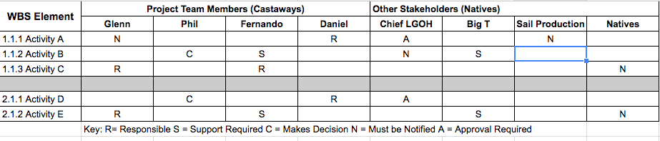

Keeping things moving
An important role of the Project Manager is ensuring that the Project continues onwards despite any issues or obstacles. This includes helping the project team to accurately define a problem with sufficient detail and ensuring that the relevant expertise and skills are available to help resolve the problems.

Working through problems
We understand that conflict is unavoidable in any project. Ideally, want to utilize team building as a positive force in countering the negative aspects of conflict. Team Building relates largely to a concerted effort to team building within an Organization.

There are several goals and results of positive team building:
- Interdependence of Team Members: Team members should be able to depend and rely on one another. Team members should work together to understand each other’s roles and responsibilities and know where they fit in for the overall scope of the project.
- Common Consensus: The team should come to a common consensus regarding the defined project goals and objectives.
- Group Work Commitment: The team members should be committed to working together in order to achieve a common end result. The team members should also be able to work together and feel that they have not been forced into doing this.
- Accountable as a Functional Unit: The team members should be able to understand that they are accountable as a functional unit within a larger Organization and they should recognize the project’s value to achieving the Organization's aims.
- Acknowledgement of Conflict: Team members should be aware that conflict may arise during the project and that it should be managed in a fair and equitable manner.

KEY LESSON TAKEAWAY
Project Execution is entirely dependent on Project Planning. This means to say that we must have first performed an adequate level of planning such that the project team has confidence in what they need to do in order to complete their assigned activities. The Project Manager has a key role in ensuring that the people performing the work understand what has to be done and that the project maintains its onward momentum despite any challenges it may encounter.

4. Monitoring Progress

PM CONCEPTS
It is critical for a Project Manager to understand whether the work being performed is going according to plan. In this section, we explore various techniques of evaluating and assessing work done.

Getting status updates
Project Status meetings are extremely valuable in making sure that project team members and project management are communicating the progress of planned tasks and identifying problems and issues that can be resolved so as not to hinder further progress.

Status Update Meetings
A well-run meeting should last less than an hour and goes through ongoing project tasks in a methodical and organized format. An effective agenda helps to set the pace of the meeting and ensures that all critical items are brought up and discussed. A status meeting agenda could include the following items:

- Summary of Status: Discuss the overall project status, key updates, and the expected plan for the next set of work
- Open Action Items: Review and update open action items
- Open Risks and Issues: Review and update open risks and issues
- Closing the meeting: Review notes and any other business

A RAG (Red Amber Green) Report template has been included with the supplemental materials for this course. It includes all of the sections discussed in the meeting agenda list above and also uses a simple color coding to depict any major issues that exist on the project.

- Red: This represents an issue. A related item may be delayed or over budget and this may have a significant impact on the project if not managed properly.
- Amber: This represents a concern. A related item is at risk of being delayed or over budget and requires additional management attention.
- Green: This means that the task or project is going according to plan.

Evaluating how the project is going
An important aspect of evaluating project success is in first identifying what key measures the project is being identified on. During the planning phase, we should have already identified key metrics for the project, which are documented in the Project Scope Statement and Charter.

Several evaluations can be performed during the lifecycle of a project:

- Mid-project Evaluation: This type of evaluation can occur more than once throughout the project. At some point in the project, such as at the end of a project life-cycle phase or when a critical milestone has been done, it is time to see if the project is meeting its objectives.
- Final (Post)-project evaluation: When the project is complete, you find lessons learned for the purposes of sharing the information with other project teams.

Evaluation Goals:
Evaluations are conducted for the purposes of understanding where the project has been, where the project is going and what went right or wrong. Activity is expended during evaluations to analyze the systems and see whether they were applied successfully or poorly. Evaluations should be conducted with all teams in a fair and consistent manner every time.

Handling changes
Changes are sometimes inevitable in a project and shouldn’t be seen of as something to avoid. Perhaps a new technology has occurred that could save time and cost significantly. The key aspect of implementing change is in how the change is managed.

Change Management
A formal process should be adopted by an organization to manage changes. A change request should be made whenever change has the possibility of affecting the scope/schedule/resources of the project.

Change Control Boards
Change Control Boards are formal committees comprising of individuals in a company who have various areas of responsibility that will be impacted if a change is implemented poorly. For Organizations with a Change Control Board, project team members cannot make changes to a project without getting formal approval. Changes will only occur with the sanction of a Change Control Board (CCB)

KEY LESSON TAKEAWAY
A key function performed by the Project Manager is in monitoring and controlling the project activities during various phases of the project. Evaluations, status meetings and implementing a formal change process are all key elements of successful project controls.

5. Wrapping Up

PM CONCEPTS
How are we marking off tasks as complete as we go through the various phases and milestones of a project? In this section we explore formal processes for closing out the various elements of a project.

Finishing a project, phase or milestone
As elements of the WBS are being completed, it falls on the Project Manager to close out completed project tasks and activities. For smaller activities that are part of a phase or workstream, completed tasks can be updated during project status meetings. However for larger and more significant phases, or the achievement of a milestone, the Project Manager may want to schedule a dedicated meeting or event to manage the completion of the project activities.

Evaluation Criteria
The project team may have specific requirements or a standardized process regarding the closure of a specific work item or task. For outsourced work, payment may be due upon delivery of specific items. Ideally, the requirements of the task have been clearly defined during task assignment and in some cases, an audit or evaluation will have to be conducted of the completed items to make sure that the deliverables are meeting specifications.

The following criteria could be used in evaluating outsourced sail production for a ship construction the project:

- Sturdiness of Sail Construction
- Waterproof characteristics of the Sails
- Measurements and Dimensions of the Sails
- Weight of the Sails

Special tests would need to be performed and conducted in order to validate that the Sails are up to specifications.

Getting sign-off
Sign-off can occur at the completion key phases or milestones of a project. Sign-off can also occur for more than one party, especially if there is a complex process that has numerous components that involve various stakeholder groups in the construction. Responsible stakeholders of the project team, including any quality assurance functions can sign off that their work is complete before the final work results are sent over to the Project Sponsor or customer for inspection and sign-off.

Tying up loose ends
It is common during evaluations and inspections that minor issues or defects may be identified. A defect is an element of the work result or deliverable that does not meet the required standards. A formal process is typically employed to list out the defects and work with vendors and other responsible stakeholders to identify ways to rectify the defects.

Contract Administration
In the case where work was outsourced beyond the project team to a vendor, there may be a formal contract that defines the nature of the work to be performed as well as the responsibilities of the customer and supplier. As part of vendor management, a review of the contract clauses may be performed on an ongoing basis and specifically upon the delivery of goods or scope items.

Common contract elements or clauses to reviewed include the following:
- Product Specification: Description of the work to be performed or the final product
- Delivery schedule: Anticipated delivery times for products or services
- Handling of changes: Formal process agreed by both parties for handling changes to the project or products contracted for
- Warranties: Any warranties made by the contracting parties in terms of delivery of goods, or payment.
- Inspections: A defined process for inspecting completed goods
- Subcontracts: Provisions for allowing elements of the work to be handled by additional parties and managed by the supplier

Lessons Learned
Project lessons learned are an effective way of documenting anything that the project team learned during the project or a project phase that may benefit subsequent phases or project teams in the organization. Lessons learned are documented and kept in a centralized repository where it can be accessed by other users and readily accessible The rationale here is that an organization is doomed to repeat the same mistakes unless it can find a way to document these lessons and transmit them to others who can benefit in the future.

Quality Assurance
Quality Assurance is a managerial function and it focuses on key activities that instill a sense of ownership for delivering a quality product by every member of the team. Key Quality Assurance activities include audits and evaluations:
- Formative Quality Evaluation: This happens during the Project Lifecycle. It is going on as the project is progressing or forming.
- Summative Quality Evaluation: This happens at the end of a project. This can also be known as lessons learned for all intents and purposes. Looking at how we functioned. What were the processes that we used and were they effective. We also look at the product or service that we created and we examine the level of quality inherent in that well.

Even though the summative quality evaluation is carried out after the project ends, there should be no or little wait time after the project ends, before the summative evaluation is carried out. This is because certain information would have been lost over time by team members after time. We want to document all experiences while they are fresh in the minds of our team members.

KEY LESSON TAKEAWAY
A formal process should be adopted to manage the closure and completion of tasks. Depending on the magnitude of the task item to be completed, an appropriate closeout event can be planned.

6. Conclusion

PM CONCEPTS
To wrap up the day, we review key learnings and identify next steps for running a project.

Workshop Summary
- We covered the major activities of getting a project off the ground, identifying key stakeholders and obtaining formal sign-off on a Project Charter
- Next, we used brainstorming to create our first project baseline, the WBS or Work Breakdown Structure
- With the WBS in hand, we can employ the concept of decomposition to add much needed details through activity definition and estimation
- With detailed activity lists, we can identify detailed resource requirements. We can also identify the sequence in which to perform the activities and also identify any specific dependencies by using a Network Diagram.
- With the Network Diagram, resource assignment matrix and other tools, we can construct the Project Schedule.
- A kick off meeting is a great way to start a project on the right foot
- As the project progresses, the Project Manager is responsible for performing regular status updates and helping to resolve conflicts
- The Project Manager should make sure that all stakeholders are kept up to date with project statuses and delays. The Project Communications Plan will help in this regards.
- As project activities get completed, the PM also leads activities to inspect the delivered items and report that they have been completed to senior management
- Finally, upon completion of the project, the PM can conduct a Lessons Learned meeting to gather valuable knowledge of the project that can be used to make future projects more successful

Next Steps: Your next project
I think you’re well armed in terms of tackling your next project. You should take the time to review the notes and sample documents. If there are other project managers near you, try to build up a support group so that you have resources for exchanging best practices and templates.

Next Steps: Learning more
Project Management is an amazingly popular skill and the best thing is that you keep learning more every day! If you’re interested in pursuing a career in Project Management, you might want to explore the steps for pursuing a PMP certification.

The Project Management Professional, or PMP certification was developed by the Project Management Institute and is a globally recognized certification for Project Management Professionals around the globe!

I’ve taught and helped get thousands of people certified in Project Management. If this is something that you’d like to be more interested in, click on this link to read an overview of the certification on my blog:

http://theroadchimp.com/pmp-exam-prep-what-is-the-pmp/

KEY LESSON TAKEAWAY
I hope that this brief (and intense!) day has given you an insight to performing effective project management. There’s a method to the madness, you just need a methodical approach.

