Below is a scenario at the East Meadowbrook Library. The team has obtained formal approval for the Maker Faire by obtaining sign off on their Project Charter. In an effort to build out a detailed project plan, the team has conducted a brainstorming session to identify the key areas of work that fall under the scope of the project.
The task for this exercise is to develop a Work Breakdown Structure (WBS) that will serve as a Scope baseline for the Maker Faire project.

Instructions: The Key Work areas for the project have been established as follows:
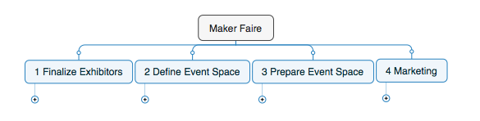
The project team has identified the activities to be performed during the project. Your objective for this exercise is to categorize the activities under the appropriate work areas.
Working in your teams, take Five Large Post-it notes and Label them as follows
- Maker Faire
- 1 Finalize Exhibitors
- 2 Define Event Space
- 3 Prepare Event Space
- 4 Marketing

With the stack of Small Post-it notes that you have been provided, record down the tasks from the list on the next page, with one Post-it note per task.
On the paper canvasses provided to you, stick the Large Post-it Notes as per the image above Stick the small Post-its under the corresponding Large Post-its.
We will discuss the solution together as a class.

Activity Name | Activity Duration
Update Library Website | 14
Finalize Exhibitor requirements | 14
Confirm Event Dates with Venue and Exhibitors | 7
Prepare Attendee Surveys | 7
Identify Space requirements | 7
Exhibitor Setup | 7
Identify potential layout plans | 7
Finalize Exhibitor requirements | 14
Exhibitor Outreach Program | 14
Event Space Construction | 21
Event Space Completed | 0
Finalize placement of Carts and Accessories | 7
Obtain Permits from Town | 7
Finalize Workshop Schedules | 7
Exhibitor list completed | 0
Purchase Makerspace Equipment | 14
Marketing Activities completed | 0

