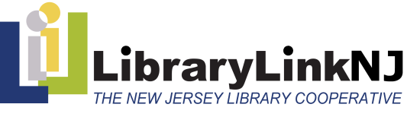
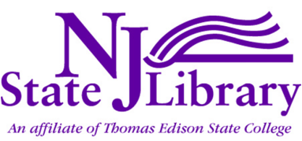

New Jersey Library MakerSpaces -
The Leading Edge, 2013-2014

Subsidy Chart

Public Libraries

Population Served | Subsidy
Fewer than 14,999 | $3,750
15,000 – 24,999 | $3,750
25,000 – 37,499 | $5,000
37,500 – 49,999 | $7,500
50,000 – 99,999 | $10,000
Greater than 100,000 | $12,500

Academic, Hospital/Medical Libraries
FTE | Subsidy
Fewer than 2,499 | $3,750
2,500 – 4,999 | $3,750
5,000 – 7,499 | $5,000
7,500 – 9,999 | $7,500
10,000 – 19,000 | $10,000
Greater than 20,000 | $12,500

School Libraries
Organization Type | Subsidy
Public School District – can be used with a single school as a pilot or several schools within a district | $5,000
Private School | $3,750

