Below is a scenario at the East Meadowbrook Library. After assembling the WBS and the Detailed Activity list, Patricia decided to compile the activity list into a GANTT chart.
The task for this exercise is to analyze potential issues that may arise during a project and identify how the GANTT Chart can be used to find solutions to these problems.

Instructions: The GANTT Chart for this project is listed in detail on the next page. The GANTT chart details are listed below.
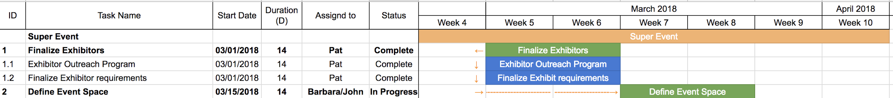
The GANTT Chart comprises of two separate views. The first view is known as the activity and task assignment view.
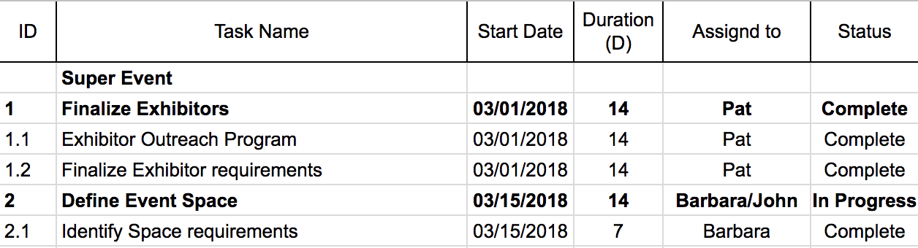
This view lists out the individual tasks to be performed as well as pertinent information relating to these tasks as follows:
ID: The ID is taken directly from the WBS
Task Name: The name of the task or activity to be performed
Start Date: The Calendar date that an task is planned to start on
Duration: The amount of time required to perform a task (Hours, Days or Weeks)
Assigned to: The resource(s) that the task has been assigned to
Status: The status of the task (Not Started, In Progress, Complete, Cancelled, Delayed)

The second view is known as the schedule view.
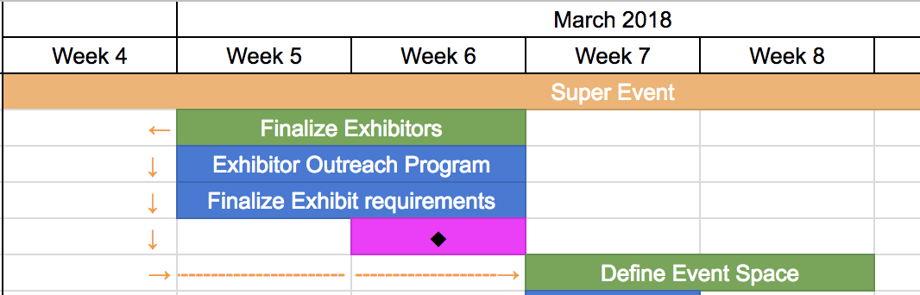
Dates are listed along the top row. In this case, dates are formatted into Weeks, but days can be used instead.
Bars represent the amount of time it takes to perform a task. Most Project Management tools use the concept of summary level and sub-tasks. In our example, summary level tasks are depicted in green and sub-tasks are depicted in blue.
Milestones are represented by a purple cell with a black diamond. Note that a milestone does not occupy any resources or effort. It’s just a great way to line up resources
Dependencies are represented by small arrows. For example the Define Event Space summary level task is dependent on the Finalize Exhibitors task being complete, before it can start. An orange arrow can be seen connecting the two tasks.

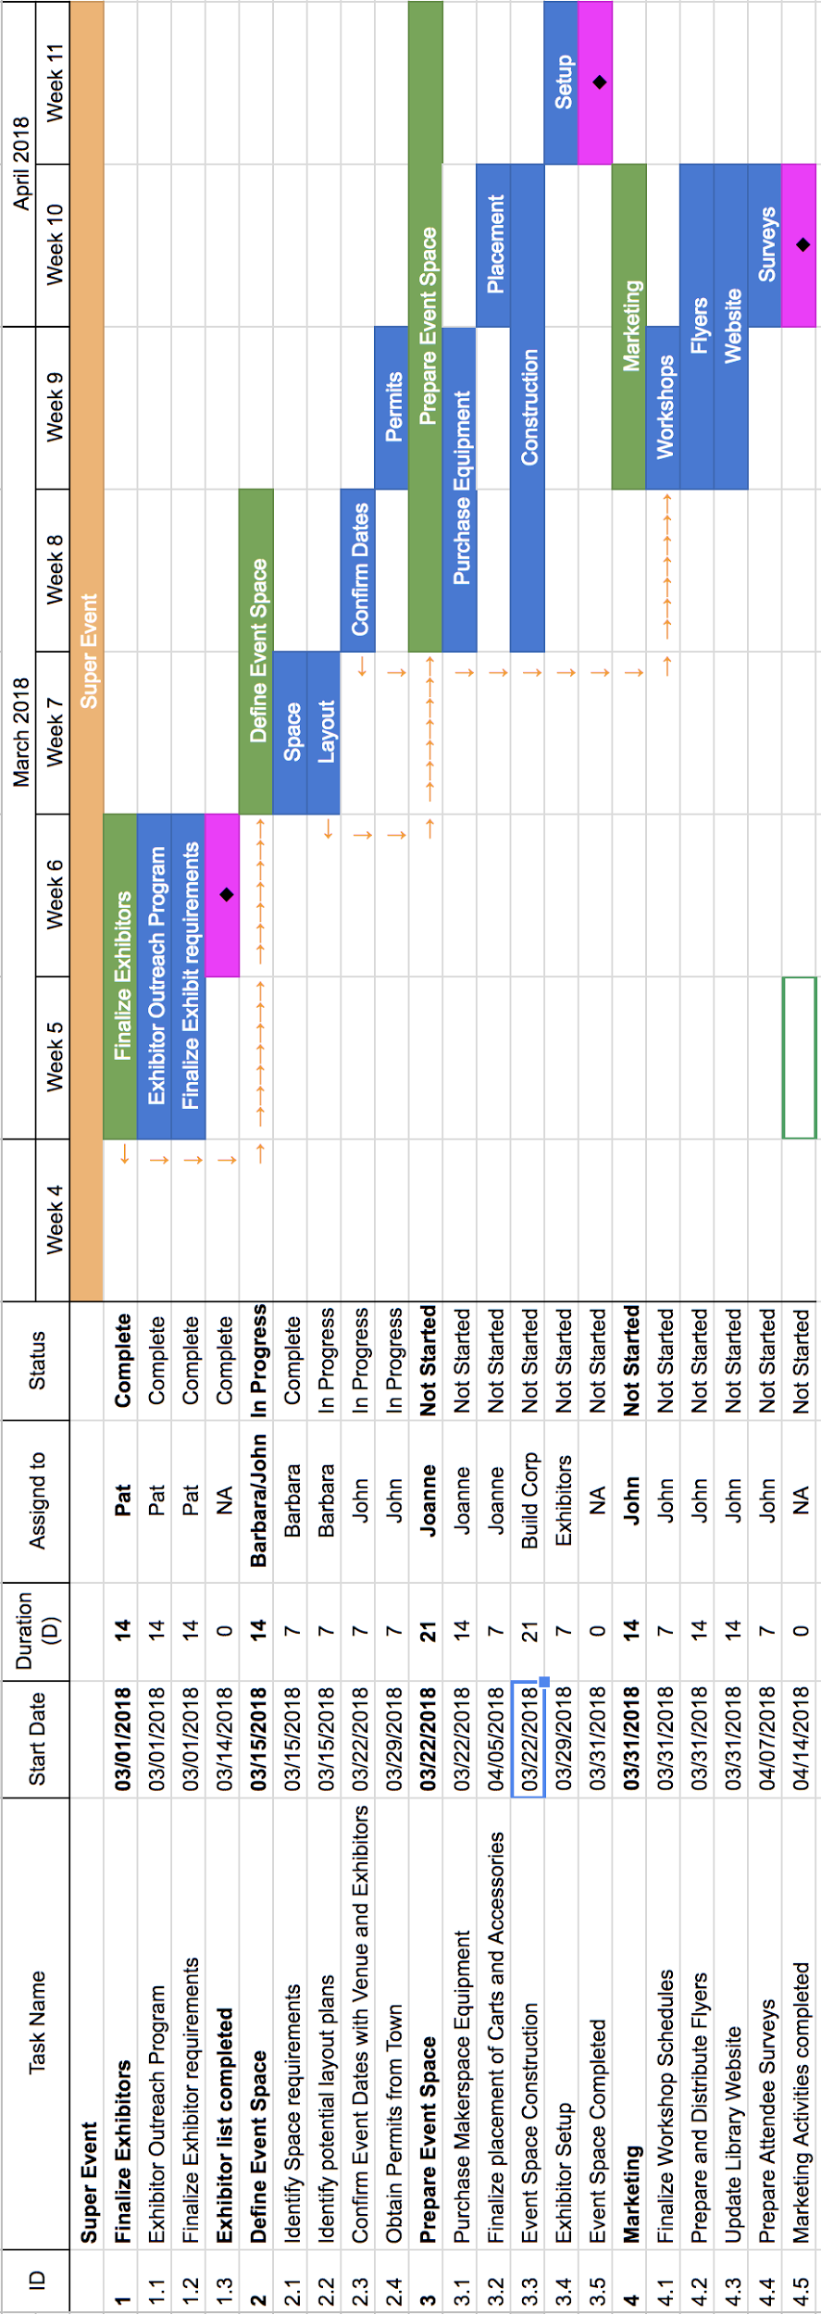
Exercise
Use the GANTT chart on the previous page to answer the following questions
Q1. A makerspace equipment vendor has informed the team that a crucial piece of equipment that was supposed to arrive on week 9 has been delayed by a week. Will this delay impact the timeline for the project? (hint: try to find the relevant task item and check to see if there are any dependencies on that task)
Ans.________________________________________________________________________
____________________________________________________________________________
____________________________________________________________________________

Q2. Build Corp is an event management company that the team has engaged to setup the event space for the maker faire. Build Corp informed the team that they recently won a bid on a much larger project and need to move the event construction task forward by a week. Can you identify how this change will impact the project?
Ans.________________________________________________________________________
____________________________________________________________________________
____________________________________________________________________________
Q3. John informs the team that the town is unable to issue a permit until the construction of the project is completed. The town planners require a week to schedule an inspection and another week to issue the permit. How far will this push back the project completion date? (hint: disregard Q1 and Q2 when answering this question).
Ans.________________________________________________________________________
____________________________________________________________________________
____________________________________________________________________________

