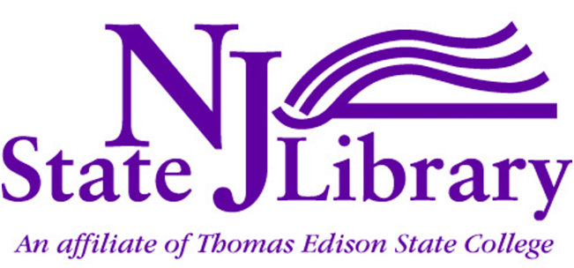
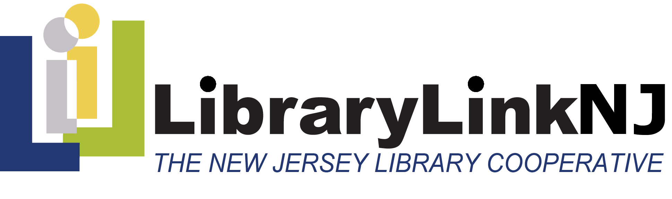
July 2013
Statewide Strategic Plan
For the Future of Libraries in New Jersey
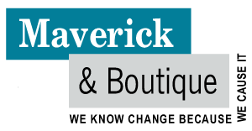
Prepared by John Findlay & Abby Straus
Maverick & Boutique
www.maverickandboutique.com
Copyright Notice
Except where otherwise noted, content in this document is licensed under a Creative Commons Attribution 3.0 License. Readers are invited to distribute, remix, tweak and build upon this work, even commercially, as long as they credit The New Jersey State Library and LibraryLinkNJ for the original creation. To learn more visit http://creativecommons.org/licenses/by/3.0/

Contents
Executive Summary 1
The Context 16
Our Stakeholders 20
Goal 1: Communicating the Value of Libraries 29
Projects for Goal 1: 31
Goal 2: Leadership and Coordination 44
Projects for Goal 2: 48
Goal 3: Collaboration & Partnerships 54
Projects for Goal 3: 58
Goal 4: The Library as Community Anchor 68
Projects for Goal 4: 71
Goal 5: Cycles of Innovation 83
Projects for Goal 5: 87
Goal 6: Professional Development & Self-Care 100
Projects for Goal 6: 103
Goal 7: Creative Funding Sources 110
Projects for Goal 7: 114
Implementation Options 122
References 125
Appendix 1: Project Table and Planning Principles 126
Strategic Planning Project Table 126
Strategic design principles: setting ourselves up for success 128
Appendix 2: Additional Project Ideas 131
Appendix 3: Participants in the Strategic Planning Process 135

Executive Summary

This strategic plan to guide the future of New Jersey’s 2000+ public, school, academic and special libraries was developed through a process of public engagement by representatives of the library community and stakeholders during 2012-2013. The plan is a collaborative effort between the membership of LibraryLinkNJ (LLNJ), The New Jersey Library Cooperative and the New Jersey State Library (NJSL).
Our vision
We envision every library in New Jersey as a thriving, vibrant hub of its community. We envision the people of libraries—librarians, staff, boards, customers and all library stakeholders—as happy, fulfilled and collaborating productively to realize our shared goals.
Our future role
In a world of growing complexity, uncertainty and change, libraries and librarians have much to offer the communities we serve. We see our roles as:
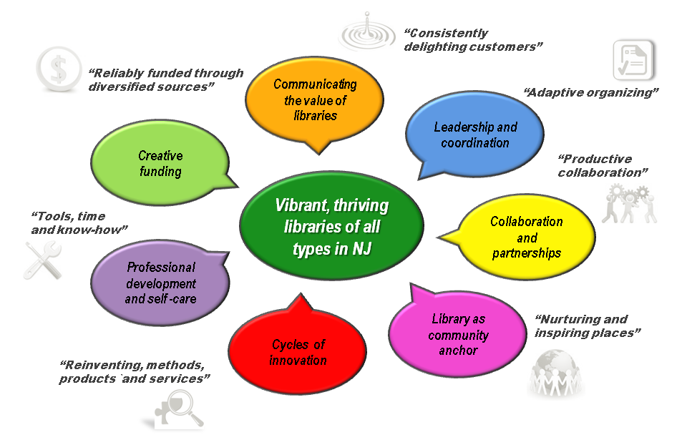
Libraries as the heart of our communities: Libraries play an increasing role as a place for people to collaborate and exchange ideas and to gain access to information, knowledge, tools and methods. In a partnership with our customers we will help build more robust, vibrant communities, incubate new businesses, develop new skills for 21st century work and life and be a safe haven in times of crisis.
Librarians as wise knowledge facilitators: Librarians will increasingly help people make sense of and navigate a world that is ever more complex, rapidly changing and uncertain. We will become role models for how to bridge and leverage new knowledge spaces in a multiplicity of roles: trusted, responsive partners, guides and content curators and publishers, teachers, advocates and cross-boundary facilitators.
The Trends
The New Jersey library community identified numerous local, national and global trends which have major impacts on libraries, the services we provide and the way we engage with our stakeholders. The most important of these trends are:
- 24/7 always-on world
- Blend of high-tech and past-tech
- Budget cuts with changing priorities, e.g. retirement and health bubble
- Content shift from text/print to multimedia/electronic
- Dissolving boundaries in terms of connectivity and yet more divisions between disciplines
- Emergence of social deserts, people want meaning-making time together.
- Explosion in availability of tools such as iPhones that do “everything”
- Focus is scattered: Shorter attention spans
- Growing demand for access to physical tools, computers, machines, apps
- Growing demand for skills for working across boundaries
- Growing democratization of apps, machines and Internet
- Growing diversity of disciplines, skill sets, cultures
- Growing number of have-nots lacking skills and access to 21st century work and world
- Increasingly shorter waves of change demands regular personal reinvention
- Instant gratification; anticipatory awareness of customer needs/interests
- On-line access to content, multi-function tools & people anywhere
- Shift from content/information curation to knowledge creation and implementation
- The Internet of things

The process
The strategic planning process began in November 2012 and concluded in June 2013 with the publication of this report.
The “living plan” process comprised the following activities:
- A Kick-off meeting: to decide the process and who to involve.
- Research and Briefing Notes to inform the process and challenge our thinking.
- An Advisory Committee Workshop to canvas ideas about the future of libraries in the context of the trends, identify customer and stakeholder needs and interests, understand what value libraries have to offer and the resources and skills we have and need, consider new ways to deal with competitors and possible collaborators and explore new sources of funding.
- A series of Community Workshops to expand on the issues considered by the advisory committee and generate ideas for projects and programs we can undertake.
- A First Iteration of the Strategic Plan including an environmental scan, preferred future position, stakeholder interests and dynamic capacities resources analysis and project and program concepts.
- Supplementary Inputs to the Plan include targeted interviews with thought leaders, a statewide survey of librarians and a schools survey.
- Synthesis into seven Strategic Focus Areas each with 6-7 project concepts
- On-line Task Force Workshops to create very detailed Project Plans and goal, strategy and measures of success statements.
- A Draft Strategic Plan Review by the Advisory Committee.
- Preparation of the Strategic Plan in three formats, a slide show, a report and a website.
The entire process can be viewed at:
https://www.mindmeister.com/237766551/llnj-strategic-planning-process
Strategic Principles
The strategic plan is based on six core principles that are a balance between the contrary forces that shape the emerging world in which we live and work. We seek to:
- Serve New Jersey’s library community as a whole and serve individual libraries, their staff and communities.
- Honor our tradition as an institution and innovate to stay relevant and add value.
- Be visionary and be grounded in current reality.
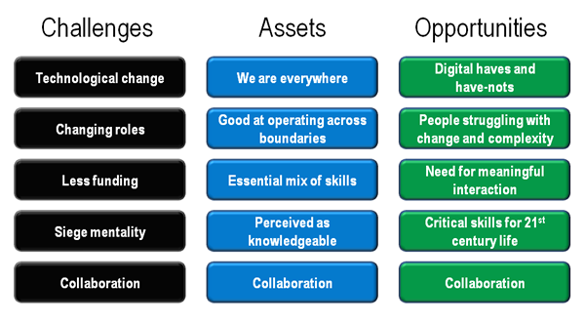
- Advocate for what we believe and inquire about what others believe.
- Conserve and work with existing resources and develop new, creative funding streams.
- Provide structure and be flexible to accommodate change.
Strategic analysis
A strategic analysis of the key factors having an impact on New Jersey’s libraries reveals not only a variety of pressing challenges, but also a host of opportunities for capitalizing on our existing assets and for developing new skills and services to meet the needs of 21st Century citizens.
For example, libraries have, or are well-positioned to acquire, the capacities for success an emerging economy that is based on the wise application of knowledge.
These capacities include:
- Essential mix of skills: The required education, research, relationships, technology and other skills critical to the 21st Century work and life.
- Working across boundaries: This is an essential skill in a complex ever changing world. We are able to operate in both the virtual and the real-world.
- Safe haven: We are seen as a portal and a safe haven for those who do not have access to the 21st century skills and tools.
- Perceived as knowledgeable: Our clients expect/think librarians know or have access to everything and anything.
- Collaboration: We have the skills to collaborate well with each other and our stakeholders.
- We are everywhere: In communities, schools, universities, community colleges, corporations and on-line.
However, libraries do face a number of critical challenges, none of which are insurmountable provided we take the kinds of actions that have been developed during the planning process. These challenges include:
- Technological change: Keeping abreast of technological change, the new skills required and new business models.
- Less funding: Higher demand, means doing more with less, especially to respond to change.
- Siege mentality: We see ourselves as under attack.
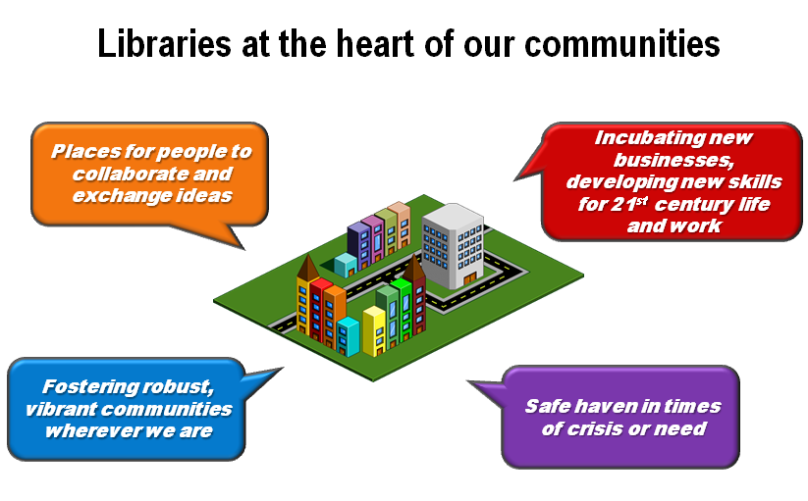
- Undervalued by some political leaders: They think Google and the Internet have all the answers.
- Role change: A shift in roles from content & knowledge curators to creators and facilitators.
- Barriers to change: Some rules and systems are unfriendly to customers’ new needs, e.g., No talking, no eating.
- Collaboration: We know how to collaborate but need and want to do it better and more frequently.
Arising from the intersection of the trends, challenges and capacities are major opportunities. It is vital that libraries and librarians capitalize upon these to more effectively meet our needs and those of our stakeholders. These include:
- People and communities struggling with change and complexity: accelerating change that has become permanent.
- Digital have and have-nots: Growing digital divide between access have and have-nots.
- People who desire meaningful interaction: As a response to living too long in cyberspace or having become socially isolated. Many of us now want more meaningful face-to-face opportunities to meet, work, learn and create together.
- Critical skills for 21st century life: A growing gulf between the skills required for living and working in the 21st century. Libraries becoming the go-to place for becoming re-employed and reengaged.
- Collaboration: Libraries are in the right place at the right time to work with our stakeholders to help people work across or live more successfully in multiple worlds.
The Seven Strategic Goals
The LLNJ community identified seven goal areas on which to focus in order to implement the strategic plan. They are numbered in this plan for convenience and are all of equal importance. The goal areas and accompanying strategies are as follows:
Goal 1: Communicating the Value of Libraries- Our libraries offer a consistent brand promise through which we delight our customers and anticipate their evolving needs. All stakeholders appreciate the value of the libraries in their world, and participate actively in joining and belonging to the brand.
The strategies to achieve this goal are:
- Strategic positioning: Position ourselves as co-creators of new ways to help people improve their quality of life, learn, develop and participate more fully in society.
- Develop a branding strategy: Create and deliver a comprehensive branding strategy for NJ libraries.
- Monitor awareness: Track public and political awareness through usage measurements, surveys, and event attendance.
- Advocacy: Create a statewide advocacy and collaborative relationships group to help libraries of all types better communicate and deliver on the brand.
- Future planning processes: Involve political, community and business leaders in implementing this plan and future planning processes.
Goal 2: Leadership and Coordination- Our libraries are led, organized and managed so that we are able to rapidly adapt our methods, systems, and offerings in anticipation of the emerging needs and interests of customers, funders, partners, suppliers, staff and other stakeholders.
The strategies to achieve this goal are:
- Efficiency and effectiveness: Provide a service to undertake reviews of the efficiency and effectiveness of library service delivery to identify opportunities for improvement.
- Learn from each other: Establish forums that enable the staff of libraries to regularly meet and share best practices in funding, service delivery, advocacy, innovation and leadership.
- Distributed leadership: Develop the capacity among library leaders to work with each other and their stakeholders in the most productive ways.
- Alignment with stakeholder interests: All libraries in New Jersey that are publicly funded will prepare a strategic plan in collaboration with key internal and external stakeholders.
The NJSL “SWAT Team of Library Transformers”
Goal 3: Collaboration and Partnerships- We collaborate productively with each other and with our stakeholders, internally, between libraries and library systems, across functions and disciplines, with our funders, customers, competitors, government and legislators.
The strategies to achieve this goal are:
- Promote collaboration: Create incentives for and reward collaboration.
- Develop cross-boundary skills: Develop and offer cross-boundary collaboration tools and skills for librarians, staff and stakeholders.
- Resource sharing: Promote collaborative resource-sharing models between libraries and stakeholders.
- Events: Facilitate opportunities for networking, collaboration and creativity amongst library colleagues, to learn from each other’s successes.
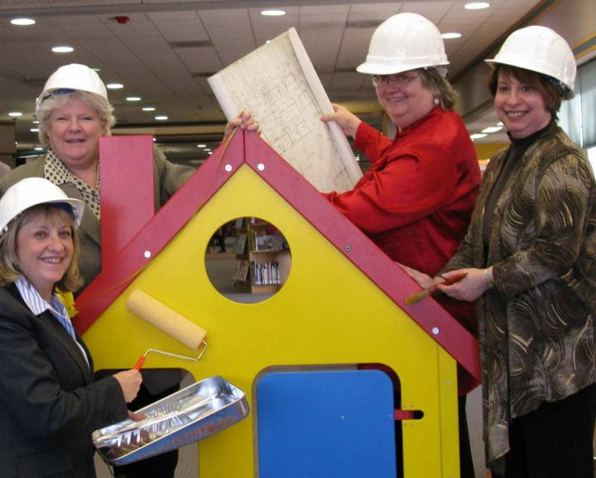
- New partnerships: Promote libraries as trusted partners for business, community, education and government.
Goal 4: Library as Community Anchor-Libraries are safe, nurturing and inspiring places for people to meet, work, learn, grow and exchange ideas together.
The strategies to achieve this goal are:
- Create hubs of activity: Work with municipalities and cities to plan the development of "villages" around libraries including the co-location of dining, consulting, education, personal development, recreation and communication storefronts.
- Meet new needs: Develop programs and services to address changing user and community needs, including new citizens and the differently-abled.
- Offer services for others: Become the local agencies of business, education (especially higher education) health and government services.
- Safe haven: Build the capacity for libraries to be the go-to place for information and help in emergencies.
- Non-users: Engage with people who don’t use libraries to see how we might enroll them and meet their needs.
Goal 5: Cycles of Innovation- We reinvent our methods, models, products and services to keep pace with the “new normal” of transformational social and technological change.
The strategies to achieve this goal are:
- Pilot projects: Design, pilot and replicate innovative projects in all library types that align with emerging customer and partner needs.
- Balance with traditional models: Maintain an appropriate balance between new and traditional services for which libraries are widely valued.
- Guidelines and certification: Provide guidelines for libraries for appropriate technology, skills and services and to help late adopters to more quickly take up new models of service delivery.
- Commit % of funds: Devote a percentage of resources to innovation to stay current.
- Reward innovation: Celebrate success with opportunities to replicate the results elsewhere. Allow failure as a learning experience.
Goal 6: Professional Development and Self Care- We reinvent our methods, models products and services to keep pace with the “new normal” of transformational social and technological change.
The strategies to achieve this goal are:
- New skills: Examine the structure and skills of the library workforce in relation to new services.
- Cross-training: Offer training in areas critical to success in the “new normal”, including leadership, facilitation, project management, fundraising, business development, partnering and process design.
- Collaborate with educational institutions: Ensure that librarians receive the training they need for high performance and career satisfaction in the future.
- Time to learn: Designate time for informal networking, brainstorming and learning from each other.
- Self-care: Provide opportunities for library staff to take care of themselves through stress reduction, coaching, improvements to the workplace and fun.
Goal 7: Creative Funding Sources- We are reliably funded through diversified sources including federal, state and foundation grants, business partnerships, seed funding and entrepreneurial activities. We work closely with political leaders to maintain or grow funding from traditional sources.
The strategies to achieve this goal are:
- Efficiency and effectiveness: Develop more efficient ways of delivering services. Shift the resources to new projects that have strong customer or stakeholder support and those that reflect the most promising practices.
- Value-add: Generate new revenue from adding value to jointly-created and delivered services.
- Grants: Pursue state, federal and foundation grants as both a revenue source and a service.
- Specialized partnerships: Develop partnerships around issues facing key government, business and community groups, e.g. school readiness, workforce development and enterprise incubators.
- Revitalize existing funding: Work with political leaders to identify gaps in service delivery for new projects that underpin traditional funding.
Next Steps
The strategic plan provides opportunities for all librarians and all types of libraries to participate in the implementation of the plan. These options comprise:
Lead or join a task force: to collaborate with other librarians in New Jersey to create a future of our choosing with the support of key stakeholders
Choose to implement one of 33 ready-made projects: you can start today in collaboration with your community, customers or political leaders.
Develop one of 33 project ideas: and start a planning process with your own staff and in partnership with your local community, school, business or university.
Secure new funding using some of 8 strategies: for existing and new projects and programs including federal, state and foundation grants, LLNJ and State Library seed funding, sponsorships, new political commitments and partnerships with suppliers, government agencies and community groups.
Libraries create their own version of the strategic plan: using key elements of the LLNJ strategic plan.
Design and deliver new professional development programs: for your staff and boards in advocacy, project management and partnering that will enable libraries to achieve their goals.
Develop and offer a new state-wide service: by finding the talents in your library e.g. grant writing that could be offered through other libraries on an exchange-of-value basis.

Our Strategic Planning Process
The "Living Plan" approach to strategic planning adopted by LLNJ/NJSL is designed to be an iterative process of planning and implementation that can be continued by libraries and our stakeholders throughout New Jersey. We use the process to synthesize our creativity, passions and expertise and to collectively create our desired future one step at a time.
There are many ways to make use of this plan. Key elements of the plan, including goals and strategies, can easily be incorporated into individual library strategic plans. Individuals can join task forces to implement specific projects, and libraries can also choose to undertake a similar strategic planning process, but at a local scale.
1. Kick-off meeting
The process began with a meeting to discuss and finalize the process, decide who we want to invite and what we expect to achieve by the end of the project. The process began in the LLNJ offices on October 9, 2012, followed by the official kick-off meeting with the Statewide Strategic Planning Committee on the afternoon of October 25.
2. Research and Briefing Notes
Desktop research was undertaken to prepare briefing notes to inform the strategic planning process, especially to provide inputs to the series of workshops. This information included trend data on emerging technologies, changes in the role of libraries, shifts in patterns of knowledge management and knowledge creation, as well as relevant financial and population statistics. Thought provoking challenges from thought leaders about future scenarios were derived from journal articles, meta-studies and presentations on TED.
3. Advisory Committee Workshop
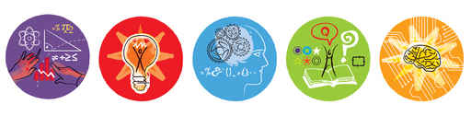
A workshop was conducted with the leadership of LLNJ to canvass the widest possible range of issues as early in the process as possible. The issues were explored using sequences of rich questions including:
- Our role: What are the roles of libraries and librarians in a world that is ever more complex, and where many more people are involved in the creation, dissemination, remixing, categorization and publishing of works (film, books, research, learning resources, etc.)? What is important to keep that we have done in the past? What is our new work/activity?
- Our brand/identity: What are we known for? How will our citizens regard libraries and librarians in the mid-21st century? For what will we be recognized and valued? How will we help people, where are they located? How do we interact with our community?
- The context: What are the major trends in the world of libraries and librarians? What might we borrow from other industries/sectors, e.g. hospitality, publishing, communications? Where are libraries/or the new functions of libraries needed where they do not exist already?
- Our customers and other stakeholders: Who uses libraries now? What are our customers’ needs and do we serve them well? Who might use libraries in the future? How might we engage more people/new groups of people in becoming part of the NJ library community? What other stakeholders are important to our future and why?
- The value of libraries: How is the value of libraries perceived and by whom? How are they perceived as entities that embrace the future? If not, how might we change that? What value/perceived value might we add so that libraries become known as a great thing to fund?
- Competition: Who are the competitors to libraries? Where do we compete where can’t be successful? How and where might we compete where we have a strategic advantage? How might we collaborate with competitors to offer higher overall value?
- Governance, leadership and influence: How can we play a leadership role in the fields of knowledge management, knowledge creation and the wise application of knowledge? What are the gaps in society/business where we can make a difference or be influential?
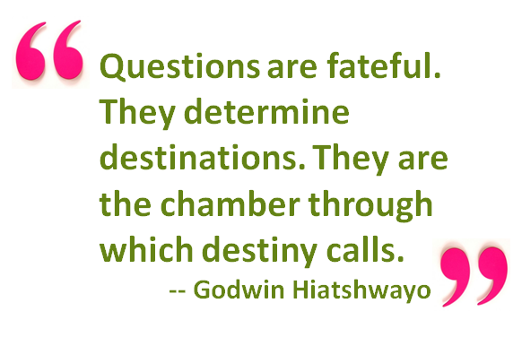
- Structures and processes: How should we structure/organize and co-ordinate our activities across New Jersey so that we integrate the interests of our member organizations and their communities, customers and stakeholders? How might we apply economies of scale to take advantage of resources? What activities require local/custom/just-in-time services and how might we best deliver these?
- Professional development: What new skills/capacities will librarians and their staff need and what old skills do we want to maintain or further develop in order to perform our new role(s)?
- Resources, technologies and methods: What kinds of buildings, equipment, processes and methods will we expect in the library of the mid-21st century? Describe a day in the life of the "library", virtual, physical or otherwise?
- Sources of funding: How will our work be funded? Who will want to pay for our services/support our work, and why will they want/need to do this? What will be free and why?
- What new sources of funding might we tap? How might we expand on or manage existing sources of funding more effectively?
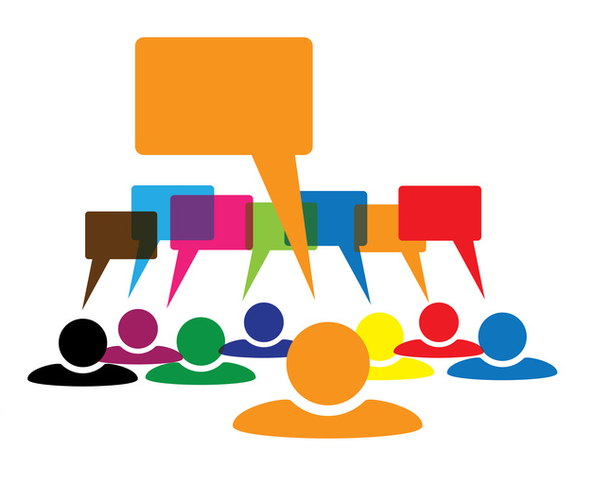
- Choice trilogy: What are we doing well that we want to KEEP? What is an obstacle or barrier to our success that we might ABANDON? What new activities or revised activities are we drawn to INVENT/REINVENT?
- Envisioning the future: Craft a definition of “library” for Wikipedia in 2020. Be sure to include librarians/other library people, who uses libraries and how, as well as their structure, physical and/or virtual.
- Projects: What is a project we need to start today in New Jersey to create or further develop our new or enhanced services, systems, roles, methods, processes, governance models, funding mechanisms etc.?
- Measure of success: How will we know when we are successful? What will we have achieved and how will we be able to measure it? E.g. Number of new library users and positive experience satisfaction reports. Number of people trained. Number of documents published.
After each workshop, the results were published on an interactive, web-based mind map that enables LLNJ and the broader community to see and track the progress of the plan.
4. Community workshops
A series of public workshops was held throughout New Jersey – in Hammonton, Monroe and Paterson - to give librarians and other stakeholders an opportunity to participate and contribute their thinking to the plan.
5. First Iteration of the Strategic Plan
An initial version of the plan, in the form of a narrative framework, was developed early in the process to act as a reference point. It combined the initial research and the advisory committee deliberations, including:
- Environmental scan: The major trends and emerging issues
- Preferred future: The main goals; what we should be striving to achieve so we either align with the emerging future or take an active role in creating it
- Stakeholder interests: The major stakeholders and their interests and how their relationships with libraries and librarians may possibly evolve
- Dynamic capacities analysis: What activities should we keep? What should we abandon? What should we invent or reinvent?
- Dynamic resources analysis: What roles do we need to play? What tools/technologies/methods and resources do we need to have or continue to use/enhance? What are the rules of interaction with our stakeholders?
- Projects/Programs: A list of projects or programs and tentative measures we need to put in place so that a) the activities are aligned with the emerging preferred future, b) the stakeholders’ evolving interests are met or surpassed, c) the changes we need to make to our organization or system (keep, abandon, reinvent) are in place and d) the new roles we need to play in relation to our stakeholders are all identified and understood
- Measures: Initial list of possible indicators/measures of success

6. Supplementary Inputs to the Plan
A series of non-workshop activities were also undertaken to include a broad spectrum of opinions to enrich the planning process:
- Targeted interview were conducted with 12 domain experts and key leaders/influencers in the library community with a deep understanding of New Jersey libraries in a national/international context.
- A survey sought opinions from the LLNJ network unable to participate in the workshops, to which 520 responded.
- A survey of school students’ opinions about the future of libraries elicited 457 responses.

7. Synthesis into Strategic Focus Areas
The workshop outputs were consolidated/synthesized into a set of seven themes/strategic focus areas, each exemplified by 6-7 project concepts.
8. On-line Task Force Workshops to Create Project Plans
Thirty six people volunteered to join task forces to create detailed project plans and generate goal and strategy statements and measures of success for each of the seven strategic focus areas. Participants worked in groups using telephone conferencing and Google Docs.
The goal statement format was:

- Goals (What)
- Strategies (How)
- Measures of Success (How will we know when we’ve succeeded)
The project plan format was:
- Project Title (4-5 words)
- Project Description (25 -100 words)
- Governance: Roles and responsibilities, who will own the project
- Objectives: What will the project achieve?
- Stakeholders: Which stakeholders and their interests will be served by the project? Who will make use of the product/service and how, who will be the suppliers?
- Time frame(s) for development, implementation etc.
- Estimated cost range and sources of funding
- Actions/activities (in detail)
- Measures of success (benefits, measurable, clear, simple, actionable)
- Professional development required
- Resources, technological or facilities requirements
- Integration with other projects/programs
9. Draft Strategic Plan Review
The advisory committee met to review the project plans, the stakeholder interests analysis, as well as the goals, strategies and measures of success, and to further refine them. This process involved reviewing all of the information collected during the process, as well as the tentative goal statements and project plans and synthesizing the concepts to a new and higher level of integrated order.
10. Strategic Plan Preparation
The formal strategic plan was developed by analyzing the contributions of all of the participants and the analysis by the advisory committee, and drawing these together into an environmental scan, a vision statement for New Jersey libraries and librarians, seven strategic goals and a selection of projects to operationalize the plan consisting of:
- A slide presentation or “haiku” version of the plan, which was presented at the New Jersey Library Association conference in Atlantic City, on June 5, 2013.
- This report, which is a formal strategic plan.
- The entire strategic plan and process, step-by-step, complete with briefing notes, workshop outputs, the early project plan framework, project plans, slide presentations and survey results located at: https://www.mindmeister.com/237766551/llnj-strategic-planning-process.

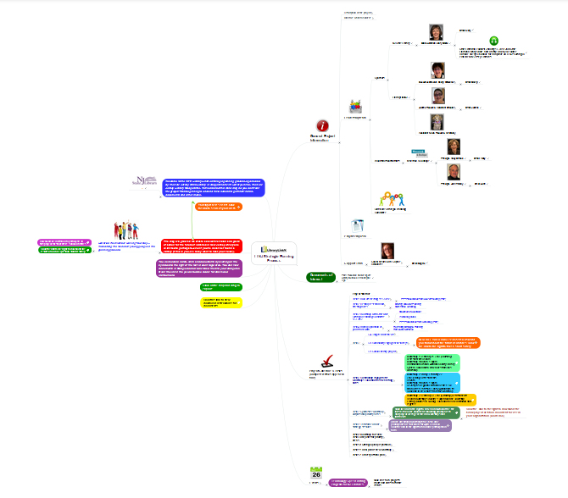
NJSL/LLNJ Interactive
Strategic Planning Mind Map

The Context

Global trends
These are exciting and challenging times in which to plan for the future of libraries, in part because the future itself is unclear. Change is rapid and constant, with disruptive technological and social shifts happening in less than a human generation.
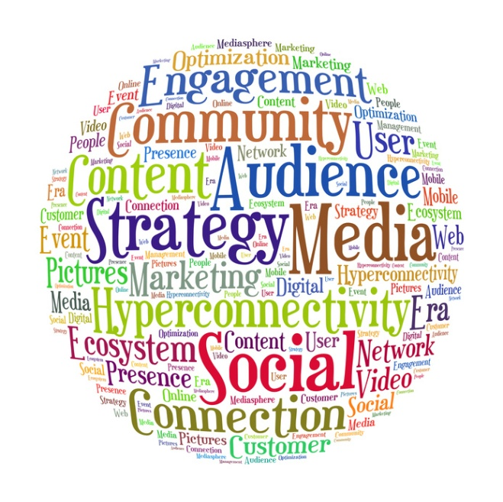
Information is ubiquitous, easily obtained by anyone, anytime and much of what we can access on the Internet is free, or almost free. New technologies make it possible to have it all now. Information is no longer stored in a physical place; it is everywhere, publishable by anyone and everyone.
It is difficult to tell which information is reliable and which is propaganda, the product of research or advertising, reported facts or opinion.
The democratization of information has, by some standards, lowered the tone of discourse. Much of what passes for commentary is partisan bile, chastising political opponents, competitors and even colleagues. We are in a state, which in the 80s, John Naisbitt famously described as “drowning in information and starved for knowledge.” ¹ And the wise application of the knowledge we possess is in increasingly great demand.
Communication has changed dramatically. It is instant, fluid and cheap. People are globally connected 24/7. Social media, such as Facebook and LinkedIn, allow us to share our lives with others in ways that, just 20 years ago, we never would have imagined.
Along with technological change have come shifts in our culture: how we communicate (globally, instantly, for free); how we share our lives and maintain privacy (you can “Google” almost anyone); how we do business (creating with our customers and collaborating with our competitors). With the dissolution of social and spatial boundaries comes a flux in rules and social agreements. Technology has enabled us to share the more intimate details of our lives instantly, broadly and publically, which gives rise to questions about privacy.
How we learn, where we learn and what we do with knowledge are also in a stage of flux. Brick and mortar schools, once the main source for learning about the world and building skills, are meeting significant competition from online sources, including for-profit providers of educational materials, and the ability of the motivated individual—aided by technology—to learn much on his or her own. Indeed, many are questioning the need for formal higher education, certainly the traditional forms, which, in many instances, no longer guarantee a robust livelihood while carrying a huge price tag.
There is an ever-increasing shift toward entrepreneurial activity. Small is the new big. Play is the new work. And in some quarters, it’s a mix of being in both worlds at the same time. Some boundaries between work and play and between disciplines and cultures are dissolving while others are becoming deeply defined and separate.
We are already moving away from mass-customization to high-value artisanal product and service creation, where the experience and the interaction are at least as important as the things we buy. And, with markets shifting as the result of globalization and the redistribution of value, more and more people are finding it necessary to change careers or to invent new ones altogether.
Some major global trends that are presenting challenges (and, perhaps, opportunities) include, “storms of the century” that now seem to occur every other year, species dying out in one place and descending on other regions, and our communities being increasingly taxed by the cost of responding to disasters, changing the location and strength of infrastructure and making preparations in order to be resilient in recovery. In addition, we have an aging population and the changes this brings for the economy and for society. In some countries, sales of adult diapers have surpassed those of baby diapers².
Our global connectivity ensures that political movements cross borders in minutes rather than years.
Although we have the technical ability to communicate and collaborate across the boundaries of language, culture and professional disciplines, we often fail to appreciate each other’s ideas or points of view, rather than resolve our differences to collective knowledge creation. All of this requires us to rethink how we interact and how we govern. The intersections of interests and worldviews frequently give rise to conflict, lawlessness and terrorism, which must be addressed wherever we can do so. The proliferation of communication technology is proving to be a double edged sword where learning and teaching is concerned.
Attention spans are different; shorter, in most cases. One course on writing for the Internet encourages authors to use paragraphs of minimum length, good advice in a world where many people communicate in 140-character bursts via Twitter and other texting media. Crowdsourcing and social media are frequently trumping knowledge “experts”. Open source and open access, Creative Commons has frequently replaced traditional copyright and trademark applications, permitting greater collaboration and content sharing. Thanks to advances in technology and distribution, it is easier than ever to self-publish in almost any medium, the result being that there is little or no need for intermediaries between producers and consumers. In fact, a new word has been coined, “prosumer”, to describe this blurring between these roles.

What this means for libraries
While it is easy to judge these trends, they are nevertheless here, if not to stay, to color our world until new ones come along, which they surely will. It is vital to our purpose to figure out how to integrate the information we have gathered about this rapidly shifting landscape into our vision and plans for the future.
What do we do, we might ask, that still works well and that we want to keep? What no longer serves us that we want to discard? And what services, models or processes might we invent or reinvent to serve our communities in new and important ways? Also, how might we develop the capacity to adapt efficiently and effectively to change?
In a world where the “Google” answer is good enough for most people, and communication for many consists of sound bites and texting on the go, where do libraries—traditionally bastions of focused, methodical scholarship—fit in and add value? While they still have ardent champions, overall political support for libraries is waning as societal and environmental challenges increase, creating more competition for limited funds.
Change issues that are being addressed by the library community include the demand for 24/7 access to information, the increasing trend toward content creation as opposed to content consumption and curation and the new frontier of the library as a virtual space.
Libraries are also rethinking their physical space, asking how it might be repurposed to help address the needs of communities and their citizens for mobile office space, places to learn new professional and technical skills or to collaborate with others to make art or address the challenges and opportunities brought about by our changing times.
As our education system changes—for example, the shift from focusing on “non-fiction” to “information-based text”—libraries and librarians have an opportunity to shine as content experts, providing guidance in updated ways to help the next generation of students learn the next generation of skills.
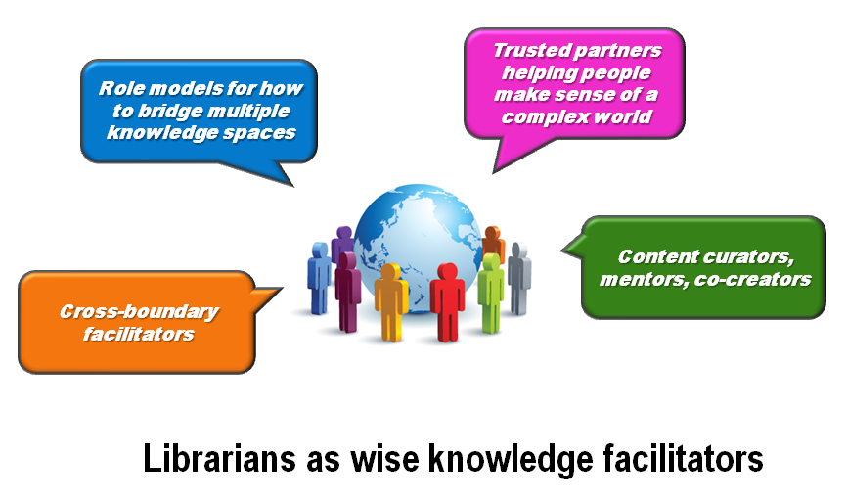
In order to do this, librarians themselves will need to learn new skills: as technologists, coaches and co-creators of knowledge. Some are less interested than others in recreating themselves and their profession for a new age, but there is no question about the imperative to change. The very role of libraries is changing to a place where one not only finds things, but where one goes to make them as well: knowledge, art, a new business, a new career. The ubiquity and complexity of information provides a robust opportunity for librarians to be facilitators of understanding and new knowledge creation. Libraries will increasingly be known as “wise locations” where people can come, virtually and in person, to make sense of their world and to find the support and tools they need to apply what they have learned in order to thrive.

Our Stakeholders

We have taken a synergistic, whole-systems approach to identifying and engaging stakeholders. We began by encouraging participants to consider the broadest spectrum of stakeholders, which includes unusual choices like competitors and people who do not yet use libraries. This helps to define the largest system possible and the broadest range of opportunities. We then ask how we might engage these various groups in a two-way process, where we serve their interests as they serve ours. This collaborative—as opposed to transactional—approach allows us to envision and develop a strong, resilient and productive network of people and organizations with which we can co-create the future of libraries.
Below is a table including:
- A list of stakeholders identified by participants in the planning process
- Each stakeholder’s interest with regard to libraries
- The library’s interest in engaging each stakeholder
- The greater good that the integration of these interests might serve

Stakeholder | Their Interest | Library Interest | The Greater Good
Applet and software creators | Access to the Internet. Meeting spaces to plan, design and work with co-developers and/or clients. Acquire skills. Advice on design and marketing. | Provide spaces for people to go on-line, meet, work and learn together on-line, or start new micro businesses around iPhones, computers and the internet of things (devices that “talk” to each other). | Foster the development of local STEM capacity which is in short supply. Help create new businesses, especially those that address the customization of apps to meet local specific unmet social, learning, sustainable development and other needs.
Authors | Fame, fortune and freedom to create stories for others to enjoy. More and more people are becoming consumers, creators and re-mixers of new works. | Provide authors with potential readers, and readers with new authors. Expand the opportunities for authors and readers to meet and interact. | Enrich the lives of authors and readers, to improve literacy generally.
Book sellers and  book stores | Increased book sales. | Help people of all ages develop or rekindle an interest in reading books, articles, newspapers etc. for both work and pleasure. | Increased community literacy,
Broadband and other Internet service providers | More widespread adoption and greater use of broadband services. | Develop value-added information and knowledge services which make use of the unique features of broadband capacity/bandwidth. | Improve access and more powerful use of the feature of broadband access in a way that allows a community to thrive.
Business and social entrepreneurial  start-ups | Meeting spaces, access to data, methods and processes. | Expand the role for libraries in a very complex fast moving sector. | Grow enterprises and jobs for the community.
Chambers of Commerce | Help members develop more profitable and rewarding businesses. | Play an active role as both a member of chambers of commerce and provider of information, advice, meeting venues, access to thought leaders and other talents. Help them connect and learn from other communities who meet at the library. | Local businesses that are more successful and well connected to their communities.
Competitors, e.g. Amazon, Google | Delivering content, products/services in anticipation of customer needs. | Add value to the services of competitors for face-to-face or local situations. | Expanded range of hands-on support for tools, methods or facilities locally.
Consumers or users of State, Federal or Local government services | Easy access to government services, help dealing with the complexity of complying with regulations, registering, applying for grant or other funding, getting approvals for new activities. | Work with government agencies at all levels to provide a one-stop shop for services, information about what is required. Provide assistance in completing forms. | Improved access to government services. A better understanding of how to comply with regulations or interact with agencies.

Stakeholder | Their Interest | Library Interest | The Greater Good
Creative artists | Space to create, exhibit and perform. Audiences. | Curate works by local arts community. Provide spaces to exhibit and perform. | Improve access to cultural and artistic works by the arts community.
Digital content users including listeners (pod-casts), movies (downloads), e-books and journal articles (researchers and students) and browsers (web site cruisers, newspaper and blog readers) | Access to high speed internet to download and view, listen to or contribute content. | Provide customers who do not have internet access with access to a rich variety of resources. | Increased cultural knowledge and information literacy of all Americans and in doing so increase community safety and economic and social stability.
Economic development organizations | Data to help new ventures better understand their competition and emerging markets. Incubators to help foster new start-ups. Help in dealing with the complexities of the regulatory environment. | Offer research and knowledge creation services to help develop and incubate new social and for profit ventures. Meeting and work spaces. Facilitate community participation in new opportunities. | Help ventures become better able to thrive in rapidly changing market conditions, especially to identify local opportunities by engaging with communities about their new needs and interests.
Emergency services and FEMA | Reliable partners to provide support during emergencies especially for power generation, safe refuge, collecting and disseminating critical information and warnings, e.g. health advice and warnings, maintain communications during the emergency. | Be a vital hub for the community’s emergency management and communications system. Be a nodal meeting place for community groups involved in crisis preparedness. | Develop community resilience and capacity to handle emergencies.
Funders including foundations | Opportunities to make investments in specific public good projects and receive a good return on the investment. | Work with community leaders to help them identify suitable funders, design projects and prepare grant applications. | Improved social outcomes for communities as a result of grant funding from foundations.

Stakeholder | Their Interest | Library Interest | The Greater Good
Health workers including doctors and nurses | The latest information about patient care, continuing education, a source of information for communities about public health issues. | Provide practitioners, people, patients and communities with reliable up to date medical or public health information. | Improved community knowledge about health issues, treatments, and quality of life.
Immigrants | English as a second language, help with access to services, translations, interpreter services, books and other media in languages they speak or understand. Path to citizenship resources, basic information and referral to support agencies. | Expand the capability of libraries to serve communities where a migrant population is expanding, support immigrants in their integration into US society, help enrich cultural and life experiences for all citizens. | Better integration and assimilation of new arrivals into the US culture. Celebrate and benefit from the diversity of many cultures, especially food, literature, arts, cultural artifacts, ideas. Develop economic links to other countries.
Independent Service Providers and Consultants | Seeking customers for their unique services, access to knowledge to constantly improve their offerings, and a place to meet and work with customers. | Be a one-stop shop for people and businesses seeking help or advice from consultants and independent service providers. | Improvement connection between knowledge creators and consumers.
Information brokers, providers of competitive analyses | Access to databases. Seek clients who need specialized data or information, especially data/ information that has been consolidated from multiple sources to reveal past or emerging patterns. | Offer access to specialized databases. Undertake searches for firms or people who do not know how to analyze or produce value added data or information sets. | New economic activities.
I-phone makers and  app content stores | Sell more i-phone, and applications, and help drive voice and data use, especially for broadband. | Provide short term or trial i-Phone, i-Pad or other tablet devices access to underserved populations for reading news and books, watching other media, or creating new artifacts. | Increase penetration of iPhone and broadband into underserved populations.

Stakeholder | Their Interest | Library Interest | The Greater Good
Library non-users or future users | Unaware of how they might find libraries useful, or no longer have a user for libraries | Convert non-users into users by finding out how libraries can offer valuable assistance or make a difference to their life or work. | More educated and engaged communities
Library staff | Appreciation for their work. New skills and career opportunities. Job security. | Attract and develop talented, adaptive, multi-disciplinary staff able to lead & collaborate with each other/others. | Provide new kinds of services to meet the changing knowledge needs of the community.
Local communities | A place where a variety of community needs are met. | Establish libraries as community anchors. | Healthy, happy citizens and vibrant community.
Makers of devices that communicate with each other (the Internet of Things) | Need for reliability of information knowledge that will be embedded in everything, a huge liability/responsibility if wrong or out-of-date. | Help young people develop the skills to know when information or knowledge is reliable for devices they create or support. | Help maintain the reliability of knowledge for people as it continues to evolve, and what we knew yesterday is a poorer explanation than what is emerging or being created.
Makers: creators of devices, artifacts and other things | Access to tools, machines, equipment, resources and design tools to support people engaged in designing, creating and marketing new products, works of art, artifacts, crafts etc. | Expand the range of artifacts that libraries and librarians curate. Make available many kinds of local scale design and maker technologies to citizens on an as-required basis. Also provide access to know-how about how to use the tools. Act as a local resource and venue for helping workforce development agencies achieve their goals. | Expand the economic capacity of local communities, new skills, new jobs and new technologies. Democratization of high tech design and manufacturing e.g. 3D printing. Provide access to tools and machines for people with limited resources.
Medical patients/clients | Good health and fitness. | Provide access to reliable information about healthy eating and living. | Higher quality of life and improved patient care.

Stakeholder | Their Interest | Library Interest | The Greater Good
Movie and music publishers | Greater penetration of movies and music into both the general population, especially for creative works that did not have widespread initial distribution, but deserve greater use. | Be a clearing house for all kinds of content especially to make creative works available to a broader population based on interest profile. | Communities develop broader cross-cultural interests through expanding their viewing and listening horizons.
Neighbors | Cordial, helpful relationships, care about their needs, especially the positive the environmental values of safety, quiet etc. | Be a good neighbor to our neighbors, while also being a center of community activity. | Promote positive community values by modeling those values.
Non-elected government officials and administrators | Need balanced budgets, the allocation of resources for a safe, well educated, happy, and prosperous community. | Pay attention to particular issues that township councils (politicians) and administrators care about. Provide leadership to communities about what is needed for future success. Reaffirm the relationship between the library and its community. | Ensure the community continues to invest wisely and adequately in its capacity for renewal.
Other institutions, e.g. universities and hospitals | Local support in the delivery of outreach services, e.g. tutorial, health information. | Become recognized as the best place to deal with complex life and work issues and concerns. | Acquisition of new lifelong learning skills for dealing with complex life and work issues.
Parents of school age children | A safe place for their children to meet, socialize and learn together outside school hours. | Offer activities for young people that promote their social development, literacy and learning out of school hours. Access to the internet for families who cannot afford it. | Enhanced community safety and social development.
People impacted by disasters | A sanctuary in time of disasters, emergency power, information, shelter, centralized communications. | Be a communication hub and safe haven during and after emergencies. Help people locate loved ones. | Communities are able to bounce back more quickly after disasters, or have a place where they can get help, or offer help.
Political leaders | Recognition for serving unmet community needs. | Achieve reliable long term funding for public benefit services. | Vibrant, thriving communities that can adapt/learn.
Public transport services | Greater ridership to increase revenue to offset the costs of providing the service. | Generate traffic as a destination for a broader range of information, knowledge creating and application services. | More effective and efficient use of public transport.
Publishers and content retailers | Promote useful and interesting content to achieve book, e-book and other content sales. | Provide access to books and content to whoever has a need, especially the underserved. | Expanded views and readership of books and content. Wider community literacy.
Schools and their students | Access to information and knowledge and assistance with meaning-making. | Cultivate life-long learning and library use. | Young adults who are well equipped intellectually and socially.
Service clubs and organizations | Opportunities to contribute to their community through direct provision of time and resources and/or donations. Places to meet regularly. | Develop stronger community and political ties by hosting service clubs for meetings, providing spaces for them to undertake some of their activities and provide links to others in the community who could benefit from their assistance. | Better alignment between what is needed in communities and what is delivered. Village scale projects undertaken more as partnerships between the donor and the recipient.
Social workers | Care for those who are unable to adequately meet their own needs in some way, e.g. health, young people, former inmates, unemployed. | Work together to provide safe spaces for people to meet, socialize and develop. | Help create a society in which all contributions are recognized and valued, and those who are less capable receive support.
State Department of Education | Achieve improved student outcomes, especially for learners who currently leave school largely unable to read, write or count adequately. | Expand the role of school libraries so they too become dynamic centers for community social, cultural and economic growth and as a result help schools improve their graduation rates. | Increase the percentage of people who graduate from school who have the skills to participate in the more complex and demanding 21st century workplace.

Stakeholder | Their Interest | Library Interest | The Greater Good
Teachers | Students who enjoy learning. See young people (and older learners as well) grow and develop. | Work closely with school educators to better integrate what we all do to help people—young people especially—flourish socially, culturally and socially. | A well-educated community, whose skills match the emerging demands of 21st century living and work life.
Tutors and mentors | Student customers in need of coaching. | Attract people to libraries who are seeking help with their studies or business development. | Provide a high-touch face-to-face service to complement high-tech virtual facilities so that learning and development are enhanced.
Unemployed or underemployed | Acquire reading, writing and numerical skills in order to get a job. Grow a resume. | Develop literacy and other life skills. Help people prepare resumes. | Move people out of un-employability into successful participation in community.
Universities and community colleges | Flexible delivery of courses to students anywhere in a region or country particularly with specializations. More points of access to improve accessibility to students who face geographic, economic or transport constraints. | Support students who need access to the Internet and assistance with research skills, especially those studying courses with a high degree of internet content or interconnectivity. Support students studying MOOCC (free-on-line offerings) where the credential/exam is available via a local college or university. | Expand the opportunities for people anywhere to participate in continuing education so they are better able to adapt to social and technological change, especially in terms of career transitions.
University students | Find articles for essays, learn how to undertake book and on-line search. | Increase the use of curated collections to validate the purpose of librarians. | Grow percentage of knowledge workers in economy to design and support complex systems.

Stakeholder | Their Interest | Library Interest | The Greater Good
Very young children and their parents | Get a great start to life through development of language skills from being read to and participating in collective play. | Help parents discover how to create positive learning and development environment for their children, especially with respect to reading and discussing books, telling stories, having conversations, and engaging positively with each other. | All young people are school ready with good language skills and positive experience with parents.
Workforce development  agencies | Increased skills particularly those that match the kind of industry sectors that align with the community’s resources and objectives. | Provide access to knowledge, tools and information about new fields and future trends, especially cross-boundary integration of disciplines. Help coordinate linkages between business, community and educators to invent the new kinds of jobs needed in the future. | Increased capacity of a community to participate in the emerging economy.

The following sections contain detailed descriptions of the strategic goals identified in the planning process, including strategies for implementing the goals. Also included are project ideas for each goal area that have been suggested by participants, and which might be adopted or adapted as part of implementation.

Goal 1: Communicating the Value of Libraries

Since time immemorial, the role of the library has been to gather, store and safeguard knowledge. The role of the librarian has been to steward that knowledge and help people find and make good use of it. However, the huge technological and social changes that have taken place in recent decades have led some to question the relevance of libraries and their value to society.
When Google will provide you with information instantly from wherever you are, what can the library and librarian offer? When funds are scarce for even the most pressing of community services such as fire and police protection, or the purchase of basic supplies for schools, why should we use tax dollars to support libraries?
The answer is simple: Libraries are uniquely poised to help people successfully navigate the complexity and disruptive change that everyone in society is experiencing. All citizens, new and established, from young children to elders, in all walks of life, and with all levels of skill, have needs that libraries can meet and are meeting. They contribute to the quality of life in myriad ways, including educating and entertaining
Goal 1: Our libraries offer a consistent brand promise through which we delight our customers and anticipate their evolving needs.
All stakeholders appreciate the value of the libraries in their world, and participate actively in joining and belonging to the brand.

us, providing us with information, helping us make sense of it and providing safe, nurturing places, both physical and virtual, where we can come together to exchange ideas and create new knowledge.
But there is one question we must ask ourselves: Are we clear about what our value is and are we communicating that value in ways that people understand? In other words, do we have a “brand” that people want to join?
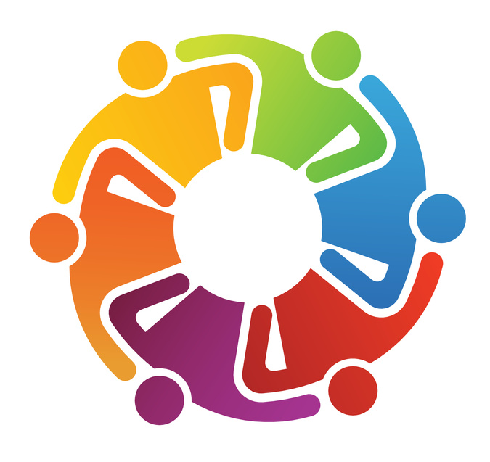
Branding isn’t just for commercial products anymore. Changing perspectives and increasing competition for people’s attention in an always-on, have-it-now world means that even venerable institutions like libraries can no longer take for granted that the people they want to serve understand who they are and what they have to offer. Things change so much and so quickly that perceptions held by customers—and potential customers—may well be outdated. In the words of one librarian, “Most people have no idea what we do all day!”
Do entrepreneurs know, for example, that their local library can do sophisticated market research to help them launch a new enterprise? Do patients know that medical librarians can help them navigate the morass of information surrounding their health issues? Increasingly, libraries are providing maker spaces for the creation of new products and services, and they are serving as community anchors and hubs of information in emergencies such as hurricanes. They are offering safe haven in troubled urban areas and training people in the essential skills needed to find a job or change career.
As people are required to deal more nimbly with disruptive change and play a more active role in creating the world in which they want to live, there is a growing need for services that deliver understanding and personal connection as well as information. Libraries are performing this role. They are places where people can learn to use the technologies they need to connect online, and places they can come when those same technologies leave them feeling in need of in-person interaction and community. And you can still find a good book to read!
So how do we capture all of this value so that it’s understood? In the end, a brand is a promise that someone makes to do or provide something. Communicating that promise and then keeping it builds loyalty and a sense of value delivered. Libraries, regardless of their type or location, might promise, for example, to make their customers’ lives “easier, more successful, happier and satisfying.” They might keep this promise in any number ways, all of which will delight their customers, from always greeting them with a smile to providing high-tech training or on-the-spot information and research services. The key is to communicate our brand promise and then to live it, be it and demonstrate it every day, in everything we do. Then, the value of libraries will speak for itself.

Strategies for Goal 1:
- Strategic positioning: Position ourselves as co-creators of new ways to help people improve their quality of life, learn, develop and participate more fully—and successfully—in society.
- Develop a branding strategy: Create and deliver a comprehensive branding strategy for NJ libraries that includes keeping the brand promise.
- Monitor awareness: Track public and political awareness through usage measurements, surveys, and event attendance.
- Advocacy: Create a statewide advocacy and collaborative relationships group to help libraries of all types better communicate and deliver on the brand.
- Future planning processes: Involve political, community and business leaders in implementing this plan and in future planning processes.

Projects for Goal 1:
Six projects have been developed and adopted to communicate the value of libraries to our internal and external stakeholders. The primary purpose of each project is to “live the brand promise,” to be well known and admired for the valuable contributions that libraries and librarians make to society.

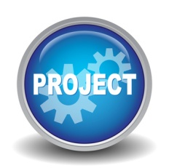
Project No. 1: Building Our Brand
This project will support libraries in creating, executing and monitoring branding tactics in order to build and promote their individual and institutional brands. It will develop a common tagline, e.g. “Libraries for Life,” that can be used by all types of libraries. This project incorporates actions that are related, directly or indirectly, to each of the six real time strategic change principles.
Governance and responsibility: This project will be a joint venture between LLNJ, the State Library, and a team of 5-10 volunteer “Brand Ambassadors” (ideally, the team should have at least one ambassador from each type of library) who will act as liaisons between LLNJ, the State Library, and individual libraries/library staff.
Objectives: Establish and maintain a clearly defined, and positively impactful multi-tiered library brand that facilitates the increased use of libraries, the visible support of libraries and library staff, and the funding opportunities available for libraries of all types.
Stakeholders and their interests:
- Library directors – strengthening of their own individual professional brand and an increase in positive exposure to their individual libraries.
- Individual Library Staff - learn how to define and build their own individual professional brand and how their personal brand contributes to the larger institutional brand.
- Individual Libraries of all types - served by the creation, adoption, and expansion of a brand that, if correctly established, can strengthen the core of institution on several important levels.
- The State Library - success, growth, and increased exposure of individual libraries and the library community as a whole.
Time frame:
- Development of project business plan: 3 months
- Technical Development: 3 months
- Development of project documentation: 3 months
- Creation of educational and support resources (workshops, tutorials, toolkits, etc.): 3-6 months (ongoing)
- Recruitment and training of “Brand Ambassadors”: 3 months
- Launch pilot project: 6-9 months
Estimated cost and sources of funding: Production of documents and training materials, and technology costs (hosting, online meeting software, etc.), $7,000. 12 month salary for 1 part-time project manager to oversee the project: $25,000. Consulting fees for hired trainers: $3,000.

Actions:
- Hire a part-time project manager to oversee the project
- Design synchronous and asynchronous educational programs and workshops for library staff on the subject of branding, specifically, brand creation, promotion, monitoring, maintenance, and growth for individuals and institutions.
- Identify 3-5 general tactics for branding /identity management that are easy to implement, beneficial and appropriate for libraries and librarians at all levels (i.e. individual, local, state, and national) and of all types (e.g. public, academic, and school). Individual personal branding opportunities and strategies that reflect and strengthen the larger institutional brand should be included for library staff at all levels.
- Build a reference database/blog/wiki (and accompanying listserv or forum) for the sharing of effective advertising and marketing ideas, toolkits, media, and other resources that have proven successful for other libraries.
- Build a team of volunteer “Brand Ambassadors” to: (a) oversee the initial development and growth of the program, (b) provide individual and institutional support and guidance for libraries and library staff, (c) maintain and monitor the blog/wiki and accompanying listserv/forum, (d) collect statistics and data for reports that will endorse the program and that can be used to obtain funding for program maintenance and growth, and (e) act as liaisons between LLNJ, the State Library, and individual libraries/library staff.
Measures of success:
- The number of participants including number of individual library staff, libraries, and library types.
- Increase in patron membership, the use of library services, funding and other measurable criteria directly related to participation in the program as indicated by program participants.
- The amount of grant or other funding secured because of the success of the program.
- Media attention garnered for the program itself, or for individual libraries and/or library staff as a direct result of participation in the program.
Professional development: This self-study focused program provides opportunities for community building, idea sharing, and additional support. Brand ambassadors may benefit from additional training in general branding/marketing related strategies and techniques and in the creation of branding related training materials, toolkits, etc. provided to program participants.

Resources: Team includes a project manager, team of 5-10 volunteer “Brand Ambassadors”, program related contact person/liaison at the State Library, program-related contact person/liaison at LLNJ. Technology required is a blog/wiki with integrated forum and/or mailing list software, hosting/domain registration, online meeting software.
Integration with other projects: The program provides a strong foundation for the development and implementation of projects related to each of the defined core task force areas and the overall success of libraries in general.

Project No. 2: Clarifying and Evaluating our Brand
We will assemble a task force that will decide on a brand message that properly conveys the services at all NJ libraries. We will hire a consultant to help us create a “secret shopping” program that will evaluate libraries of all types throughout the State. Results will be shared and libraries will be given the tools to evaluate and improve their own libraries. Examples of exemplary environments, tools, and services will be shared. Negative examples will be shared, but not attributed to any one individual library.
Governance and responsibility: A library task force will be formed to implement this program, under the umbrella of the Strategic Planning Committee. This committee will be assisted by an outside consultant. All library employees will own the project.
Objectives: The project will help libraries align their materials, facilities, and employee behaviors with the library’s brand message. As a result, customers will receive consistent, excellent service that they can count on. Library use and customer satisfaction will increase.
Stakeholders and their interests:
- Library employees’ interests will be served by giving staff the tools to improve services and retain and increase library usage, helping them to retain their jobs.
- Library users will receive a higher level of service.
- Libraries will be better equipped to promote their brand message after their message has been clarified and all libraries are properly delivering that message.
Time frame:
- Committee discusses and finalizes brand message and hires consultant: 2 months
- Committee meets with consultant to discuss brand message and services to be evaluated in libraries:1 month
- Libraries representing all types and sizes of NJ libraries are evaluated, report created, findings shared on project wiki: 3 months
- Workshops conducted to share project findings and share ideas on ways to improve alignment with brand message: 6 months
Estimated cost and sources of funding: About $50,000
Actions:
To implement this project we would need to accomplish the following broad tasks:
- Meet to discuss wording of library brand message.
- Create a rubric for evaluating library services.
- Select consultant services or librarians (if funding is not available) to conduct library evaluations.
- Go over findings and create detailed report.
- Create wiki on LLNJ site.
- Gather examples of excellent service, facilities, displays, publications and put on wiki.
- Offer workshops and/or webinars, sharing findings and training on use of wiki.
- Highlight libraries that have used what they have learned, displaying before/after images on wiki.
It will be necessary to clarify our brand message, for example “We make our customers’ lives easier, more successful, happier, and satisfying” or “We solve problems, entertain, inform, and are at the right place when needed” Before we can publicize this brand message, we want to ensure that all of our member libraries deliver on this brand message. Use “Libraries for Life” as a tagline since it applies to all types of libraries. This should include:
- Friendliness and helpfulness of staff members. Does the staff member acknowledge a customer’s presence? Is the customer greeted with a smile? Are emails and voicemails answered in a timely manner?
- Ease of use of facility. Are materials difficult to locate? Are sections clearly defined with proper signage?
- Quality of assistance. Do customers leave the public service desk with answers or referrals to other places to turn to for help? Does the librarian get out of their seat to show a customer where materials are located?
- Clear and attractive fliers, pamphlets and website. Is the website easy to navigate? Is the library logo and contact information clearly displayed in a consistent manner, on all library materials?
- Are there displays highlighting materials?
User and staff behavior will be observed. Similar to “Secret Shop” of libraries for positive feedback on signage, friendliness, ease of use. Library users can also be interviewed for feedback on services.
Libraries will be evaluated by an outside consultant or volunteer librarians, following a list of criteria that has been established by the Strategic Planning Committee. The purpose of this evaluation will not be to penalize any individual libraries or staff members. It will be to identify areas of strengths and weaknesses. Examples of excellent products and services can be recorded and shared.
Since we will be unable to evaluate all libraries, every library will be given tools to evaluate their libraries themselves.
Assistance will be provided on signage, furniture and layout to promote libraries that are on the cutting edge that support collaboration and flexibility.
The findings from the projects will be gathered and shared with other libraries. The task force will create a wiki housed on the LLNJ site where libraries can access articles and product samples to emulate. Allow libraries to upload articles, info, and questions. Workshops will be offered throughout the State on specific topics such as creating inviting displays, customer service, etc. These can be offered as informal meetings where participants can share tips and tricks that would not necessarily require paying the consultant.
As part of the project, a pilot “NO log” will be established to keep a record of every time a staff member says no to a patron. Rules are evaluated to see if noes can be turned into yeses.
Measures of success: The Task Force will identify areas of strengths and weaknesses and identify relevant measures that require improvement.
Professional development: Consultants will train a few library community members to train others in brand marketing. Workshops will be held in different locations throughout the State where librarians can share ideas for improving service. A branding wiki will be established on LLNJ website to share ideas on aligning services with brand message
Resources: Space on LLNJ or NJSL server for the branding wiki. Fees for consultant to evaluate services and create report on findings. Meeting space in libraries throughout State for branding workshops.
Integration with other projects: This project will lay the groundwork for future social media campaigns and networking with public officials, etc. If is important for us to clarify our brand message if we are going to convey it to the public. Libraries could be evaluated by an outside consultant, our users and themselves.

Project No. 3: Everyone in the Library
This project will identify a distinct set of characters and their purpose for using the library. These could include a student looking for SAT prep, financial aid, and college resources, someone looking for ESL books and classes and citizenship resources, a young mother bringing her child to story time, a senior looking for health information and coming to the library to socialize and attend programs, a student looking for homework help, an adult looking to start or advance their small business.
We will create a social media advertising campaign focusing on each character and how the library enhances their lives. For example:
- A photo of a mother and child at story time with the caption, “Story times and programs at my library enhance my daughter’s literacy skills. Librarians always know how to find books that she will love.”
- A person in their twenties or thirties with the caption, “My library helped me kick off my business. A librarian helped me search Reference USA for marketing information and connected me with resources that helped me write a business plan, locate funding, and more.”
- A new American talking about ESL classes, tutoring and citizenship exam books and how we helped them gain US citizenship and a job.
- A middle-aged person or senior citizen talking about computer classes, one-on-one sessions and books for job seekers accessed through the library and how this has enhanced their life
- Story times, programs and books selected with the help of librarian to enhance literacy and social skills in children.
Each ad would include a consistent tagline at the bottom such as Libraries for Life. The focus of the campaign will be on our users, not on us. We will show how libraries enhance lives with specific services for different users. These ads would look similar to the job seeker promotional materials created by the NJ State Library that say, “It’s time to land that job.” Maybe we can hire the same company if sufficient funding is available for this project?
Governance and responsibility: A task force for this marketing campaign, LLNJ, the NJ State Library, individual libraries.
Objectives: Show the public how libraries are relevant to their lives. Increase library usage and improve public perceptions of libraries. Provide an ad template for libraries to use and adapt to their own users and services.
Stakeholders and their interests:
- The community will gain a greater awareness of what libraries have to offer.
- Library use will increase.
- Libraries will have the ability to create ads with have a consistent, professional look with the template provided.
Time frame:
- September 2013: The Task Force meets and identifies key service areas to promote and characters to feature in a State-wide social media ad campaign
- October 2013: The Task Force hires a company to create ads and place on social media sites - Facebook, Twitter, Pinterest. Company also creates ad template that can be adapted for individual library use.
- Dec 2013: Advertisements are created and placed.
- Jan-March 2014: Libraries are trained on use of the advertisement template and steps to place online through in-person classes and/or webinars. This training can be done by librarians.
Estimated cost and sources of funding: $10,000 for ad agency to develop ads and place on social media sites. Additional funding for strategically placed Facebook ads.
Actions:
- Select list of services we want to highlight in ads and choose characters to show in those ads.
- Write tagline and text of each ad.
- Hire an agency to create social media ads.
- Train libraries on how to adapt template and use themselves to promote unique local services.

Measures of success:
- Increased public understanding of library services.
- Increased library use and public perception.
Professional development: Training on editing ad templates for local use, taking high quality photography and social media marketing including appropriate wording for local advertisements. Advice on ad placement.
Resources: Meeting space for workshops on adapting template and branding training. Space on LLNJ or NJSL site for template with instructions for adapting and posting to social media sites, copy of waiver form for libraries to give to local customers granting permission to use their image, and more. Digital camera for individual libraries to create local advertisements
Integration with other projects: This could tie into a program that offered workshops where we share ideas on how to improve what we decide on as our core services. These include:
- Increasing literacy skills
- Helping job seekers
- Providing access to health information
- Helping small business owners
- Being a community center
- Providing research assistance

Project No. 4: Libraries for Life
This project will increase collaboration among school, public, and academic libraries to deliver more efficient service and promote available services, promote public library resources through school libraries and share how to get public library card information with faculty, students, and parents/guardians. It is also designed to help promote communication among high school libraries and local college/university libraries.
Governance and responsibility: School librarians promote Public libraries. Public libraries work with school libraries on shared programs. School librarians work with academic librarians on related projects/programs.
Objectives: Strengthen partnership between different types of libraries. Increase community awareness of libraries and how they can help, support, enhance life.
Stakeholders and their interests:
- Community members of all ages
- Public, school, academic librarians/staff.
Time frame: 3 - 6 months
Estimated cost and sources of funding: Existing resources.
Actions:
- Members of the Task Force develop ideas to promote community awareness and collaboration among all types of libraries. Review LLNJ Strategic Planning document and promote ideas through NJSL, LLNJ and library-related organizations.
- Work with NJSL and LLNJ to share information from partner libraries on available resources. Promote those resources and encourage use/ library card sign-up.
- Develop joint project to connect different types of libraries with community members (database access, author visit, college/career program) etc.
- Promote collaboration among NJSL, LLNJ, NJLA, NJASL, VALE, HSLANJ and other library-related organizations.
Measures of success:
- Increased interest in library
- Increased number of public library cards
- Program attendance
- Increase in awareness of how school and public libraries support each other for the overall benefit of the community
- Increase awareness of how to navigate libraries physically and virtually.
Professional development: Promotion and coordination through LLNJ or NJSL
Resources: Staff from LLNJ, NJ State Library, Library organizations - NJLA, NJASL, VALE.
Integration with other projects: NJASL/NJLA partnership between public and school libraries. LLNJ programs

Project No. 5: Open House during National Library Week
The NJSL or LLNJ coordinates the date, provides resources such as programming ideas, promotional materials, and helps with publicity (press release, television coverage, radio). Each library plans, organizes, and runs own activities. Libraries can highlight their unique or valuable library services that are important to their users. Example: Set up the local history exhibit, host author event, art/music festival, special presentation, carnival or trivia contest at the library.
Governance and responsibility: The project would be owned by each participating library, with the support from NJSL or LLNJ.
Objectives: Public awareness and support of library services
Stakeholders and their interests:
- Libraries of all types will get greater visibility in the community.
- The public will be able to demonstrate their support of the local library.
- In addition, administrators such as the school principal, library board, school president, town/county administrators and public elected officials other stakeholders could be involved.
Time frame: NA
Estimated cost and sources of funding: Existing resources and $1,000-$2,000 for publicity
Actions:
- LLNJ or State Library coordinates the date in relation to National Library Week.
- LLNJ or NJSL collects details of special events at each Library. Libraries are encouraged to present an unusual event to attract special attention to their library.
- Arrange media publicity in local newspapers and in social media for unusual or interesting events.
Measures of success:
- Increase of library users and partnership.
- Posted pictures and survey results.
Professional development: Promotion and coordination through LLNJ
Resources: Promotional materials. Website to co-ordinate all major events.
Integration with other projects: Similar campaign can apply to the National Library Legislative Day.

Project No. 6: Picture Your Business
Free READ posters of local business leaders and owners created and distributed throughout the community. Businesses display the posters to promote their support of the library as well as encourage clients to visit and use the library. The posters would feature local merchants, business persons, medical office and community leaders holding a book relevant to specialty, e.g. staff a doctor’s office can hold copies of Gale’s Medical Encyclopedia; owner of Italian Restaurant can display a cookbook by Lidia Bastianich.
Governance and responsibility: This project would be owned by each local library, with support from NJSL or LLNJ, as appropriate. Software for the READ posters would be purchased by either NJSL or LLNJ and offered to libraries - perhaps for a one-week period - that express an interest. Initially the cost of printing the posters would be offset by some grant opportunity.
Objectives: Greater awareness of the services and materials provided by the local library, particularly among the business community.
Stakeholders and their interests:
- Business and community leaders are showcased/recognized for their skills and by association with a valued community service.
- Libraries will get greater visibility in the business community.
- Business libraries will be able to demonstrate their support of the local library.
- In addition, other community members such as the mayor, BOE President and other stakeholders could be involved.
Time frame: NA
Estimated cost and sources of funding: Existing resources for each library and grant as necessary for software and printing.
Actions:
- Work through the local Chamber of Commerce, Kiwanis, etc, to spread the word that the local library is offering this photo opp.
- Photos can be taken at a central location on a particular day or, library staff time permitting; a photography crew can travel from business to business on pre-arranged dates.

Measures of success:
- Increased contact with the business community.
- Staff working in those offices, or visitors who have seen the READ posters.
Professional development: Promotion and coordination through LLNJ.
Resources: ALA Read Poster software.
Integration with other projects: ALA, NJSL, LLNJ, NJLA, NJASL, VALE etc. Could be expanded to include and promote all types of libraries and community members.

Goal 2: Leadership and Coordination

Librarians as leaders of the community are in an interesting place. We are at the confluence of a series of transformational changes that are remaking the world in which we all live, in ways that many find it hard to understand or deal with.
Goal 2: Our libraries are led, organized and managed so that we are able to rapidly adapt our methods, systems and offerings in anticipation of the emerging needs and interests of customers, funders, partners, suppliers, staff and other stakeholders.
It is a world in which the use-by date of knowledge is shorter and shorter, the gulf between disciplines grows broader and deeper by the minute, the technologies for accessing data and information are radically transformed in less than a human generation and the knowledge have-nots line up, desperate for help.
Libraries have a special responsibility, not just to keep track of what people are thinking, saying and creating, but also to help them exchange those ideas, for the benefit of society. We do so from every direction of the political compass, left, right, radical and moderate, from any point of view or culture and from every discipline imaginable.
Librarians are the custodians and access point for much of the knowledge and many of the creative works upon which 21st Century Civilization rests. The solutions for many of today’s problems are to be found in the knowledge collectivity created in the past, as well as the new models, theories, concepts and works that are being curated by librarians as they are created, because that is what we do.
We are an honest broker in the midst of vast oceans of differences. We are the glue that helps society to remember what we have forgotten. And we help people discover what happens in other’s worlds. This is the stuff from which social revolutions are created and new products, services, careers and lifestyles are fashioned.
In order to perform our role as society now expects, we have some important changes to make to the way we operate our libraries. For a start, the wise library leader needs to play a role in reinventing his/her library so it is always aligned with the needs of customers, anticipating their needs and responding to requests.
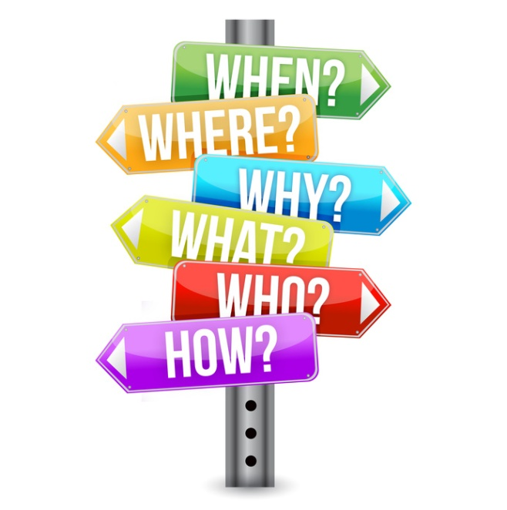
Asking questions of stakeholders, both internal and external is critically important. Questions such as “What are the biggest issues you are dealing with?” and “What knowledge, resources, skills, and methods can we help you with?” can generate the kinds of conversations libraries need to have with political and community leaders to help communities become more successful in the future and libraries more sustainable.
There’s a generation gap or two to overcome. Today’s digital natives, both customers and staff, think and operate very differently from the people for whom the library and its processes were originally designed. Although many libraries have adapted to change, for some, the many rules, procedures and policies that persist from earlier more different times constrain how we think and what we do. Some are long past due for a renovation.
In times of constant change, we need to perpetually develop better understandings of what customers want, especially to anticipate their emerging needs in the same way that Amazon and Google are in the “anticipatory awareness” business, fulfilling needs before you know you have them.
In doing so, however, we must be careful not to throw the baby out with the bath water. We need to keep offering what continues to serve us from the past, although not quite as much, perhaps, while introducing new services that are better aligned with changing community and customer needs.
Not only do we need to curate and help people make sense of the long standing literacies of reading, writing and research, but also the new literacies of emotional and spiritual intelligence, which are all about developing relationships and creating possibility.
We need to frequently review our methods and processes and subject them to two kinds of change. One is slow and incremental, where we continuously improve existing methods so they are faster, more efficient, deliver higher quality, are less costly and use fewer resource and people. The other is fast and transformational, the kind of change usually associated with the arrival of a new technology (e-books, the Internet, 3D printers, etc). This second type usually requires the reorganization of entire systems. At these times, the skills librarians need, the roles people play, the way we interact with each other and the customer are all simultaneously transformed.
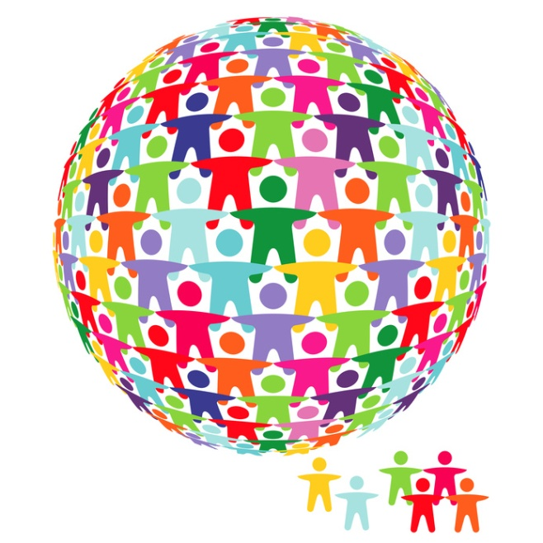
As the work of librarians becomes more specialized, complex and technically discrete, there is a need for people to work together in teams, to take responsibility for planning and implementing projects, budgeting and coordinating with other teams. Such teams still require oversight and leadership, but not the rigid, tightly constrained rules-based approaches of the past, when work was divided up into clear bite-sized chunks and performed the same way day in and day out.
A new kind of distributed leadership is required, so anyone can step up at any time and take a leadership role around their specialty or unique skill set. The new kind of library leader is more of a coach, mentor, inspirer, marketer, relationships developer and advocate. This person “leads from behind,” inspiring others and creating a container for shared success.
We also need to provide a professional development pathway for librarians who are destined to become directors, to help them acquire the new skills needed for leading or managing organizations operating in a state of social, political and technological flux.
For small libraries, particularly school and local municipal libraries, the roles that librarians play is also overdue for change. We can no longer function primarily as administrators, performing largely clerical and customer service functions. We need to add to this role the skills of the small business owner: marketing, communication, budgeting, improving processes and quality of service, supporting staff, developing and introducing new services and phasing out that which is no longer required.
Boards also have a major strategic role to play, along with the library director, of connecting to political, business and community leaders to find out what is wanted and needed, and to help their organizations meet these needs.

Boards have the task in rapidly changing times of not only asking their librarians, staff and community, “Are we doing things right?” They also must ask “are we doing the right things?”; “What assumptions and values are we basing our decisions on?” and “What other choices might we make that are more in alignment with what our community values or needs right now for success?”
As library leaders, we have the responsibility to understand what it means to facilitate the wise application of knowledge, to acquire and model the skills necessary for the new times in which we live and, most importantly, to mentor others as they find their way. We must have both the courage to step up when no one else will, to lead our communities in new directions and the foresight to give away our power and our capacities to others, so in the end, when the work is done, people say, “we did it ourselves.”

Strategies for Goal 2:
- Efficiency and effectiveness: Provide a service to undertake reviews of the efficiency and effectiveness of library service delivery to identify opportunities for improvement.
- Learn from each other: Establish forums that enable the staff of libraries to regularly meet and share best practices in funding, service delivery, advocacy, innovation and leadership.
- Distributed leadership: Develop the capacity among library leaders to work with each other and their stakeholders in the most productive ways.
- Alignment with stakeholder interests: All libraries in New Jersey that are publicly funded will prepare a strategic plan in collaboration with key internal and external stakeholders.

Projects for Goal 2:
Three projects have been developed and adopted to ensure that our libraries are led and managed so they rapidly adapt to and enhance life in the 21st century.

Project No. 1: Systems and Procedures Review
Some of the rules, policies and procedures adopted by libraries have not changed in over 40-50 years and may no longer be relevant. Many of the procedures were design to deal with inventory control and are not designed for superior customer services. This project sets out to review and change where necessary the rules, systems and procedures employed by libraries in order to operate more flexibly and in alignment with our new roles, e.g. dispense with no talking and no eating rules, especially in environments where libraries are offering Internet access, meeting and incubator spaces, minimum loan periods, library card renewals in person.
Governance and responsibility: This project would be undertaken initially as an LLNJ/NJSL pilot project with 4-5 participating libraries to demonstrate the potential benefits of eliminating inappropriate procedures that add unnecessary work for staff and result in patron dissatisfaction.
Objectives: Libraries to eliminate unnecessary policies, procedures or methods to increase efficiency and free up resources for other activities as well as improve patron satisfaction. Involve customers in identifying opportunities for improvement.
Stakeholders and their interests:
- Library staff: More efficiency and better working experience.
- Library customers: Better experience in using the library.
Time frame: 3 months
Estimated cost and sources of funding: $20,000 to $30,000 for a pilot project with 4-5 libraries.
Actions:
- Hire a process review consultant to work on a pilot project with selected libraries.
- Undertake a review of processes which are no longer necessary or relevant.
- Identify processes where the rules/procedures are poorly defined and result in poor quality of service.
- Share results of the process improvements with other libraries.
- Design a one day training package to teach all librarians how to improve their processes and eliminate unnecessary steps and delays.
- Involve staff in the identification of policies and procedures that result in patron dissatisfaction and get in the way of doing their jobs well.
- Find out from customers what aspects of library service they appreciate, what they would like to see changed or improved, so the service most closely aligns with their needs.
Measures of success:
- Number of unnecessary steps in existing library processes eliminated
- Increase in time available to undertake other activities
- Increased patron satisfaction with library services due to removal of impediments and sources of dissatisfaction.
Professional development: Training in simple to apply method to conduct a review of processes and procedures with the participation of library staff. Training in facilitating focus groups with customers to identify issues and opportunities.
Resources: Process review meeting method. Focus group meeting method. Charts to identify ways of eliminating unnecessary steps in procedures.
Integration with other projects: Integrates closely with I Love it here: Bringing Systemic Delight to YOUR Library. Time savings from this project will free up resources that could be devoted to other more relevant activities.

Project No. 2: Specialized Consultancy Teams
This project will support libraries’ efforts to plan and roll-out new services or to improve their management of existing resources, programs and services by using the expertise of established teams of specialized consultants. Examples of possible specialty areas include:
- Planning and Creating a Makerspace
- Creating a Non-profit Foundation for your Library
- Development of Cost Recovery Models, including fee-based services, budgeting techniques and value propositions
- Getting Started with In-House Digital Projects
Governance and responsibility: The Project will be a joint effort between LibraryLinkNJ and a team of representatives from all library types who volunteer to develop and guide the Project from inception through its first year. Once established, the Project will become an on-going program/service sponsored by LibraryLinkNJ.
Objectives:
- Support library efforts to enhance the development and implementation of new services or to improve the management, efficiency or effectiveness of existing resources, programs or services.
- Provide library managers easy access to a database of qualified consultants on a broad range of topics, although initial efforts will focus on only 3 or 4 areas.
Develop an assessment framework for collecting feedback on satisfaction with the consulting services provided and the overall effectiveness of the Project.
Stakeholders and Their Interests:
- Library directors – strengthen their libraries’ services and/or the management of their resources.
- Individual library staff –provide easy access to the expertise of skilled consultants for assistance in the development and roll-out of new programs and services and from whom new skills can be learned.
- Individual libraries of all types – assistance from specialized consultants on an as-needed basis will be valuable to all libraries, especially as the database of specialties expands.
Time Frame:
- Development of Project Plan (survey, topic(s) and team(s)) – 3 months
- Technical Development – 1 month
- Review after one year – keep, discard or add topics
Estimated Cost and Sources of Funding: Volunteer time and resources. LLNJ staff time and resources
Actions:
- Create list of possible Project topics and survey Library Directors on their current top three needs.
- Identify volunteer team to work on project, a team leader and a LLNJ project liaison.
- Define nature and scope of selected “specialties.”
- Develop a web-based, searchable database of colleagues that are specialist experts.
- Determine what kinds of data should be included: names, contact info, particulars of expertise, cost information, references, etc.
- Develop a means for identifying and certifying the specialist experts.
- Develop promotional campaign.
- Develop assessment framework for measuring success.
Measures of Success:
- Number of uses of the consulting services.
- Degree of satisfaction with the service as reported by Library Director on feedback survey. Some use of Outcome Based Evaluation or other established evaluation tool.
Professional Development: Specialist experts will need to keep up on latest developments through reading, personal learning plans and consulting with colleagues.
Resources: Team to work on the project, a team leader and a LLNJ project liaison. Technology advice and expertise to create the web-based, searchable database.
Integration with other Projects: The program provides a strong foundation for the development and implementation of projects related to each of the defined core task force areas and the overall success of libraries in general.

Project No. 3: Ongoing Roundtable Series
Establish an ongoing set of Roundtables that would enable libraries (either by type, or in any combination) to come together to compare their performance and learn from each other’s successful activities. They might explore desired outcomes, needs, challenges, a particular interests or future trends. This would also be a forum for engaging stakeholders around particular topics of interest and could include the participation of “experts” who would be invited to share their perspectives on the topic at hand. Particular attention would be paid to data and measurable outcomes so that the community could make practical use of the knowledge generated at the events.

The Roundtables would be “permanent” in that they are ongoing and use a consistent structure. They would be flexible in that any topic or group/groups could be “plugged into” the process, the most important criterion being a commitment to keep talking and moving things forward for libraries in New Jersey. The primary events would be in person and could then spin off in-person or virtual task forces that would do research or take on initiatives.
The Roundtable process could also be used to engage the Statewide Strategic Planning Committee in overseeing and regularly reviewing implementation of the Strategic Plan.
Governance and responsibility: NJSL and LLNJ would expand its current activity around forums to include the Roundtables. Roundtables would be sponsored regionally depending on need or topic, e.g. disaster preparedness could be sponsored by Ocean or Monmouth County libraries; an event on the topic of health care could be sponsored by a medical institution. NJSL and LLNJ would work with local staff to plan and deliver the events and would arrange for a shared, easily accessible data base that would give the entire community access to knowledge generated.
Objectives: Increase/improve communication, collaboration and partnerships between and among libraries of all types in New Jersey. Maximize our resources (both intellectual and monetary) by sharing data and experience. Encourage and support innovation. Support the success and well being of libraries in New Jersey.
Stakeholders and their interests: LNJSL, LLNJ, libraries and their staff. Other stakeholders as applicable.
Time frame: Any. Could begin immediately. Roundtables could be held on a monthly or bi-monthly basis (good to have them regularly) and additionally as requested.
Estimated cost and sources of funding: Minimal, time, food, preparation of data base, online forums, etc.
Actions:
- Create a team responsible for designing/implementing Roundtables
- Design Roundtable meeting process and gather/train facilitators
- Survey NJSL/LLNJ community for topics of interest
- Prepare data base/reporting mechanism
- Plan and hold an initial set of Roundtables (4-6)
- Assess process

Measures of success:
- Degree of participation, better communication, collaboration, support, innovation and replication of projects.
- At the end of the trial period, consensus that the process has helped libraries to improve success/performance.
Professional development: Facilitation/process training as necessary for core delivery team.
Resources: Meeting space, food, facilitator, AV, e.g. Zing, communication/outreach via web, etc., data base space.
Integration with other projects: This project could integrate with any or all projects in the plan and with implementation of the plan itself. It also could integrate with outside initiatives, such as emergency management or the incorporation of affordable health care education into library functions.

Goal 3: Collaboration & Partnerships

Goal 3: We collaborate productively with each other and with our stakeholders:
- Internally
- Between libraries and library systems
- Across functions and disciplines
- Our funders
- Our customers
- Our competitors
- Government and legislators
Productive collaboration and partnerships are essential to the well-being of New Jersey’s libraries. In today’s complex and rapidly changing environments, we need the creativity generated by bringing people together across the boundaries of geography, cultures, disciplines and world views to create the outcomes we desire. It makes sense, particularly when funds are in short supply, to join together to realize economies of scale and to share information about what works well, so that each of us benefits from the experience of the whole.
A wise place to begin is by collaborating with each other. New Jersey’s librarians know themselves to be good collaborators. We are also aware that we must do it more to create the future we have in mind. A consistent theme in the strategic planning process has been a desire to eliminate silos and open lines of communication between libraries of the same type and those of different types. To this end, a project was developed to institute a “permanent” roundtable series bringing together different combinations of libraries, staff and stakeholders to compare data, learn from each other and share ideas on topics of interest or concern for each group (See Goal 2: Leadership & Coordination).
Many other suggestions were forthcoming about ways to collaborate, including partnerships between school and public libraries, joint staff development programs and shared portals for programming, lesson plans, service delivery and database/resource selection and development. Some of these already exist and need to be more widely promoted so they can be taken advantage of and/or replicated in other topic areas.
We can also collaborate with our customers, engaging them in the process of creating new products and services, for example. The best way to understand what our communities need and want is to ask them and to partner with them to make it happen.
We can continue to nurture relationships in our communities by being members of chambers of commerce and other community groups and by embedding ourselves as trusted partners in businesses, community organizations, medical institutions and government.
Another opportunity is to develop partnerships that include exchange of value with businesses and state agencies to deliver needed services. This is also a way to realize creative funding streams. We might also build on this theme by joining with national organizations to deliver local services such as a joint service with AAA to be the go-to place for local workspace and research services for traveling business people.
There are 120,000 libraries in the United States, including 16,000 public libraries³. How might we all partner to create a powerful industry sector with a major voice in government and business, not just having a place at the table, but “setting the table,” as one of our colleagues said? And how might we collaborate to compete in the world of publishing and content creation? We might also think of “competitors” like Google, Amazon and Wikipedia as potential partners and engage them in conversation about how we could serve their interests while also serving ours.

Today’s technologies make it easier than ever to collaborate. Tools like Google Docs and digital media of all kinds provide ways to access information and work together smoothly, whenever we want from wherever we are. What makes it all work, however, is not the technology we use, but the ways we think and interact and what we understand to be possible. The state of New Jersey, for example, has a long history of home rule and a culture that celebrates and supports the uniqueness of individual communities. While this is a good thing, there may be administrative structures in place that hinder partnering and collaboration, thus limiting the efficiency and the effectiveness of what we do.
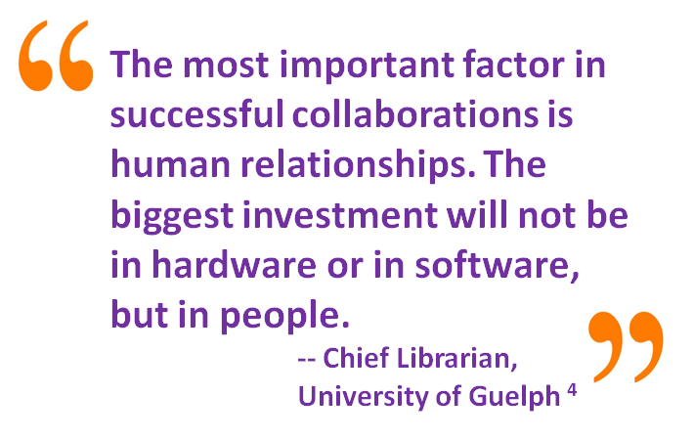
There are places where combining forces in new ways may prove to be advantageous, particularly to maximize purchasing power of items such as databases and collectively designing programs that can be delivered locally. We need to be willing to rethink the ways in which we organize and be willing to remove administrative and political impediments to achieving collective success. It may not be necessary for each municipality to provide everything to each community. There may be ways to specialize and co-deliver important services while maximizing resources. The idea is to work smarter, not harder, and to be clear that what we’re doing is, indeed, in alignment with our strategic goals.
Some questions to ask are:
- What can we do together that we can’t do alone?
- How do we best serve the interests of individual libraries and their communities while also serving New Jersey’s libraries as a whole?
- Where does it make sense to centralize and where do we need the freedom at the local level to serve individual constituencies?
- What rules or administrative procedures are standing in the way of effective collaboration and partnerships and how do we change them?
- What assumptions are we making that, if we changed them, might help us to be more successful as collaborators and make us better partners?
One pivotal assumption has derailed, and continues to derail, collaborative activity, not just in the world of libraries, but in the world in general: that it isn’t possible for everyone’s needs to be met; that there isn’t enough to go around. While this may appear to be true in the short run—when there are finite municipal funds available, for example—if we change our thinking, and ask how we might work together to everyone’s benefit, we can, and will, find alternatives that provide the necessary resources. This is why it is so important to bring people together from across traditional boundaries to develop fresh perspectives and to co-create the future of libraries. It may just be an unlikely combination of ideas that provides the answers to our most pressing questions.
We need to develop environments in which we might partner well, including well-defined common goals, clear agreements, distributed leadership, effective interaction skills and, perhaps, most importantly, a belief in the benefit of what we do together. We need to reward collaboration and make it a priority by providing resources such as time and training in skills like cross-boundary facilitation, negotiation and collaborative process design.
We also need to support strategic risk taking so that people are able to try new things, learn from failure and move forward to success. State organizations might reward collaboration by making it a criterion for receiving funds or have contests where winners have demonstrated the most effective collaborative strategy. Indeed, the possibilities are only limited by what we’re willing to imagine. We’re inventing our way to the future, a process in which there are no sure bets, but one we can dynamically steer if we stay open to the possibility of what we can co-create.

Strategies for Goal No. 3:
- Promote collaboration: Create incentives for and reward collaboration.
- Develop cross-boundary skills: Develop and offer cross-boundary collaboration tools and skills for librarians, staff and stakeholders.
- Resource sharing: Promote collaborative resource-sharing models between libraries and stakeholders.
- Events: Facilitate opportunities for networking, collaboration and creativity amongst library colleagues, to learn from each other’s successes.
- New partnerships: Promote libraries as trusted partners for business, community, education and government.

Projects for Goal 3:
Four projects have been developed and adopted to facilitation collaboration between libraries and their stakeholders.

Project No. 1: The Library is everywhere
Embed the library in your community to routinely offer and provide research, resources, materials and services to community groups to support new projects and programs. Show how libraries can support all kinds of community organizations, businesses, and local government offices. Embed special libraries in organizations, such as corporate and medical, so they support all corporate employees, administrators and departments.
Governance and responsibility: Library staff in all types of libraries: public, school, academic, medical and special.
Objectives: Greater integration of libraries and, most important of all, library services into all aspects of community, business and government functions. Establish libraries as crucial links to local organizations and stakeholders to help them achieve their own goals. Embed library staff in community groups (Town/City Council meetings, Board of Education, meetings, Rotary/Kiwanis),
Stakeholders and their interests:
- Libraries: More/better exposure and increased support/funding from satisfied customers.
- Boards of Education, Municipal and County-level governance, Boards of Trustees, faculty and staff of educational institutions, Chambers of Commerce, and other partisan and non-partisan bodies throughout all New Jersey communities: Increased productivity and more effective support for their activities/missions.
- Large and small businesses: Increased productivity.
Time frame:
- Research potential organizations to work with: 6 weeks
- Recruit, select and assign staff to organizations selected for the project: 8 weeks
- Selected staff to attend, participate in, and network with stakeholders at both public and individual meetings: 12 months
- Assess progress at 3- 6- 9- and 12-month stages
Estimated cost and sources of funding: Cost to be determined by speaker fees, travel costs, and cost to develop marketing plan. The only other major cost is staff time.
Actions:
- Develop a marketing plan that touts the willingness of librarians to provide services not only in the library but outside the library as well.
- Select specific organizations to work with and begin attending meetings regularly to determine how the library can best meet their needs.
- Further steps will be determined by individual libraries and may include:
- Evaluating the effectiveness of the librarians’ roles at public meetings by interviewing organizations’/committees’ members
- Selecting additional/alternative organizations with which to collaborate (this is dependent on the librarians’ impressions and group feedback from initial encounters - highly individualized)
Measures of success:
- Stable/increased funding streams
- Public recognition of the library’s services and staff
- Improved relationships between library and stakeholders
- Participation of library in the development and execution of campus-, municipality-, or school-wide projects.
- External organizations believe their projects are more successful because of librarians’ involvement.
Professional development: Educate librarians about why being embedded in all societal activities is important. Hire a consultant experienced in the embedded librarian model to offer in-person training for the cadre of library staff participating in the program AND/OR hire them to serve as consultants via live chat & webinar for participating libraries for the duration of the project.
Resources:
Banks, D. E., Shi R., Timm, D. F., Christopher, K. A., Duggar, D. C., Comegys, M., and McLarty, J. (2007). Decreased hospital length of stay associated with presentation of cases at morning report with librarian support. Journal of the Medical Library Association, 95, 381-387. doi: 10.3163/1536-5050.95.4.381 http://www.ncbi.nlm.nih.gov/pmc/articles/PMC2000787/
Galston, C., Huber, E. K., Johnson, K., and Long, A. (2012). Community reference: making libraries indispensable in a new way. American Libraries. Retrieved from:
http://americanlibrariesmagazine.org/features/06132012/community-reference-making-libraries-indispensable-new-way
Gutsche, B. (2012). The engaged and embedded library: moving from talk to action. OCLC WebJunction. Retrieved from: http://www.webjunction.org/news/webjunction/Engaged_Embedded_Library.html
Kranich, N. (2012). Hosting public forums @ your library. ALA Connect Archived Webinars and Downloads. Retrieved from: http://connect.ala.org/node/167956
Shumaker, D. (2012). The Embedded Librarian. Medford, NJ: Information Today. Retrieved from: http://books.infotoday.com/books/Embedded-Librarian.shtml
Stern, D. and Brown, T. (2012). Engaging your whole community: principles and practice to influence policy. AmericaSpeaks Webinar. Retrieved from: http://www.webjunction.org/events/webjunction/Engaging_Your_Whole_Community.html
White House Council for Community Solutions. Community collaborative toolbox. Retrieved from: http://www.serve.gov/new-images/council/pdf/CommunityCollaborativeToolkit_all%20_materials.pdf
Urban Libraries Council. Civic engagement: stepping up to the civic engagement challenge. Retrieved from: http://www.webjunction.org/content/dam/WebJunction/Documents/webJunction/ULC%20Civic%20Engagement%20Report.pdf
Integration with other projects: Integrate this outreach into staff members’ current workflow. Investigate other Task Force projects for synergies.

Project No. 2: I love it here!: Bringing Systemic Delight to YOUR Library
Transforming NJ’s libraries - physical and virtual - into warm, inviting spaces that give customers what they want, when they want it and how they want it. NJ libraries will discover and, wherever possible, remove barriers to community delight. Users of all kinds of libraries will identify the structural, policy, and service barriers to delight their experience at the library. Changed policies, rules, programs, and space.
Governance and responsibility: Library boards/committees, library directors, all library staff have responsibilities for this project.
Objectives: Thinking “outside the box” to provide the services customers need and want, rather than the services that librarians think customers need and want.
Stakeholders and their interests:
- Library boards/committees
- Library directors
- All library staff
- Library customers
Time frame:
- Roll out project: 2 weeks
- Survey development: 2 weeks
- Development of checklists for staff to use to ensure they are engaging with a sample of library users that reflects the diversity of the community: 1 week
- Advertise, recruit, and conduct focus groups: 4 weeks
- Analyze data and select 1-3 areas and themes to develop further (based on stated interest and urgency, as well as ease and speed with which they can be implemented): 3 weeks
- Implementation of selected projects/changes: 1-6 months, depending on complexity and cost.
Estimated cost and sources of funding: Cost will be determined by the changes implemented. Some changes may utilize only staff time, others may require the purchase and implementation of software and/or hardware, possibly minor physical renovations. Funding sources may be found in current library budgets by re-appropriating funds.
Actions:
- Brief surveys (2-4 questions) will be developed to assess users’ current perception of library services. Surveys can be handed to customers, as well as presented as pop-ups when using library web site. Library staff can also ask survey questions when working directly with customers.
- Library staff will be surveyed to assess their perception of library services. Staff should also be asked for ideas or suggestions for improving current services as well as new services.
- Focus groups will be organized to gain a more in-depth understanding of the perception of current services. Ideas for new services will also be presented to assess participant’s thoughts.
- Use anecdotal evidence, as well as evidence based upon the notion that if we ask directly, "what should the library be doing for you,” people (especially adults) will answer based on their preconceived notions of what a library CAN be or CAN do.
- Library staff in all kinds of libraries should be encouraged to observe their users, and even to ask directly, "what's the one thing in your life (professional or personal) that's keeping you up at night," and use this information, to inform programming decisions and changes.
- We can draw out themes and ideas that emerge from the data.
Measures of success:
- Improved library use (measured by statistics such as gate counts, program attendance, circulation, etc.)
- Improved staff morale
- Increased faculty/library collaboration
- Increased patron delight (as expressed through video, photographic and/or written testimonials)
Professional development: Training on software packages implemented as well as for new services.
Resources: Some possible resources include:
Survey software (Surveymonkey, Google Docs, Wufoo, etc.)
Popova, M. (2013). Brand Thinking: Seth Godin, Malcolm Gladwell, Dan Pink, and Other Mavens on How and Why We Define Ourselves Through Stuff. Brain Pickings. Retrieved from: http://www.brainpickings.org/index.php/2013/05/01/brand-thinking-debbie-millman/
Integration with other projects: Integrate with “Systems and Procedures Review” and the “Participating in the Local Community” project.

Project No. 3: Programs for Older Adults
How can we facilitate access by older adults to educational/arts programs that we offer at libraries and in college settings for those who have limited mobility and/or are homebound?
Governance and responsibility: LLNJ and NJSL
Objectives: Increase accessibility to programs by providing more convenient locations (e.g. college classes offered in libraries) and technological means (e.g. programs offered in local nursing homes).
Stakeholders and their interests:
- Older Adults (65+) interested in library educational and arts programs and courses offered by affiliates of Elderhostel lifelong learning.
- Limited mobility or homebound adults
Time frame: Six months to determine which populations in a specific geographic area stand to benefit the most by easier access to these programs and develop plans to enable this. Six months to implement.
Estimated cost and sources of funding: Not known.
Actions:
- Targeted communities’ libraries and colleges/community colleges would assess current programs aimed at this age group.
- Assess current means of access to these programs, physical locations and transportation, technology.
- Devise alternative means of delivering these educational/arts programs for older adults.
- Develop ideas for those who cannot attend in person: iPad; telephone classes; video streaming.
Measures of success:
- Increase in locations where older adults participate in /enjoy library and college/community college programs.
- Increase in means of delivery of programs for older adults.
- Increase in joint public library/nearby college program offerings.
Professional development: Needs of older adults, particularly homebound and in educational technology.
Resources: Technology/online tool to map out focus areas, e.g. Google Maps. Technology for delivering programs. Staff/training for delivery.
Integration with other projects: “The Library is Everywhere” and “Join Key Community Groups” re. elders/elder care.

Project No. 4: Create Partnerships to Support Libraries’ Role in Education
Develop synergies among public, school and academic libraries and other educational organizations to explore the challenges that we can help each other meet, while benefiting from the strengths of each other.
Governance and responsibility: This project will be a joint venture with LLNJ, NJASL, VALE and NJLA to focus on the objective below. This ties in with NJASL’s Vision - “Every student in every school in New Jersey is served by a certified full-time School Library Media Specialist. All students are empowered to achieve college and career readiness through active, collaborative library programs guided by credentialed School Library Media Specialists who are recognized as educational leaders and indispensable resources in their school communities” and with the Progression Standards for Information Literacy prepared by the New Jersey Library Association College and University Section/Association of College & Research Libraries New Jersey Chapter, User Education Committee; Central Jersey Academic Reference Librarians and Virtual Academic Library Environment (VALE) Shared Information Literacy Committee (October 2009).
Objectives: Help stakeholders to recognize the value of using library programs and services to ensure that all of New Jersey’s students (pre-K - adult) attain a greater and more consistent level of information literacy.
Stakeholders and their interests:
- NJASL, NJLA, VALE, LibraryLinkNJ greater use of library services, more effective teaching of information literacy
- NJ Department of Education NJ DOE Office of Literacy (Mary Jane Kurabinski’s department), and if possible, someone from the Secretary of Higher Education’s (Rochelle Hendricks) staff involved with Academic and Student Programs would result in more information literate citizens, schools more effective at meeting Common Core State Standards
- NJEA, AFT
- NJASA (New Jersey Association of School Administrators)
- Subject area (English teachers, History, Science, etc.) and technology organizations such as New Jersey Association of Educational Technology (NJAET) for secondary and post-secondary
- Anyone who is interested in an information-literate community
Time frame: 9-24 months several months to gather participants, and then time would be dependent on direction chosen for project work.
Estimated cost and sources of funding: Explore funding with NJEA and AFT.
Actions:
- Identify specific project representatives.
- Discussion of specific roles and responsibilities of different groups represented as related to education of New Jerseyans from early childhood through adult.
- Develop project plan (determine product desired, e.g. guidelines, regulations/policy incorporating requirement for school library programs and certified school librarians, Pre-K - 16+ continuum of skills benchmarks, including audience and distribution; steps to accomplish).
- Work toward fulfillment of plan/attainment of project goal.
- Publicity and training to follow results, e.g. how to fulfill specific roles and responsibilities –meeting standards collaboratively, assessing student skills collaboratively and consistently, etc.; how to support other groups in fulfilling their roles and responsibilities.
- Meeting of public library representative(s) with college representatives, including librarians, or from various academic and administrative departments. For example, Montclair State, has an Office of Education and Community Outreach (OECO), which “develops community-based programs in multiple arts disciplines that serve children as well as young and older adults including university students.
- Establish a pilot group in one of New Jersey’s 21 counties, which has ongoing meetings.
- Develop, expand, and refine partnerships among school, academic and public libraries.
- Host an ongoing series of forums, held in the public library, where college and high school students come together to discuss the realities of college life (academic, social, logistical).
- Create and implement a K-16+ Information Fluency (IF) continuum for all NJ students and residents.
Measures of success:
- When all NJ schools have a full-time, certified school librarian working collaboratively with classroom teachers toward a consistent and high level of information literacy (meeting all relevant standards).
- When teachers and professors assess skills and assign grades in collaboration with librarians and in full consideration of IF skills.
- When education programs in colleges and universities require pre-service teachers to learn what to expect from and how to work with school librarians to teach information literacy/fluency.
- When employers make hiring decisions based, in part, on the candidates’ ability to successfully maneuver in a complex information landscape.
- Growth of the events. Feedback/survey results participants. Increased participant demographics (i.e. parents, teachers, counselors, etc.).
Professional development: Librarians will continue to need professional development in effective collaboration methods for planning, teaching, and assessing student learning. How to most effectively reach and engage adults (e.g. parents of pre-school children, parents of students, adult learners) will be a necessary skill. Participants from most groups (non-librarian and librarian educators) may benefit from learning how to develop curricula across subject areas that incorporates consistently scaffolded learning of information processes and skills. Members of educational groups need training in what to expect from school librarians (administrators and supervisors: how to hire, support, and evaluate; teachers and pre-service teachers and those responsible for teacher and administrator education: how to collaborate meaningfully, what is the expertise that school librarians can contribute)
Resources: The most important resource to the success of this project will be participants who represent articulate, informed, influential members of their specific communities/organizations, who are committed to the objective of the project. Centrally located or rotating meeting space(s) for in-person meetings as well as technology required for collaborative work at a distance will be needed. All participants should have access to/familiarity with Common Core State Standards for English, AASl’s Standards for the 21st century Learner, ISTE’s National Educational Technology Standards for Students, VALE’s Information Fluency Progression Standards.

Goal 4: The Library as Community Anchor

As we live our lives increasingly via the Internet, people all around the world have learned how to work, learn, create and operate new ventures together. We can even enjoy the same experiences together, such as watching and responding to the same spectacular event broadcast, not in the same living room, but on Internet TV. In response to this kind of connectivity, people are more than ever wanting to connect face-to-face. They want ultra-high-touch to complement ultra-high-tech.
Libraries and their librarians are in the right place at the right time to create a community center with the library at its heart. A village scale collection of cafes and coffee shops, consulting and tutorial rooms, storefronts for publishers and purveyors of creative works of any kind, galleries and micro theatres, maker spaces for designers and artisans, as well as incubator spaces for budding social and business entrepreneurs aged five to 95, spaces for personal development and wellness…whatever the community needs to engage happily in being fully modern and fully human at the same time.
The village around the library is a safe haven for people to meet as a community and solve problems together, a space in which a new kind of locally global democracy can develop and flourish. It’s a space which inspires and invites people from all walks of life to become involved in learning, discovering and creating community together.
Goal 4: Libraries are safe, nurturing and inspiring places for people to meet, work, learn, grow and exchange ideas together.
As a community anchor, the library and its companion ventures are spaces that:
- Are virtual and face-to-face.
- Allow us to keep the very best of tradition while adapting and innovating to meet the needs of an ever-changing world.
- Inspire the creation of new ideas and facilitate their implementation.
- Integrate knowledge across the boundaries of cultures and disciplines and deepen people’s understanding of their own worlds.
- Are safe havens for exploring and taking risks.

Because libraries are everywhere, they can facilitate fine-grained connections between civic leaders and administrators with their constituents, to better customize solutions to local needs. Librarians are the ideal people to broker the information and knowledge needed right now to do things differently and to mine the creativity of others around the world, whose experiences would not otherwise be available as a resource.
Princeton Public Library
Libraries can play roles as resilient nodes during weather events and other emergencies, serving as a communications hub, charging station and disaster relief center from which to grow out reliable communications after an emergency has passed.
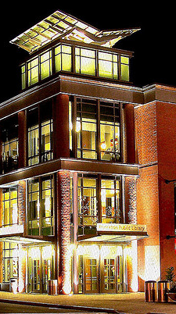
We can serve all kinds of specialized communities we have never served before, building up collections for and with new immigrants or specialized professionals in our neighborhoods or be local service providers for large-scale organizations that need help with local scale delivery and customization.
This plan calls upon civic leaders to rethink the library precinct in terms of the needs of citizens of the 21st century. We can create spaces that help us develop new ways of working better together to reinvent and revitalize the democratic process. We can explore together and support each other in taking risks and finding new ways to bridge our cultural, disciplinary and philosophical differences.
Some library buildings are in need of renovation and, on their own, are too small to support the scale or range of services required. But rather than tear them down, we might incorporate them, or their architectural style, to honor the tradition they represent and the contribution that tradition has made to the community.
Existing centers from which we might draw inspiration include the rich cultural creativity of the tourist hamlets of Vermont or the Appalachians, the interdisciplinary co-creativity of university campuses from Rutgers to Berkeley, the hive of economic activity at hotspots such as Grand Central Station or Times Square and the integrated efficiency of civic centers and their services—the town hall, school, library, police and fire stations—at the heart of villages across the nation. The idea is to keep the best of what has gone before, but re-arrange the parts in a new way that helps people deal with the complexity of 21st century life and delivers satisfying and life-enhancing ways to be human together. For inspiration see: http://www.psmag.com/culture-society/new-libraries-revitalize-cities-8596/

Strategies for Goal 4:
- Create hubs of activity: Work with municipalities and cities to plan the development of "villages" around libraries including the co-location of dining, consulting, education, personal development, recreation and communication storefronts.
- Meet new needs: Develop programs and services to address changing user and community needs, including new citizens and the differently-abled.
- Offer services for others: Become the local agencies of business, education –especially higher education–health and government services.
- Safe haven: Build the capacity for libraries to be the go-to place for information and help in emergencies.
- Non-users: Engage with people who don’t use libraries to see how we might enroll them and meet their needs.

Projects for Goal 4:
Six projects have been prepared to help libraries develop as safe, nurturing places for people to meet work, learn, grow and exchange ideas together.

Project No. 1: Library as Community Hub
Use non-traditional partnerships, non-traditional programming and out-of-the-norm thinking to attract more library users. Get customers to start thinking of the library as a community center that welcomes all and can be used for a multitude of purposes. We’re not just books!
Governance and responsibility: The library owns this project, but a sense of buy-in needs to be created so that community partners and customers begin to change their way of thinking.
Objectives: Increased awareness of library services, increased patronage, increased foot traffic, increased circulation and increased worth of the library in the eyes of the community.
Stakeholders and their interests: The customers themselves will benefit the most from this concept. The other community partners will also benefit.
Time frame: This would have to be an ongoing initiative that is tailored to the size, needs and capabilities of each individual library.
Estimated cost and sources of funding: The majority of the cost would come from staff time and energy. There would also be funding needed for postcard campaigns, fliers and other advertising. If this were a statewide effort, then possibly LLNJ or the State Library could defray some of these printing costs and/or a grant or angel funding could be obtained.
Actions:
- Partner with other community anchors, both traditional (schools, service organizations, municipality, etc.) and non-traditional (laundromats, bowling alleys, pizza shops, toy stores, etc.), with an emphasis on the non-traditional to advertise programs and services.
- Try non-traditional programming that invites people in who are generally non-library users. Seek out religious groups, plan workshops geared toward non-readers, invite meet-up groups to use your meeting space, etc.
- Library administrators make this project a priority and either head up the outreach or delegate to interested and able staff members. This could be a concerted effort involving the whole staff, in some cases, where everyone contributes with ideas for partnerships and programming or each staff member is assigned to a location for distributing materials or making contacts. Bilingual staff members can be engaged at locations where their second language is spoken to reach out to new groups.
- Hand out postcard-sized informational cards about the library/services on the streets, in malls, in stores, etc. Bi-lingual cards a plus!
Measures of success: Increased cooperation with community partners, increased interest in the library, more customers, more cardholders, higher foot traffic, possibly higher circulation. More people!
Professional development: A discussion/tutorial about how to approach a business owner or how to interact with a person who does not use the library, how to discuss library services with ESL customers, etc.
Resources: Telephone, e-mail, fax, ability to leave the building and meet contacts face-to-face.
Integration with other projects: While we are making connections with people and businesses about our regular library services/offerings, we can also remind them about the assistance we can provide in the case of an emergency.

Project No. 2: Library as the Center of the Village or Campus
Undertake a New Jersey-wide town planning initiative to explore how libraries could be developed as a village of campus, as a hive of community activity with clusters of complementary services and facilities. These facilities may include restaurants, cafes, bookstores, theaters, incubator spaces for business and social entrepreneurial start-ups, maker space storefronts, publishers/printers and shippers, small business office space, foundations and social entrepreneurship offices/meeting rooms, government agencies, child care, community health, after school activities and workforce development facilities. Become satellite sites for colleges and universities out of the area.
Governance and responsibility: Undertake a pilot study of the project with the Urban Mayors Association of New Jersey and Thomas Edison State College.
Objectives: To create and trial multiple approaches to the development of libraries as a center of the village or campus and identify what mix of facilities would generate sufficient patronage or traffic to achieve critical mass. To find one or more formulas that would be economically and socially sustainable, e.g. like the original formula for shopping centers of a department store, two supermarkets and 20-50 specialty shops needed to achieve critical mass.
Stakeholders and their interests:
- Urban Mayors Association of New Jersey – new economic development in urban centers, job creation, improvements in literacy, social development.
- New Jersey State Library – new workable library models
- Urban communities – developing/redeveloping community centers as vibrant, multi-purpose hubs for community life/placemaking
- Libraries in urban centers
- Local chambers of Commerce
- Property developers
Time frame: During 2013
Estimated cost and sources of funding: $50,000 - $100,000 for an initial study and pilot from grant funding.
Actions:
- LLNJ, NJSL and Urban Mayors Association develop a proposal for funding.
- Begin the project by undertaking a study of the NJUMA communities (19 in the TESC project) to determine which ones are the best candidates for pilots. Also to determine the assets and challenges involved in creating a master plan for further development of the project in these communities.
- Select 5 sites around current libraries that have potential for redevelopment and undertake a town planning study with input from local communities and potential operators of facilities. In a spirit of friendly competition, communities could be engaged to present cases for why their community is right for selection for the pilot.
- Libraries work with mayors to invite key residents and community leaders to explore the possibilities.
- Identify the types of desirable companion business, services etc. for libraries in each locality.
- Produce 5 local prototype master town plans in collaboration with each municipality/city.
- Identify potential partners including: Small business: Start-up support, new business opportunity research, links to university/industry commercialization centers, proposal and grant writing assistance. Universities: tutorial centers, commercialization of research. Unemployed: Resume writing support, maker space services to acquire new skills. Community groups: Grant and proposal writing services.
- Apply for funding
Measures of success:
- Development of stronger political ties between libraries and the municipalities.
- Development of strong ties to business and community leaders.
- Plans for future development around libraries.
- A model that can be replicated elsewhere.
Professional development: Workshops on social business innovation, town planning, workforce development, setting up and managing incubators, and library traffic generation needs as part of the project.
Resources: Commitments from 19 local libraries to participate in the process and commitment from the 5 chosen communities to follow through.
Integration with other projects: Integrate with all projects focused on the creation of new services for libraries.

Project No. 3: Library as Information Central
Making the library a central repository for all important community information. Ensuring that when something that is applicable and important for the community as a whole to know, the library receives this information and makes it publicly available. Play a critical community communications role especially during emergencies, such as we had during Hurricane Sandy.
Governance and responsibility: A designated information officer/librarian, the director, any staff member who already has strong ties in the community, anyone who is comfortable with networking with the community.
Objectives: Will make the library the place people turn to find out what is going on. Specifically when there is an emergency, but also on a day to day basis, that all important information flows through the library.
Stakeholders and their interests: The community as a whole will be served by the project. Whoever is having an event or important town/community event; it will enable the news to spread. The whole community, as well as the staff, will benefit because libraries will be included in the information loop. The suppliers will be the people who hold the information: Town Hall, the various departments, the school/board of education, community organizations and local businesses.
Time frame: No more than one week to establish the list of people in the community who need to be contacted, and however long it takes to contact them and make them aware of the library’s desire to receive their information. The real time cost will be in follow up, making sure it becomes second nature for them to contact the library. All told this would be an ongoing project, one that adds to the library’s mission.
Estimated cost and sources of funding: The major cost will be staff time. Additional costs may be bulletin boards or displays in the library of town events, dedicated for community notices and additions to websites/social media.
Actions:
- Individual libraries decide how big in scope this project will be. Emergencies only? All town meeting/event notices? Private businesses and organizations. For academic libraries, fraternities, campus organizations, academic departments. For corporate libraries, HR departments and other departments, management.
- A staff member contacts government agencies, local businesses, town groups, cable providers, telephone company, emergency services, office of emergency management and first responders.
- The library makes it known that as a part of it is community service the library wants to be the center of information. Establish the fact that there is already a large part of the population trafficking through the library and it is a place where people are seeking information.
- When there is an emergency, such as Hurricane Sandy, the library has shown that even people who do not use the library regularly are coming to the library for information and to have a place to charge their devices, so when there is emergency information to be given the library should be on the list of people who receive it. As a result, any notices, specifically during an emergency, should be given to the library.
- Let the community know that the library wants to be involved in community news and affairs so that we can keep the public informed with any information that is important for them to know. This can be as simple as changes in garbage pickup or as complicated as to know when the power company will get to their block. This can be extended, depending on the library policies and type, to any local community organization. No information is too small to be sent.
- Once relationships are established, follow up will need to be done on a case-by-case basis and contact information and a list of the organizations should be maintained. Relationships should be built.
- Once contact is made and information starts flowing in the library has to make this information public. Many libraries do this already, with community bulletin boards and links on the website, but dedicated effort to keep this information updated and public should become part of the regular routine.
- E-mail lists for emergency notifications could be developed using free email list serves such as Mailchimp. As we learned during Sandy, we can’t always depend on e-mail and internet access so it may at times require paper print outs being distributed. In emergency situations, the staff information officer should make in their business to keep the whole staff apprised of important updates.
- The website should also make apparent the library’s access to information and the patron’s should know that they can turn to the library for help when there is an emergency. Any emergency information can be made public using social media accounts.
Measures of success: The mayor or the fire department, or the sanitation department is putting you in the loop for events. The library is being invited to participate in important community decisions. Measure of success will be new people coming in or visiting website to check schedules or to find information. Being contacted regularly by community organizations.
Professional development: Networking skills, the ability to organize, what could become, a large stream of information and to make it public. Training on any software used, such as social media or email blasters. Good communication skills a must.
Resources: Can be as small as a bulletin board or as big as a dedicated local information area. Can include technology/web presence as deemed appropriate by the individual library.
Integration with other projects: This could be a part of all community outreach. This can be mentioned whenever a joint program or town meeting is held or attended by a librarian.

Project No. 4: Emergency Information Infrastructure
Equip libraries with generators so they can operate effectively as community hubs in the event of emergencies. During hurricane Sandy, many people came to libraries to obtain information and to charge communication devices. It was suggested that there might be funding for a project like this one as part of ongoing community development for resilience and disaster preparedness. Even if it were not possible to provide a generator for every library, libraries within a given distance from each other could be equipped, thus providing a network of support.
Governance and responsibility: NJSL/LLNJ task force to explore funding options and coordinated implementation in coordination with state and local offices of emergency management (OEM).
Objectives: Equip libraries throughout New Jersey with emergency generators.
Stakeholders and their interests: Libraries of all types and their communities.
Time frame: Depending on variables with grants, etc., this could be accomplished within FY14.
Estimated cost and sources of funding: Cost unknown. Costs include staff time to investigate and write grant, purchase and installation of generators. Possible source: FEMA. Other state and federal grants.
Actions:
- Form a task force to look into cost and funding options.
- Develop prototype plan in coordination with OEMs.
- Write necessary grant(s).
- If money is obtained, install generators.
- Create a communication plan to inform community members of this resource and guidelines/protocols for emergency procedures.
Measures of success:
A significant number of libraries throughout the State are equipped with emergency generators.
Professional development: None.
Resources: Research and grant-writing capability.
Integration with other projects: This project would be coordinated with No. 3, Library as Information Central.

Project No. 5: Keep Reading Each Summer
Public libraries have historically offered summer reading programs for the children of their community. Recent studies show that this is more critical than ever. A national effort, the Campaign for Grade Level Reading, has shared data that a significant portion of children are not reading with proficiency by third grade and, if they are not, they will most likely not have academic success in higher grades and will not be prepared for college or career. A major component of lack of reading proficiency is the summer reading loss, when children, particularly in urban areas, have little or no learning activities for three months of the year.
Public libraries have a natural role in increasing summer literacy-based programming. This project will provide public libraries and school libraries with models for cooperation, suggest funding options and partnerships, and provide models for summer program expansion.
Libraries will recruit agencies providing summer services to participate; these agencies will receive weekly services for a period of weeks. These services can include deposit book collections, weekly visits from volunteer readers, provision of publicity to encourage parents and children to read, incentives for children who participate, among other things. Volunteers will be recruited and trained by library staff in order that they may visit these sites to provide literacy and other learning opportunities.
Governance and responsibility: LLNJ will coordinate the discussion, partnering with organizations that already have an interest in this issue and set up a task force. The NJ Summer Reading Task Force, the New Jersey Association of School Librarians, and a number of NJLA sections (including Administration, Children’s Services, Young Adult Services and Urban Libraries Section) will be invited to participate in this effort.
Objectives:
- Third grade reading proficiency scores will increase by at least 15-20% in the communities that participate in the program.
- Public libraries will develop and maintain strong relationships with the local school district, to the benefit of students.
- Public libraries will achieve community recognition of efforts to address the academic needs of the children of that community.

Stakeholders and their interests:
- Public libraries will serve as the primary conveners of this effort; increasing activity in summer learning cements the position of the public library in the overall wellbeing of the community, most particularly the children of the community. The public library will serve as the primary supplier of programs and content.
- Community organizations, such as preschools, camps, Boys and Girls Clubs, YM/WCA’s, etc. will be an integral part of planning the program, but will be the primary recipients of the Summer Reading Program.
- The local school district will also be invited to participate, to the extent possible. Summer schools will be included in any efforts and the school district will be urged to act as a supplier (of talent and/or funds).
Time frame:
- Fall-Winter 2013-2014: Task Force is created. Coordination with Summer Reading Committee is extended. Research regarding funding opportunities is undertaken; suggestions are compiled. Program outline and options are developed. Publicity inviting participating libraries is developed and distributed
- Spring 2014: Webinar outlining program options is created; in person training sessions are scheduled and offered. Participating libraries are asked to commit to program to allow for data collection. Materials developed by Task Force are distributed by participating libraries
- Summer 2014: Program is executed. Data regarding level of participation and other benchmarks is collected.
Estimated cost and sources of funding: Cost range can vary, depending on the population served by the library, the existing resources of the library and the range of services to be offered. For example, a decision to provide permanent book collections to agencies outside the library can cost up to $3,000. Potential cost projections will be developed by the Task Force. Some sources will be in-kind, but it is recommended the LLNJ develop a grant program that requires a match. And, part of the program development will include suggestions for foundation funding.
Actions:
- Development of program ideas, including utilization of volunteers
- Suggestion for volunteer training and management
- Outlining ideas for transcending the remedial model of summer school
- Highlighting the resources and ideas from the Summer Reading resources
- Recommendations for deployment of books/enhancement activities (e.g., crafts, experiments, etc.)
Measures of success
- Statistical measurements, e.g., number of children who participate, amount of time spent reading, are easily gathered and compared to previous years.
- Public libraries that have a program offered jointly with their school district may be able to ask the school district to track student’s achievement based on testing at the end of one school year as compared to the beginning of the next school year.
Professional development: Training sessions will be offered with suggestions for the development and implementation of the program, including volunteer management. Speakers from the National Summer Learning Association (http://www.summerlearning.org/) or the Campaign for Grade Level Reading (http://gradelevelreading.net/our-work/summer-learning-loss) should be invited to address potential participants regarding the importance of this effort.
Resources:
- A book collection sufficient to share with agencies in the community served by the public library, to include the potential of deposit collections and support for weekly summer reading activities in agencies throughout the community.
- A technological infrastructure that permits rapid communication between a library, participating agencies and volunteers is critical.
- Space to accommodate a base for volunteers, whether so they can access books and other resources they will use in visits to participating agencies, or for preparation of needed materials, such as crafts.
- Funding to provide materials for learning activities, as well as promotional materials and small incentives for participating children.
Integration with other projects: This is perceived as an offshoot of a library’s usual summer reading program. On a wider scale, it is also perceived as an enhancement to the work done by the Statewide Summer Reading Committee.

Project No. 6: Sign-me-up
Using a product such as the Vanguard ID systems Family-pak Enrollment package, distribute “generic” Library cards through a defined area (municipality, county, etc) via churches and local businesses to increase the number of library card holders. The printed enrollment card would be brought back (or mailed back) to the library to activate Library membership.

Governance and responsibility: Any library that chooses to sign up to the program.
Objectives: Greater visibility of libraries in the community; increased number of library cardholders. Get more library cards into the community.
Stakeholders and their interests: Each library, whether county or municipal or other, will order a finite number of cards to distribute throughout the community. Cards will be packaged somewhat like a commercial gift card, with instructions on completing registration data and delivering that print card back to the indicated home library. Once the home library receives the registration data, the card will be activated so the card holder can immediately begin obtaining library services.
Time frame: 3-6 months.
Estimated cost and sources of funding: Estimate provided by vendor. Calculate ordering 10,000 cards on a statewide initiative, to be distributed on an as-requested basis to perhaps 100 libraries. Cost to be covered by grant money, LLNJ? Quotes: Gift Card w/Sombrero Cut out 10,000 @ .42 each = $4200, Application with 1 Card & 1 standard key card 10,000 @ .60 each = $6000. Set-up fees would apply for each product.
Actions:
- Survey library community to determine which and how many libraries are interested in initial participation.
- Print cards with a generic logo specific to New Jersey, but each participating library will need to identify on the cardpak the municipal or tax-supported facility for which the card provides participation. If Gift-Card style cards are used these can be hung on hooks in a retail environment; if Sign-Me-Up! type of card is used a small display unit will need to be used.
- If local merchants will display cards for reciprocal promotion in the library, the outlets for the cards are practically infinite, but an effort should be made to reach residents who may be non-library users by targeting, Laundromats, dry cleaners, convenience stores, etc.
Measures of success: More new library cardholders. Requests for more of the cardpaks from local organizations and businesses.
Professional development: Community outreach. Networking skills. This could be considered an extension of the GALCO concept. Perhaps even a predecessor a to statewide library card.
Resources: Staff time to distribute cardpaks in the community. Funding for statewide printing of generic cards. Integrating bar codes that are compatible with all NJ libraries.
Integration with other projects: Greater visibility of libraries creating larger awareness of the services provided by a library.

Goal 5: Cycles of Innovation

Goal 5: We reinvent our methods, models products and services to keep pace with the “new normal” of transformational social and technological change.
In a world that is increasingly instantaneous, on-line and round-the-clock, where knowledge and information are ubiquitous and available at the touch of a button, libraries have both a great imperative and a terrific opportunity to reinvent themselves as centers of innovation for 21st century life. We can help people use and create with digital technologies, such as laptops, cell phones, iPads and software. And we also can become experts in the complementary technologies of relating, thinking and wisely applying new knowledge, which are equally necessary to adopt and at which we can and will excel.
We are on the way to being able to offer what thought leader, Mark Prensky⁵, calls Digital Wisdom, “integrating the technology of our times into our thinking and decision making, doing it wisely, and sharing the results” in order to deal successfully with the challenges we all face in these fascinating and challenging times.
The library is well placed to deliver the ultra-high-touch experiences people increasingly demand in order to balance the ultra-high tech of the virtual world. Libraries are widely distributed and well-connected into both aspects of life. We are located in most townships, in almost every school, in every university and community college, in a growing number of businesses and government departments.
We have the opportunity to help communities refresh their social fabric, to retrofit suburbs with more sustainable lifestyles, to deliver health information services to exactly where they are needed, and to create rich and meaningful places to live, work and play and spaces where they want to meet, socialize, and engage with each other.
We are reinventing our physical library spaces, not only to make room for the growing number of customers for internet access, but also to accommodate the different kinds of activities we now engage in, like maker spaces, theater and all sorts of creative endeavors. We are centers of collaboration and able to make more powerful use of broadband to meet with colleagues or partners, and discuss what we have learned, what it all means and what we can do together.
While new libraries become more like coffee shops, cafes, homes, hotel lobbies, business centers and storefronts, we still have many architecturally distinctive gems from 19th and 20th Century that have the potential to be a symbolic anchor for new revitalized campuses, reminding us of the value our forebears placed on libraries as keepers of learning and knowledge, and its importance in helping working men and women get an education in order to maintain a civil society in the industrial age.
Innovative library types are popping up in interesting places: on trains, planes and in storefronts. A popular new trend is mini-libraries outside homes, so residents can lend their books to neighbors. And libraries ranked No. 3 on a 2013 list of desirable features for airports. Only cinemas and sleep pods were more popular⁶.
Libraries can also lead the way in transforming how we use mobile devices such as smart phones, e-book readers, i-Pads and tablets. We can partner with young designers to think about creating apps that embed learning and decision making processes in technology to help us better handle our work as managers, leaders and people who help.
We are finding new ways to organize and keep track of content and collections. Very soon, every book, journal and artifact might have its own Internet address or RFID (Radio Frequency ID), so you can find it easily using your mobile phone. You might also be able to borrow it from the library using your online membership instead of a traditional library card.
The Internet also is driving the growth of citizen journalism, remixing and the curation of personal collections of photographs, art, music and historical artifacts. Increasingly, people are both producers and consumers of creative works. A question arises about which personalized collections libraries should track. Should they, for example, track the blog entries of thought leaders (especially the archived variety that may no longer be available) that might need to be brought to the attention of subscribers or customers? Or is this a role for others?
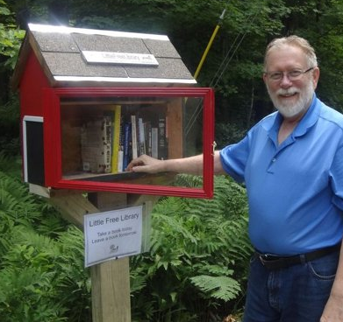
At the same time that there has been a growing availability of open source products and platforms, there has also been a huge increase in the sheer numbers of applications produced by citizens, now numbering in the millions, and growing. The price of apps has come down from hundreds or thousands of dollars to a few dollars or cents. Very close to free and very close to the library ideal. We can help promote these devices by tapping into local talent and encouraging them to become even more creative than they are already, via maker spaces and incubators.
Libraries may not be able to maintain the same kind of free data storage facilities as Google, Microsoft and Yahoo, but we can partner with them to deliver value-added services wherever they are needed, rather than the one-size fits all solutions that are largely on offer. While these giants of the digital world seem to have stepped into the world occupied by libraries – the public domain and the free – the truth is that the “free” access comes at a cost, that of receiving advertising messages and giving up privacy.
Privacy is something the younger generation has traded for access, interconnectivity, interactivity, ubiquity of information, speed of delivery and storage space. In exchange, they are able to create and maintain complex websites, converse with each other anywhere in the world and curate their own collections of photographs and music, much of it created or re-mixed themselves.
And while librarians have been early adopters, making use of Google Docs, wikis, blogs, Doodle and other tools, we have been slow to adopt the tools that facilitate collaboration to work together on projects with our internal and external stakeholders. We need to commit a certain percentage of our revenue to innovation, to find the gaps in service delivery and fulfill those needs to a new standard of customer delight.
A neighborhood mini library
The work of reinventing libraries is something that we cannot—and should not—do alone. We need to use our skills and the magnificent technology at hand to collaborate with each other, with our communities, our customers, businesses, educators and government to start many new projects, see which gather attention, support and resources, and further encourage what works. We should also conduct experiments with our stakeholders, to try out new models of co-operation, such as crowd-funding, where many people pledge resources or small amounts of money, helping to start new things that are aligned with what they value.
Within our library community we have considerable expertise that can be shared internally. For example, academic and public libraries have vital knowledge about processes and new ways of organizing that is vital for school libraries. Academic libraries have resources that when delivered locally can change the way communities make use of information and in doing so become more successful.
Libraries need to do what Singapore Airlines does. The world’s leading carrier maintains two departments that focus on customer service. One works to do things faster, cheaper and smarter. The other’s mission is to delight the customer. Together they achieve superlative performance. Libraries can do the same.

Strategies for Goal 5:
- Pilot projects: Design, pilot and replicate innovative projects in all library types that align with emerging customer and partner needs.
- Balance with traditional models: Maintain an appropriate balance between new and traditional services for which libraries are widely valued.
- Guidelines and certification: Provide guidelines for libraries for appropriate technology, skills and services and to help late adopters to more quickly take up new models of service delivery.
- Commit % of funds: Devote a percentage of resources to innovation to stay current.
- Reward innovation: Celebrate success with opportunities to replicate the results elsewhere. Allow failure as a learning experience.

Projects for Goal 5:
Six projects have been developed to support the reinvention of methods, models, products, and services to keep pace with the “new normal” of transformational social and technological change.

Project No. 1: NJ Digital Creations Cloud
Provide a server based networked infrastructure to host local community digitally created content that would be publically accessible to both the public at large as well as the creators of the content. Libraries would serve as facilitators of content, as well as resources to the creation process. The NJ Digital Highway can be looked to as a model for this type of project (http://njdigitalhighway.org).
Governance and responsibility: State Library, LLNJ, Library Friends group(s), local business grants/donations.
Objectives: The project will provide cloud based storage and retrieval tools for individual and group- based digital projects created by members of the local communities in New Jersey. The design of the retrieval system interface would provide a taxonomy indexing that would allow content generators and consumers to search for creations by community, type, theme, tag, date, and other relevant categories.
The project will also:
- Foster creativity and innovation at the community level in a variety of areas such creation of original audio, video, image, textual, or hybrid projects.
- Help rebrand libraries as spaces for “content creation” as well as “content consumption.”
- Enhance a sense of both local and statewide community based around the original works of the “homegrown” content producers.
- Allow libraries to help patron with digital literacy skills in the use and development of software and equipment for content creation.
- Provide a practical interface and storage system for original community works that would document the creative history of those communities. This would be as much a documentation of the historical record of communities as it would be a technology hosting solution.
Stakeholders and their interests:
- Artists/Arts community: Create digital artistic objects of various types.
- Music and Film Creators: Host original audio and video recordings.
- Individuals interested in local history and historical preservation of community.
- Schools/Educational institutions: Provide storage and access to student works and projects in present and over time.
- Libraries: Provide assistance and collection management with hosting and access while also providing access to their community’s local history.
- Museums: Provide the ability to create exhibitions and educational modules based on the creations of their local communities, or specific local and state level groups that fall under their mission.
Time frame:
- Sept 2013: Research and development
- Dec 2013: Secure funding sources (grant, donation)
- April 2014: Infrastructure development and UX Interface Design
- Sept-Dec 2014: Potential pilot launch of initiative with selected libraries/participants.
Estimated cost and sources of funding: $200,000 for project costs and development
Actions:
- Research current and sustainable hosting (self-hosted infrastructure versus “cloud” based pay models) and interface design models including the NJ Digital Highway. Research methods for local institutional level account access and upload capabilities.
- Reach out to potential funders to secure funding levels conducive to a project of this scale.
- Design framework for prototype of server configuration and database interface for the collection.
- Hire 3rd party network administrator(s) (if developing in-house server infrastructure), database designers(s) and web interface designers(s).
- Develop guidelines and policies regarding content submission to include defining subjective acceptable content and submission workflows.
- Purchase hardware and other networking resources as needed (if developing in-house server infrastructure).
- Install and setup the network; Write and develop the interface and backend database.
- Alpha and beta test with selected libraries to debug and make changes based on recommendations.
Measures of success:
- Collected feedback from users of the service (anecdotes, stories).
- Number of entries uploaded to the service.
- Number of communities/libraries represented by content on the service.
- Web based usage statistics including uploads, views and interactions.
Professional development: Professional development will be necessary for staff of libraries who will contribute content and/or collections to the service. This would include instruction on uploading, using the interface, and providing metadata. Library staff would also need to be trained on popular products and services used to create digital content, as well as basic familiarity with peripherals and equipment used in this process. Ideally, beyond traditional training/webinars the project could provide a clearinghouse (for instance through the LibraryLinkNJ Technology Exchange) where library staff can access tools and resource information for assisting customers with their creations.
Resources: Initial setup could require significant hardware configuration (if in-house infrastructure is chosen). If an in-house structure is chosen, an additional requirement will be physical facility to store, manage and facilitate the servers and other associated equipment and machines that will run the service. Large amounts of storage space for digital creations will also be required. The ability to provide maintenance of the system either through trained professional staff currently working with participating institutions, or through contracted outside third party vendors will also be required.
Integration with other projects: This service could be integrated with numerous projects depending on its design. It would be a natural partner with the NJ Digital Highway which provides similar digital artifact hosting and discovery tools for collections sent to them by state institutions. Ideally, an interface could be designed to coordinate access to collections across both services. An API could be developed for the system which would allow libraries, museum, and third parties to design apps and other tools to extrapolate and manipulate content display and outputs. This could lead to digital exhibits, mobile accessibility and geo-location of collections, and other creative outlets for the content. This could certainly be integrated with any programs from public institutions that highlight community works, local history, and digital literacy and education.

Project No. 2: State-wide E-book Platform
Acquire a New Jersey owned e-Books collection and make it available to all New Jersey residents.
Governance and responsibility: The NJ State Library would establish a Task Force from among library people or interested people to develop the mechanisms for this project.
Objectives: A shared collection of eBooks available to all New Jersey residents.
Stakeholders and their interests: A local distributor is supplying eBooks and could be the supplier. They would be asked to be involved in acquiring the proper licensing from publishers. They would benefit from a guaranteed ongoing clientele for this format. New Jersey libraries and their customers would benefit.
Time frame: 2 years -- year 1 to develop the program and technology; year 2 to enroll libraries.
Estimated cost and sources of funding: Ongoing costs would be proportionately divided among libraries; initial costs est. $15,000 - possibly from grant program from vendor.
Actions:
- Develop the model based on other state model that has been accomplished
- Develop funding model based on Digital LLNJ model.
- Work out the details of a statewide library card including access to the eBooks to encourage participation.
- Launch the program and get libraries going.
Measures of success: EBooks available through a statewide card in all New Jersey libraries within 2 years.
Professional development: Technology needs through Adobe product or alternative.
Resources: Server storage space.
Integration with other projects: Could be integrated with other outreach/library card programs.

Project No. 3: State-wide E-book Platform
Implement a solution for providing e-Book borrowing to users throughout the State via a single user-friendly discovery platform offering a broad selection of titles. This solution will also have the goal of connecting users directly with authors, booksellers, and publishers. Note: The Massachusetts Statewide Resource Sharing Business Plan located at http://mblc.state.ma.us/grants/resource_sharing/ was used as a model for this project. Some of the information below is copied and adapted for use here. Also see Digital Arizona Library at http://www.azlibrary.gov/extension/dazl.aspx
Governance and responsibility: The NJ State Library would establish a Task Force from among library people or interested people to develop the mechanisms for this project.
Objectives:
- Through statewide library partnerships, New Jersey library users of all ages and abilities will find and have access to e-books that meet their educational, learning and individual needs.
- Allow New Jersey libraries to offer content to their users that is obtained directly from publishers.
- Allow New Jersey libraries to negotiate content agreements directly with publishers and content creators.
- Create an efficient and cost effective eBook platform for New Jersey libraries.
Stakeholders and their interests:
- New Jersey libraries and their users
- eBook publishers and content creators
Time frame:
- Jan 2014: Research and development
- April 2014: Secure funding sources
- July 2014: Infrastructure development and UX Interface Design
- Jan 2015: Potential launch of initiative with selected libraries/ participants
Estimated cost and sources of funding: $200,000 for project costs and development. Initial Funding from State sources for R&D and Development. Ongoing funding from State and participating libraries for Content and administration
Actions:
- Research current and sustainable hosting (self-hosted infrastructure versus “cloud” based pay models) and interface design models including the Douglas County, CO model.
- Reach out to potential funders to secure funding levels conducive to a project of this scale.
- Design framework for prototype of server configuration and database interface for the collection.
- Hire 3rd party network administrator(s) (if developing in-house server infrastructure), database designers(s) and web interface designers(s).
- Develop guidelines and policies regarding collection development and acquisition.
- Purchase hardware and other networking resources as needed (if developing in-house server infrastructure.
- Install and setup the network. Write and develop the interface and backend database. Use open source model developed by Douglas County, CO.
- Alpha and beta test with selected libraries to debug and make changes based on recommendations.
- Reach out to publishers and content creators. Negotiate content agreements.
- Train participating libraries in use of system.
- Develop marketing materials and tools for libraries.
Measures of success:
- Collected feedback from users of the service (anecdotes, stories)
- Number of communities/libraries represented by content on the service
- Web based usage statistics including downloads, views, interactions, etc.
Professional development: Skills needed include experience in contract negotiation, knowledge of current publishing world, library experience, collection development skills and acquisition experience, technical expertise, user support, local help desk, training skills to train library staff, promotion of the project to libraries, users and other partners; office support needed to provide invoicing, billing and other support to participants. Staff will be responsible for negotiating contracts on behalf of New Jersey libraries. Staff will work directly with publishers and book vendors. Staff will work with content selection committee to identify collection priorities.
Resources: Adobe Content Server (DRM). MySQL databases. Full text indexing. ILS connectivity. Front end for discovery. Hosted servers.
Integration with other projects: NJ Digital Creations Cloud

Project No. 4: Small Library Learning Commons
School and public librarians access a consulting team to help them develop a plan to transform all or part of their libraries into dynamic learning commons-type spaces. Assemble a team of consultants composed of: librarians who have developed learning commons, architect, furniture expert, technology expert, etc. The team will identify successful small learning commons, develop a list of criteria/questions to guide librarians (and their learning commons committees), and meet with them online to develop a plan to implement a small learning commons in any library.
Governance and responsibility: LLNJ and NJ State Library.
Objectives:
- Provide student customers and the adults who work with them a dynamic, flexible, comfortable learning space where they collaborate and utilize technology.
- Form and offer a team to support librarians in developing a plan for creating and implementing a small 21st century learning environment. Plans will be developed at whatever funding level, timetable, and technology expertise is feasible for the school or public libraries.
Stakeholders and their interests:
- Students: In the LLNJ survey, several articulated requests for a concept like the learning commons: “Restructure the physical layout of the library. Use low bookcases and in those areas, create centers for student learning.” “Purchasing movable furniture (tables, cafe tables, cozy furniture).”; “An area where we can do work collaboratively without having to worry about disturbing others. It could be an area to relax as well.”; “Add a group study room where you can talk through projects and [t]he design and architecture should be very modern. The seats should be extremely comfortable. There should be lots of computers available. They should make the student feel comfortable and at home. [Where we] don’t have to be silent. I would want a lot of tables and comfortable chairs.”
- Librarians
- Teachers, including technology teachers
- Administrators
- Parents
- Team of consultants to conduct online support meetings to help librarians create a learning commons space in their libraries
- Possible community partnerships
Time frame:
- September 2013 - January 2014: Assemble team and develop general criteria and guidelines/models.
- January 2014 - Onwards: Conduct online meetings to develop plans that librarians can bring to administration for implementation or inclusion in budgets, bond issues, etc.
Estimated cost and sources of funding: Costs associated with hiring a team to develop learning commons general criteria and guidelines/models, then conduct two-hour online consultations with interested librarians. Grant funding for renovations/technology purchase, perhaps donations from local businesses.
Actions:
- Create team to support the project.
- Team selects models from across the state of successful implementations of small learning commons.
- Team develops a list of questions/criteria a librarian might answer in developing a learning commons plan.
- Librarian invites local stakeholders to join a learning commons committee which takes photos of and measures possible locations in the library, conducts meetings to answer the list of questions/criteria to generate the basis of a plan.
- Learning commons committee submits the new plan to the team.
- Team meets with the learning commons committee for two hours in an online meeting room to help them refine and/or correct their new plan.
- Learning commons committee develops complete plan to submit to administration to be included in the annual budget, develop a bond issue, etc.
Measures of success: Librarians (and their stakeholder committees) will have the support to develop small learning commons plans customized to their libraries and for their student customers. The practical, viable and exciting plans can be implemented by the school or public library in whatever manner is fiscally feasible. The final outcome will be a learning commons that student customers and the adults who work with them can use to collaborate and utilize technology.
Professional development: Professional articles on learning commons.
Resources: Online meeting rooms. Digital cameras for librarians to take photos of their libraries to serve as the basis of the consultation.
Integration with other projects: Maker-spaces. Many districts are exploring ideas on how to update their school libraries to support collaboration. Timely project.

Project No. 5: You and Your Health
Create three regional consumer health research centers within public libraries in the State. These designated libraries will create customized packets of health information for customers. In addition, these libraries will partner with hospital systems to publicize service, do outreach and coordinate health programs at different libraries throughout the region.
Governance and responsibility: A Task Force drawn from NJ State Library and LLNJ.
Objectives: Connect customers of public libraries with health information in order to:
- Better manage their health and wellness.
- Improve consumer health literacy in the State.
- Partner with hospitals and healthcare providers.
- Show relevance of trained professional librarians to get customers exactly what they need.
- Form partnerships with hospitals in the State.

Stakeholders and their interests:
- State residents
- Public libraries
- Librarians
- Hospitals
- Doctors and nurses
Time frame: 12 months. Select the 3 libraries that will serve as the regional consumer health libraries. Make contact with hospitals in region to establish partnerships and possible funding. Hire librarians and begin training. Form committee to select databases. Create marketing and promotional materials. Plan programs and outreach. Expand the program to other libraries after the pilot period.
Estimated cost and sources of funding: $40,000 marketing and promotional materials
$40,000 databases (for access to a few specialized databases such as Gale Encyclopedia of Medicine (MedLine, MedLine Plus, PubMed, NIH are free and currently State Library provides access to additional health databases). $360,000 (2 FTE at each regional library for research/outreach/programs).
Actions:
- Establish the Task Force.
- Approach hospitals and healthcare providers to create working relationships.
- Undertake initial survey of needs.
- Identify three suitable locations/libraries for the pilot programs.
- Create a new model of reference service that focuses on customized research that is more relevant to customer in a digital world where there is information overload.
Measures of success:
- Number of custom health information packets created for customer
- Feedback from customers and partner hospitals
- Program attendance
- Requests from additional libraries to become a regional consumer health library
Professional development: Librarians get their Consumer Health Certificate through National Library of Medicine/MLA.
Resources: See above.
Integration with other projects: Integrate with Libraries as a Village or Campus.

Project No. 6: Mini-libraries
Mini libraries on post/stands set around communities. People can take and leave books at will. Stock is replenished on a regular basis by citizen library stewards who wish to share their books and/or collect used books for their libraries. This project could borrow from, and be part of, the Little Free Library movement, which was started in Minneapolis in 2009, and since then has inspired and supported the building and stewarding of thousands of mini free libraries worldwide http://www.littlefreelibrary.org/index.html. The libraries could be built in conjunction with the LLNJ Maker Spaces project by young people who need to learn skills to get a job.
There could also be teams of young people in communities who steward the mini libraries. In urban areas, this could be the library equivalent of the “gangsta gardener” movement in LA, where community gardens are being created on vacant lots http://www.ted.com/talks/ron_finley_a_guerilla_gardener_in_south_central_la.html. Young people who are in school could use this activity both as community service and as project-based learning for activities including design, language arts, social studies, marketing, business and math. The program could also be connected with elder and/or early childhood initiatives instituted by libraries and community groups (imagine how much fun it would be for small children to visit the beautiful/fun/fantastic mini library to see what amazing books have arrived!).
Governance and responsibility: Task force made up of reps from public and school libraries, LLNJ maker spaces program, workforce development and community groups, churches, etc…anyone interested in engaging young people to serve their communities and develop greater social, literacy and numeracy skills.
Objectives:
- Distribute the idea of/presence of the library throughout communities.
- Work with young people with no resumes to come to Makerspaces workshops and design and create different styles of mini-libraries.
- Help young people develop skills for work in a supportive, project-based environment while also developing a spirit of good citizenship and caring for others in an open and trusting manner.
- Spread the word that libraries are part of the fabric of communities; that they help to nurture and build communities while also cultivating the love of reading and sharing ideas.

Stakeholders and their interests:
- Libraries: Mini libraries are living advertisements for the New Jersey library brand.
- Community leaders: interested in developing good citizenship and literacy in their communities. This is a prominent display of caring and civic participation.
- Young people: Unemployed young people, to design, make and supply mini-libraries to citizens in their areas, thus acquiring important skills. Also young people in school who would benefit from project-based learning.
- Community members of all ages: elders, parents, young children, etc.
- Local hardware/lumber/art businesses: Could donate materials/expertise and become part of the “movement”; great press
- High schools and community colleges: Partnering opportunities for project-based learning and workforce development. Happier, more engaged students.
- Future stakeholders group: Invite community leaders from other parts of New Jersey to come and review the progress of the project and report back to their municipalities.
Time frame:
2013-14: This could be up and running within a few months.
Estimated cost and sources of funding: Grant funding from a variety of sources including LLNJ, NJSL, IMLS, workforce development, youth programs, local businesses such as hardware stores, e.g. Home Depot for materials.
Actions:
- Create task force
- Develop a plan including outreach to communities, schools, workforce development, church groups, etc.
- Coordinate with the Maker Spaces project
- Locate one or more pilot communities to engage in the project
- Recruit the first team of young people
- Build a first set of mini libraries and distribute
- Engage the press/social media, including things like a Google map of mini libraries, Facebook page, etc. This could be learned as a skill by participants as well.
- Establish a young people’s marketing team to go out into the community and “sell”/offer the mini-libraries.
Measures of success: Upward progress of the young people involved, either in job readiness or academic success. Increased library awareness and involvement, both in circulation/attendance at events and in the Maker Spaces project. Greater well-being in the community.
Professional development: Maker Space training
Resources: People to teach skills related to building, distributing and stewarding mini-libraries, including wood and metal working, design, marketing, drafting, accounting, etc. Materials, many of which could be recycled or found, some of which could be donated by local businesses. Space to work (Maker Spaces). Web site space (LLNJ).
Integration with other projects: Maker Spaces, project for elders/older adults, early childhood initiatives and literacy/numeracy and workforce development projects in libraries and communities.

Goal 6: Professional Development & Self-Care

Professional development (PD) for librarians and staff is a complex topic offering both challenges and opportunities. Our workforce—like every one today—consists of multiple generations with widely differing values and capacities. As the large percentage of baby-boomer librarians retires, the field will be left increasingly wide open to a new generation of library professionals who will reinvent their work to keep pace with change. On one end of the spectrum, we need to think about educating these new librarians, so they’ll have the skills they need in their expanded, reinvented roles and how we might best equip them for success. On the other, we consider how to equip those already in the profession, particularly the most senior, with new skills that help them work productively and happily in an environment very different from the one in which they signed up to participate.
It is imperative to think both in terms of the big picture and the details with regard to PD. While we need to develop skills in working with technology and leadership and business skills, we also need to deliver training on specific activities, like partnering with the autism community or using assessments for planning library services. Two questions help make it easier to know where to start: “What are we already doing well?” and “What new activities will offer the greatest leverage in realizing our strategic goals?”
We are good at designing and delivering specific, operational training, something we’ve been doing for a long time. The new territory—and the place of highest leverage—lies in stepping back to consider where our profession is going and the skills our people will need in both the short and long term. We can then partner formally and informally with members of our community and others to see that our people have what they need to thrive.
Goal 6: We have the tools, time and know-how for professional development, personal growth and self-care.
As libraries reinvent themselves, taking on new roles and transforming old ones, a host of new and enhanced skills present themselves as necessary for success. These include the skill to facilitate the creation of content in addition to curation, the ability to collaborate and partner across the boundaries of cultures, disciplines and world views, entrepreneurial skills and the skills of negotiation, advocacy and outreach.
And of course there’s technology and the ability to use and manage it well. We need to be able both to use, and teach the use of, specific technologies like apps and tablets, and we also need to be comfortable with technology in general, since it is changing so fast that individual products quickly come and go. We may find that, while a certain comfort with technology is required of everyone today, it will be best to encourage some people to specialize here, younger “digital natives,” for example. In fact, this is increasingly true in all aspects of our work as we find that we can’t be all things to all people in a complex and technically advanced world.
So, what are some of the skills that will be essential for everyone to possess? At or near the top of the list is the ability to thrive in the midst of change, to be flexible, adaptable, always learning, willing to reinvent what we do and able to coordinate with others to invent and try new things. We must become comfortable with failure and view it as part of the creative process. We must also learn to deal openly and constructively with conflict and have skills for identifying and integrating the interests of our stakeholders. We will need to work well in autonomous teams, to have the skill to lead when appropriate and to support others in leading when it is their turn. And we must look—and go—out into our communities to assess the changing needs of our customers and to work with them to create new products and services to address those needs.
Another essential skill for the modern librarian is that of self care. Librarians and library staff spend admirable amounts of time and energy caring for their constituents. With ever-smaller budgets, this adds up to more than a full-time job. Stories abound about one staff that does the work of two and about librarians working past their limits and then caring for their communities, small children and aging parents. When asked what they do to renew themselves, the answer is frequently, “not so much” or “there’s no time.”
It may seem like the highest priority to learn new technologies or develop our advocacy skills; but the truth is that we cannot do any of these things well if we fail to care for ourselves. No one benefits when we are stressed and burned out, least of all us. It makes great strategic sense, therefore, to develop a greater awareness of our own needs and how we might meet them; and the good news is that it doesn’t have to cost a cent.

We can start by recognizing our need for self-care, and make it a part of the culture of libraries in New Jersey. Suggestions from our community have included a wide range of activities, including peer coaching and mentoring, scheduling regular breaks for meditation or walks, inviting yoga, tai-chi, massage therapists and other care givers to work on library staff in exchange for marketing, health fairs for employees, more social events, using our vacation time fully and having more fun. When we make our well-being a top priority, we will be much more capable of dealing with the challenges we all face. And we can start right now.
Five minutes of deep breathing, or a ten-minute walk will take little from our schedule and add much to our day. We can support each other in finding a balance between activity and rest, between caring for others and caring for ourselves. We can make self-care plans and share and hold each other accountable to them. And we can measure the return on our investment in ourselves by observing increased productivity and quality of life.
The most striking strategic benefit of self- care is that, when we do it, we are positioned to respond proactively, rather than reactively, to change. We are better positioned to see and seize opportunity. We are energized and able to make the choices that will serve us, and our stakeholders, best.

Strategies for Goal 6:
- New skills: Examine the structure and skills of the library workforce in relation to new services.
- Cross-training: Offer training in areas critical to success in the “new normal”, including leadership, facilitation, project management, fundraising, business development, partnering and process design.
- Collaborate with educational institutions: Ensure that librarians receive the training they need for high performance and career satisfaction in the future.
- Time to learn: Designate time for informal networking, brainstorming and learning from each other.
- Self-care: Provide opportunities for library staff to take care of themselves through stress reduction, coaching, improvements to the workplace and fun.

Projects for Goal 6:
Four projects have been suggested to assist us in developing professionally and practicing self-care.

Project No. 1: Fork in the Career Road
Hold half-day un-conferences or mini-conferences in multiple locations: north, central and south regions. Librarians who are considering a change in discipline, library type or job function, e.g. from Reference to Cataloging or Administration) can discuss the ins and outs of transitioning.
Governance and responsibility: Joint venture between LLNJ, NJLA, NJASL, SLA-NJ and VALE.
Objectives: Librarians of all functions can learn about requirements for other job types, i.e. supervisory experience and educational degrees or certifications. Development of personalized transition plans for participants, either on the spot or over time via an informal mentorship.
Stakeholders and their interests:
- Libraries: cultivating an energized and informed workforce that will carry them through the 21st century.
- Librarians: developing new skills and engaging in life-long learning to enhance career satisfaction, develop collegial relationships with other Librarians and share expertise with other types of organizations within their respective service populations.
Time frame:
- September 2013: Research the project/plan events.
- October 2013: Recruit ALA-approved schools to provide informational support (advanced degrees and certificate programs available).
- January 2014: Hold first Un-conference/Mini-Con
Estimated cost and sources of funding: IMLS for professional development grants, vendors, and LLNJ/NJLA. Cost of space, printing, marketing materials and webinars.
Actions:
- Identify three to five locations for Un-conferences/Mini-Cons.
- Identify librarians who have transitioned and are willing to share their experiences.
- Contact Rutgers, Drexel, and other ALA-approved schools.
- Create a supplementary online resource (on LLNJ’s website) of willing transitioned. Librarians, including a short bio/description of their transition and contact details (for use by attendees and/or those unable to attend).
Measures of success:
- Number of willing transitioned Librarians: 10
- Number of attendees at each Un-conference/Mini-Con: 25-30
Professional development: Any training necessary for mentors and staff.
Resources: Tech requirements: “space” on and maintenance of LLNJ website for supplementary online resource of willing transitioned Librarians. Facilities requirements: three to five locations for Un-conferences/Mini-Cons. See these resources “I Need A Library Job”, http://inalj.com/. Other “titles” for MLIS grads include: http://www.michellemach.com/jobtitles/realjobs.html
Integration with other projects: This would integrate well with any other projects concerned with PD and/or building capacity in libraries.

Project No. 2: The Mentor-Ventor Connection
This project would provide library staff with mentors/“ventors” who would be “thinking partners” and give guidance as appropriate around professional issues. Individuals who are interested in mentoring or being mentored would be connected by a person in NJLA or LLNJ responsible for managing confidential connections or, alternatively, by having a list available of persons willing to be a conversation partner.
Governance and responsibility: Establish a contact person in LLNJ or NJLA. The list holder would have to compose and send out the initial questionnaire, connect people, compose and send out the reviews and (at a minimum) report back to LLNJ any information that is pertinent to their initiatives.
Objectives: The program will help individuals deal with stress, grow within the profession, provide personal satisfaction for the mentor, networking, fresh ideas and help with problem solving.
Stakeholders and their interests: Library staff will be the suppliers and consumers of this project, but the entire library community and the community of library users at large are the stakeholders. It is beneficial to everyone to increase our interconnectivity and to help each other grow. Having someone to vent to helps people gain clarity, solve problems, decreases feelings of isolation and can help keep valuable people in the profession. Having a mentor or ventor can also help with job satisfaction, which may encourage people to stay at a library longer.
Staff that stay at a library for the long haul are able to help their community by implementing and seeing through long term projects. New ideas are wonderful and often bring amazing innovation, but the flip side of staff moving along is that communities are left without continuity and long range vision. Relationships with school boards, community leaders and legislators suffer when there is frequent staff turnover because they less likely to invest in relationships with people whom they don’t think are going to stay.
Time frame: Pilot project begun in 2013
Estimated cost and sources of funding: This could be an all-volunteer initiative. However, it could be more effective if it were funded to compensate staff for initial set up and training.
Actions:
- Develop a set of guidelines/processes for the “thinking partner” process to guide/contain conversations.
- Create intake questionnaire and job satisfaction survey/review.
- Set up data base/email system.
- Assemble and train personnel to handle matching of mentors/mentees.
- Identify and offer mentor/coach training program to teach basics to providers.
- Individuals interested in connecting to address challenges and provide support to colleagues (vent) or are interested in being mentored or in being a mentor will connect through a web page or contact person for confidentiality and personal comfort reasons. People who want to participate will have to fill out a questionnaire to make sure that people are well matched. The participants will be introduced through an email from the list holder and provided contact information - it is up to the individuals to take it from there. There could also be a mentor/ventor meet-up event at NJLA - a designated meal (breakfast?) or just some tables set aside in a room during meal breaks or like the resume review done at NJLA last year & this year too - a space available all-day for drop-in help, not to vent on a drop-in basis but to find participants on both sides.
Measures of success: A questionnaire/program review completed at 6 months and a year after the partnership is initiated.
Professional development: Option to participate in a mentoring and coaching skills workshop for those who wish to participate.
Resources: Email and telephone - in person meetings (if any) can be arranged between the participants.
Integration with other projects: This has the potential to touch every program the LLNJ has - mentors/ventors can help with outreach, how to better connect with legislators, use of internal library space and more. The interconnectivity is limited only by the needs and expertise of the participants. Perhaps one of the program requirements should be to share at least one positive outcome of the partnership with the owner/facilitator of the project. Participants can also be required to share any benefit that comes from the partnership that can help with a LLNJ initiative.

Project No. 3: Restoring Ourselves
Provide an outlet for library staff to take care of themselves through stress reduction, improvements to their physical workplace and fun. On a web page, library staff will be able to post contact information for groups and vendors who provide low cost or free services that can be considered self-care. There will also be the ability to post reviews after participating in a session.
Governance and responsibility: The page is designed to be organic and self-governing. The site would be hosted by LLNJ or a library that offers to provide the service. Some general guidelines such as the length of a post and how long a review stays up will have to be established to govern the page size and regulate contributions.
Objectives: Staff stress reduction and to increase job satisfaction
Stakeholders and their interests: The stakeholders will be library staff and the vendors who provide the services.
Time frame: Immediately.
Estimated cost and sources of funding: No cost unless fees are charged to the hosting organization for increased page usage and file size.
Actions: Library staff will post information for service providers willing to provide free of low cost services that fall under the umbrella of “self care”. An example of an organization like this is – http://www.artofliving.org/us-en/overview-aolf-usa – who provide free meditation seminars. Interested library staff then review the information posted and contact providers. Once a program is complete participants are then able to post reviews of the session and note if any of the terms changed.
Measures of success: Greater professional satisfaction and lower stress—mostly anecdotal, but theoretically it would also lead to lower position turn over.
Professional development: Any training necessary for staff that will moderate the site.
Resources: Web-hosting, staff time to moderate posting area as appropriate.
Integration with other projects: Providers could be utilized for public programming and potentially be partners in projects like welcoming and senior spaces.

Project No. 4: Library on the Spot
A cadre/panel of librarians with super-skills that can work with libraries state-wide to help their colleagues implement new approaches and engage in outreach to community and business organizations.
Governance and responsibility: A task force established by LLNJ and NJ State Library drawing on leaders in specialized fields that recruits additional people to the panel and promotes their capacities to libraries across New Jersey.
Objectives:
- Build bridges between leaders in librarianship, service providers and libraries who are seeking to embark on new activities, especially to locally implement projects from the strategic plan.
- Provide librarians with the resources - whether other librarians, community leaders, consultants or other agencies to accomplish their goals and facilitate change.
- Provide libraries information and access to organizations, experts and vendors who can help make their current offerings better and to form partnerships with organizations that will increase ability to connect to political community and business leaders.
Stakeholders and their interests:
- Libraries interested in change or adopting projects.
- Leading librarians who have super-skills in specialized fields.
- Business and community organizations and their leaders with special needs libraries can provide.
Time frame: Immediate. Ongoing.
Estimated cost and sources of funding: Support from LLNJ or NJ State Library for a person to co-ordinate the service provision and to track conferences and events that super-librarians could attend as representatives of LLNJ/NJSL.
Actions:
- Form a task force to further investigate and implement this project.
- Identify community and business organizations e.g. chambers of commerce, AARP, health, school education in NJ who hold conferences and who might welcome support/involvement from libraries and librarians. Reach out to these organizations and volunteer to participate in their conferences as a speaker or information table.
- Identify people in the NJLL/NJSL network who could be members of a cadre/panel for a) outreach to business and community and b) help local libraries develop new capacities.
- Undertake a needs survey to identify libraries of any type who are interested in obtaining some kind of assistance, e.g. political, change management, strategic planning, implementing a project plan from the strategy plan, and from this identify a region to establish a pilot.
- Establish a roster of people who could participate in regional conferences of local government, business, health, community organizations.
- Undertake a pilot project that includes a county system or consortium, a couple municipal/independent libraries, a couple college/university libraries, and a couple special libraries (unsure how much corporate, hospital, law or other special libraries engage with the greater community outside their realm).
Measures of success:
- Project plans adopted by libraries in NJ from the strategic plan.
- Number of libraries that embark on a change activity.
- Number of regional conferences held by business and community leaders attended by LLNJ/NHSL super-skilled representatives.
Professional development: Coaching and mentoring skills development.
Resources: Plans and materials available in printed format for provision to libraries to assist them implementing projects or plans. A database of specialists and the services they could offer to other libraries. A calendar of conferences and other events in New Jersey that could give librarians access to key business and community leaders.
Integration with other projects: This project touches on everything because of the variety of people connecting.

Goal 7: Creative Funding Sources

During the first few decades of the 21st century libraries have come under considerable pressure to provide more services with fewer staff and smaller budgets as the demand for access to the new economy of the Internet grows at exponential pace, as well as make huge investments in new technology, people skills and methods.
At the same time, libraries have been caught up in the downturn in the economy as governments everywhere face reduced revenues from property and other taxes.
Goal 7: We are reliably funded through diversified sources including federal, state and foundation grants, business partnerships, seed funding and entrepreneurial activities. We work closely with political leaders to maintain or grow funding from traditional sources.
An argument has been mounted by some that libraries are no longer necessary given that anyone can “Google” anything from their home, school or office or access for free the vast resources of the web—books, images, art collections, movies, music, encyclopedias and other resources.
However, all collections cost time and money to create and maintain. The task of keeping track, collecting, classifying and curating the avalanche of new information comes at a huge back-end cost that is largely invisible to information and knowledge consumers.
Many collections are no longer free, as the owners seek to capitalize on the sometimes vast audiences they have attracted. After many years of growing a presence on the web, newspapers, galleries, museums and other content owners are seeking to capitalize on their investments.
Libraries also have to become more specialized to serve the knowledge management or R&D needs of the businesses, governments and professions on whom they depend for being up-to-date and competitive.
The economic challenges have fallen heavily on public and school libraries as local government administrators and political leaders struggle to find revenue to balance budgets that are under water. Some have argued that libraries are privileged recipients of a committed stream of revenue from taxes – a third of a mil – that is determined by statute, and that administrators and politicians should be the ones to determine what the mix should be.
At the same time, political leaders are under pressure by constituents who want government to play less of our role in their lives or deliver more value from taxation dollars.

The reality is that as we transition from the Knowledge Economy to the Wisdom or Wise Application of Knowledge Economy⁷, the taxes currently devoted to libraries are insufficient to support the very large investments in ever changing technology and skilled staff that are critical to developing and maintaining the knowledge-based services so critical to community success.
A new compact with political and local government administrative leaders is now needed so that libraries can help communities adapt to the rapidly changing requirements that accompany the global shift. They are ready and able to assist in meeting much larger and broader community learning/education/capacity development goals especially around employment, economic development, social cohesion, healthy lifestyles and a richer quality of life overall.
It is in this context that libraries now need to not only reaffirm the existing financial relationships with their local government funders but to extend that funding as well.
Key components of making this shift are:
- Maintaining financial stability while creating new opportunities.
- Saving money and creating new value/sources of wealth.
- Centralizing for economies of scale and decentralizing to serve the needs of individual communities.
Libraries must also diversify sources of funding to reflect expanding demand for services arising at the intersection of disciplines. These demand more complex and frequent research to better understand what is happening in the world, and how to apply such specialized knowledge quickly and with greater certainty.
As libraries become increasingly involved in supporting economic and workforce development, emergency management and community health promotion, opportunities will arise for them to derive part of their revenue from government agencies that need facilities where communities need help most. This funding may come directly from county and municipal governments, or through grant-cum-partnering through LLNJ or other specific library-focused 501 (c3) foundations/entities.
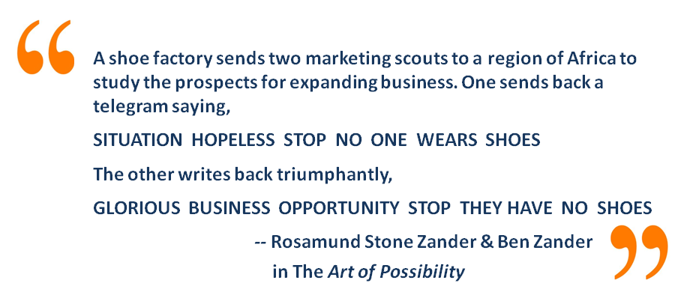
It would be beneficial for libraries to engage with fellow municipal and county departments and community groups to identify what databases and services could be shared, especially where the databases/services are associated with regional/local geographic information systems, e.g. for emergency management, on-line services for schools, health information, workforce and economic development data. By developing closer relationships with business, libraries will be in a better position to understand how to capitalize on the knowledge/information needs of that sector, especially where they are prepared to invest to ensure that a problem is resolved.
In some libraries, there is considerable demand from people who are struggling with social dysfunction of some kind that might best be delivered by a social or health worker. In these cases, opportunities for partnerships with local health and community support services might be explored. Libraries, for example, perform many services for young people to help them develop into caring, responsible adults. One source of revenue might be juvenile justice funds to help provide young people with skills to help them enter the workforce.
The re-organization of existing services could free up resources, so that people and systems can be transferred to new projects. Shifting the responsibility for delivery of a service to customers in the same way that automatic teller machines and hotel reservation systems do can offer opportunities to redeploy staff to new projects, which make better use of their high-level knowledge and research skills.
Exchange of value is a particularly important new source of resource provision. For example, the growing retiree population possesses valuable skills that could help libraries expand their programs. Many of these people seek to be of service and could add great value as volunteers. Other people could work on projects as part of an exchange of value in order to gain skills and experience and, at the same time, deliver a much needed service.
Libraries might also make use of grant opportunities, particularly from business partnerships, IMLS and the Gates Foundation, which have a focus on libraries, or E-rate, which supports the provision of technologies for libraries and schools. Libraries should also determine what free resources already exist that are not widely- used such as career development programs that could be delivered locally to those in need. The ALA, the State Library and other libraries are good sources of these materials and databases.
Opportunities also exist for community partnerships/sponsorships and fund raising events, as well as partnerships including showcases of new technologies and targeted services of value to businesses.

Strategies for Goal 7:
- Efficiency and effectiveness: Develop more efficient ways of delivering services. Shift resources to new projects that have strong customer or stakeholder support and those that reflect the most promising practices.
- Value-add: Generate new revenue from adding value to jointly created and delivered services.
- Grants: Pursue state, federal and foundation grants as both a revenue source and a service.
- Specialized partnerships: Develop partnerships around issues facing key government, business and community groups, e.g. school readiness, workforce development and enterprise incubators.
- Revitalize existing funding: Work with political leaders to identify gaps in service delivery for new projects that underpin traditional funding.

Projects for Goal 7:
Four projects have been developed to ensure that libraries are reliably funded through diversified resources including federal, state and local sources, foundation grants, business partnerships, seed funding and entrepreneurial activities.

Project No. 1: Business, Community and Political Networking and Partnering
A program coordinated with/supported by professional development for librarians to undertake new business development, project planning and political networking and advocacy.
Governance and responsibility: NJSL and/or LLNJ and member libraries
Objectives: The project showcases libraries in their roles as community anchors, taking a key role in the bi-partisan development of their communities. It provides a venue at a local/regional level for business, community, education and political leaders to get together and share ideas for new projects/programs, and to start pilots. It provides a way for local libraries to network with business, community and political leaders and government agencies to meet and develop relationships around the new kinds of services on offer by libraries and, at the same time, get feedback from the community about problems that libraries could help them solve. Librarians enlist the assistance of their boards to connect into the community, and if necessary LLNJ provides training in how to do this. The project involves a shift from advocating for what libraries have been, to what libraries are becoming, demonstrating the value that libraries can create for their community.
Stakeholders and their interests:
- Library boards and their members
- Business leaders
- Community Colleges, Universities and school leaders/talents
- Community leaders
- Members of political parties
Time frame: Pilot project during 2013, thereafter few months in different regions of New Jersey.
Estimated cost and sources of funding: LLNJ and NJSL, expansion of the NJSL Business Breakfast program.
Actions:
- NJSL secures sponsorship from government agencies, e.g. NJEDA, Workforce Development and one or more local foundations to sponsor/fund 5-6 community, economic development or workforce development pilots every quarter.
- Conduct a series of regional Creating Community Connections breakfasts to enable local, business, community and political leaders to get together to solve local issues by working well together.
- In the lead-up to each breakfast, NJSL and the group of librarians in the next region to host the breakfast, call for project proposals for the pilot projects.
- Local librarians and/or their board members contact local education, business and political leaders and personally invite them to the breakfast, inform them of the program to sponsor projects, ask each person they contact to identify one or more issue that needs attention and suggest one or more ways their organization might participate or contribute.
- NJSL sets up a public website database for community resources available to solve problems, as well as issues that need to be addressed.
- Librarians log the issues and offers of solutions. Sponsors and community group have up to one month before the next quarterly breakfast in which to write up and submit a proposal.
- The proposals must have broad backing from the community including a business or government agency supporter, education institution, community organization with a need, and bi-partisan political support, each contributing in-kind or other resource to the project.
- A cross-community task force that combines influential business, community college, school and political leaders in the region meets quarterly to evaluate the projects, which are announced and awarded at the breakfasts.
- For each of breakfast, NJSL hires high profile speaker e.g. Peter Block, author of Community, Dan Pink author of Drive or Mark Prensky, thought leader in education and information literacy to act as magnet for the events.
- All those that attend the breakfast get to be automatically signed up for the Regional Knowledge Innovation Program (See Project No. 3) and access to a librarian for a free assessment of their information/research needs to power up their business or community organization.
- With each subsequent breakfast, recipients of prior awards report on their successes, as well as act for emissaries into the community to stimulate further projects and sponsorship.
Measures of success:
- Number of participants at breakfasts
- Publicity achieved for libraries in their roles as community anchors
- Increased access to political, business and community leaders by all libraries
- Positive changes in how communities regard their libraries
- Increased funding for libraries for new projects and programs
- Enhanced support for existing programs
Professional development: Training for librarians and board members in connecting to their communities, to advocate for the emerging roles of libraries.
Resources: Initial funding to from NJSL, thereafter, the project should pay for itself, or generate surplus funds because the breakfasts should be run at a profit.
Integration with other projects: Integration with most other projects.

Project No. 2: Local Delivery of Services for Business and Government Partners
Partner with federal, state or government agencies and business organizations to deliver services locally in libraries or storefront locations.
Governance and responsibility: LLNJ establishes a contracting arm that specializes in securing contracts with State and Federal Government agencies to deliver services through local libraries to support social, workforce development, literacy, health, early childhood development, education and other programs targeted at communities with special needs.
Objectives:
- Expand the role of local libraries.
- Provide highly targeted support for federal and state agencies seeking to deliver their services into specific communities.
- Provide ease of access to people who need help starting a business or developing their skills, especially those who do not have transport.
- Be the local delivery agent/customizer for centralized support services.
- Provide short term desk/office space to community groups/social entrepreneurial start-ups/foundations who participate in the delivery of the social support programs.
Stakeholders and their interests:
- Local libraries and their staff, who wish to expand their role in community development
- Small business, community groups and consultants, seeking to establish themselves
- People seeking help
Time frame: Undertake a pilot during 2013-2014
Estimated cost and sources of funding: Initial funding to explore the feasibility with state and federal agencies to determine the need.
Actions:
- Assign an LLNJ staff member to contact state and federal agencies to determine the potential need for the service.
- Once the need is established, form a task force to develop a business plan for the project including a funding proposal.
- Enter into a pilot project with one or more state or federal agencies. Secure a percentage of the revenue to manage the project and ensure quality control.
Measures of success:
- Revenue generated through LLNJ for local libraries in the provision of local services for state and federal agencies.
- Percentage of LLNJ libraries participating in the provision of services.
Professional development: Training in the provision of each service for which LLNJ and the local library contracts as required.
Resources: Time to evaluate the proposal and determine its viability. The project should be self- supporting once contracts are secured.
Integration with other projects: Integrates with Social and Business Entrepreneurship Centers and Library as a Community Anchor.

Project No. 3: Social and Business Entrepreneurship Centers
Provide facilities and support services for enterprise incubation, new business planning, training and remote learning center for education providers.
Governance and responsibility: This project would be coordinated by LLNJ and sponsored by the State Library.
Objectives:
- Collaborate with economic development, workforce development and small business agencies of government to provide business research, strategy development at a local level.
- Support these local services in 4-5 specialized regional business-/venture-focused library hubs.
- Help improve local community access to existing business support/development programs provided by state and federal agencies, many of them free.
- Provide a fee-for service offering to business to undertake marketing, new product and process development services to business and community groups, to help them grow their ventures.
- Coordinate with and act as a local tutorial service for community colleges, universities and other education and training institutions to deliver targeted education services, to help individual businesses develop the necessary skills to adapt to change.
Stakeholders and their interests:
- Economic Development functions of municipal, county, state and federal governments
- Business ventures, owners, entrepreneurs and their staff
- People starting a business or venture who need support with registration, formation, strategy/business plans, grant writing support
- Universities and community colleges seeking to have local tutorial support for individual students, or clusters of students, especially those who are capitalizing on the provision of Massively Open On-line Courses (MOOCs), and granting degrees on the back of these free courses.
- 3D and other open-access manufacturing providers who need community college and university support for the skills acquisition of their customers e.g. University of Arizona partnership with Techshop, see http://www.techshop.ws/
- Regional economic development institutes such as the John S. Watson Institute for Public Policy at Thomas Edison State College.
Time frame:
- October 2013: Research the project
- November 2013: Secure initial funding
- December 2013: RFP for libraries to offer one of 4/5 regional business research/development support centers
- February 2014: Recruit local libraries to participate in the project.
- March 2014: Launch
Estimated cost and sources of funding: $50,000 to $100,000 for a feasibility study.
Actions:
- Establish a task force to scope out the project.
- Conduct discussions with a range of economic development, workforce development, education provider and chamber of commerce partners to determine the level of interest.
- Identify 10-12 libraries (public, academic etc.) who could be well placed to offer a regional services and gain their input to the proposal.
- Identify with potential economic development/workforce development partners the sites where there is the highest potential demand for these services. Conduct focus groups with these potential users.
- Prepare a business plan to ascertain the return on the investment and a way forward, and share with stakeholders, before making a go/no go decision.
Measures of success:
Availability of a market for incubator spaces, small business research, business plans, help with registration and other critical paperwork.
Professional development: This is a project to assess the viability of a larger project. The project would call upon people with existing skills in market research etc.
Resources: Internal resources. Funds for the market study.
Integration with other projects: Integrates with other economic development and partnering projects.

Project No. 4: Grant Navigation and Preparation Service
Offer a grant writing service through local libraries to support new or expand community (social entrepreneurs) and business projects with government or foundation funding.
Governance and responsibility: Set up a task force with support from LLNJ and State Library.
Objectives: Help small business and community groups apply for and secure access to the wide range of grants available from federal state and other sources. There are 500 types of federal grants available from 26 programs including: Agriculture; Arts; Business and Commerce; Community Development; Consumer Protection; Disaster Prevention and Relief; Education/ Regional Development; Employment, Labor, and Training; Energy; Environmental Quality; Food and Nutrition; Health. Housing; Humanities; Information and Statistics; Law, Justice, and Legal Services; Natural Resources; Science and Technology; Social Services and Income Security; Transportation.
Stakeholders and their interests:
- Small business: Start or develop a business.
- Arts community: Obtain funding for special or recurring projects.
- Libraries: Secure funding for pilot projects in education, learning, economic and workforce development.
- Social entrepreneurs: Tap into foundation funding for specific purposes.
- Consultants skilled in different types of grant preparation, e.g. E-rate, foundation, economic development, workforce development, library.
Time frame:
- September 2013: Research the project/develop business plan
- November 2103: Recruit possible providers
- January 2014: Develop manual, procedures, offering, price list
- February 2014: Train library staff in taking a brief and managing orders
- March 2014: Launch pilot project with 10 libraries and market to initial customers
Estimated cost and sources of funding: 6 month’s salary for two people to develop the project: $100,000-$150,000. State Library grant. Work with a recognized E-rate consultant.
Actions:
- Identify and develop partnerships with grant writers, e.g. E-rate consultant.
- Develop and agree on a business model that allows local libraries to offer the service to local customers, and generate revenue from the service.
- Employ the same service to help libraries apply for grants to support their own development.
- Trial in a small number of libraries.
- Promote initially to small business and community groups.
Measures of success
- Number of libraries in a pilot: 10
- Number of business and NFP customers in first 12 months: 20-50
Professional development: Training in understanding the service being offered, the range of grants available, to enable front-line staff at the participating local libraries to offer the services to clients. Marketing training for local librarians to connect with chambers of commercial, local arts and community groups.
Resources: Small central team, managing private grant writing providers, and/or develop an internal team with the ability to offer the service. Facilities required: access to database, office space, telephone, internet site and marketing materials.
Integration with other projects: Use the program to help skill local libraries to develop grant funding for their libraries and also acquire the skills. Use the program to work with local workforce development, economic development and government agencies to build stronger relationships for the longer term. Use as a key part of marketing to political leaders to help them deal with local community issues.

Implementation Options

The Statewide Strategic Plan for the Future of Libraries in New Jersey is designed to have a life beyond the planning process. As a “living plan”, it provides a rich variety of ways for librarians, libraries of all kinds, their staff, boards and our stakeholders to continue the process.
Seven ways to make things happen
1. Lead or join a task force.
The plan requires leaders, people who will encourage and inspire others to act on your proposals. Librarians and their staff are invited to collaborate with others throughout New Jersey to create a future of your own choosing, with the support of key stakeholders. You may already have been a member of one of the task forces or you would like to join or lead a task force to help implement the plan.
Each of the plans needs to involve not just library personnel, but also other stakeholders who have an interest in achieving greater goals for the citizens of New Jersey. It is important that everyone reaches out to make sure that the broadest range of participants is engaged in the implementation process.
Each of the seven key strategies has comprehensive project plans to tackle specific aspects of the plan that are ready for implementation:
- Communicating the Value of Libraries
- Leadership and Coordination
- Collaboration and Partnerships
- Library as a community anchor
- Cycles of Innovation
- Professional Development and Self-Care
- Creative Funding Sources
2. Choose to implement one of 33 ready-made projects.
An easy way to become involved is to undertake one or more of the 33 ready-made projects that have been prepared by your colleagues. You can adjust the projects to your local situation or circumstances. The main idea is to undertake the projects in close collaboration with staff, customers and community and business leaders as well as local or regional administrators and representatives.
You might also decide merely to use the plan as inspiration for your own planning process. A useful framework is the project plan template in Appendix 1. Simply print out the form (which is also available on the online mind map:
https://www.mindmeister.com/237766551/llnj-strategic-planning-process), distribute a copy to everyone at the meeting, and write down your individual idea before having a discussion. Appoint one person as the scribe to keep a good record of the group plan that you write together.
3. Further develop one of 33 project ideas.
There was insufficient time during the planning process to develop plans for every project that colleagues thought were important or necessary. Many of the ideas are projects just waiting to happen. Consult the list of 33 project ideas and choose one you might wish to adopt or adapt to start your own project. But please do so, not on your own, but in partnership with your local community, school, business or university.

4. Secure new funding using some of 8 strategies
The Library Community participants in this planning process have identified seven funding strategies to reduce the reliance on libraries as taxation as the only source of income for existing and new projects and programs including:
- Federal, State and foundation grants
- LLNJ and State Library seed funding
- Sponsorships from local business, Chambers of Commerce and service clubs/organizations
- Partnerships with universities, government agencies and the community, especially to deliver desirable new services in workforce development
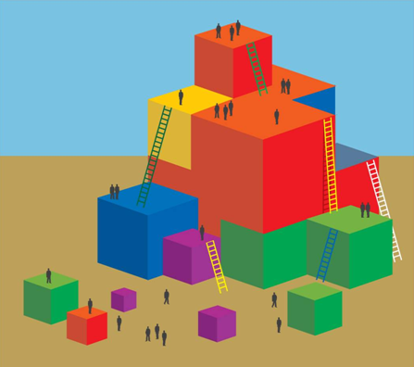
- Projects undertaken collaboratively using in-kind contributions of time and materials from each of the parties, such as the library providing the space for an agency to deliver a community service
- Freed up resources through simplifying or improving processes to provide greater customer service/satisfaction
- Volunteers – expand programs that are provided by people who have key skills for new programs and seeking to be of service to others
- Exchanges of value, for example provide opportunities for young people to gain skills and experience and at the same time deliver a much needed service

5. Create your own library strategic plan.
The LLNJ strategic plan is designed so that many of the goals and strategies of the plan are suitable for adoption or adaptation by all 2000+ libraries in the New Jersey Library Network. This does not mean a library should follow the plan to the letter, but rather, borrow key strategies that can help align your library with the kind of future that is emerging. One of the advantages of aligning with the LLNJ plan is that small libraries can work with other libraries to share the cost of acquiring support services, share the burden of start-up costs for new-to-the-world services and learn from each other or expert colleagues.
6. Design and deliver new professional development programs.
LLNJ invites member libraries to design and offer new professional development programs to colleagues throughout New Jersey so that staff and/or boards can acquire required skills in areas such as leadership, advocacy, strategic and business planning, project management, partnering, process improvement and collaboration that will enable us to achieve our goals.

7. Start and offer a state-wide service, or deliver one locally.
You and your library may be lucky enough to have extraordinarily talented people whose skills could be in demand elsewhere in New Jersey, but for which there is insufficient demand locally to afford a full-time person/team or part-time person to meet demand. Some of the new services we my offer could be provided as an exchange of value that would bring resources or services to your library.
As part of the Library as a Community Anchor and Collaboration programs, LLNJ will be encouraging libraries to identify talents who can co-locate and create traffic for other library services. Such services may already be on offer through your library via an association with a consultant, trainer or independent service provider who works locally with your organization in a collaborative relationship; they use your facilities, and in return you receive the benefit of their skills or arrange another exchange of value.
You may also want to offer, as a local agent, a service that is provided by an expert elsewhere in New Jersey who is part of the library family.

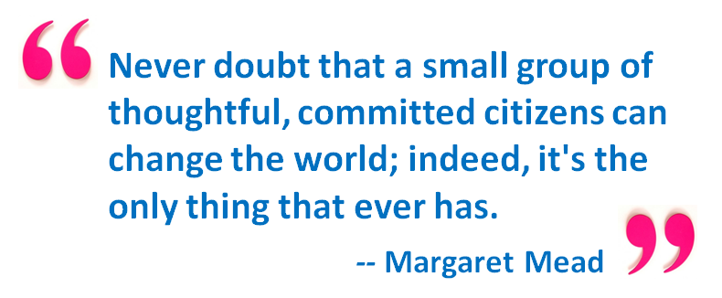

References

1. Naisbitt, J. (1982). Megatrends. New York: Warner Books.
2. Zero Hedge. (November, 2012). Japan’s population now so old that sales of adult diapers exceed those for babies. Retrieved July 10, 2013 from http://www.zerohedge.com/contributed/2012-11-24/japans-population-now-so-old-sales-adult-diapers-exceed-those-babies-1
3. Institute of Museum and Library Services. (January 2013). Public Libraries in the United States: Fiscal Year 2010.
4. Shepherd, M. (no date). Library collaboration: What makes it work? Retrieved July 10 from http://www.iatul.org/doclibrary/public/conf_proceedings/2004/murray20sheperd.pdf
5. Prensky, M. (2012). Brain gain: Technology and the search for digital wisdom. New York: Palgrave McMillan.
6. The Star Online. (July 4, 2013). Travelers want cinemas and libraries at airports, survey finds. Retrieved July 10, 2013 from http://www.thestar.com.my/News/Regional/2013/07/04/Travellers-want-cinemas-and-libraries-at-airports-survey-finds.aspx
7. Findlay, J. & Straus, A. (2011). A shift from systems to complex adaptive systems thinking. In O. Bodrova & N. Mallory (Eds.), Complex Project Management Task Force Report: Compendium of Working Papers, (pp. 24-26). Canberra: International Centre for Complex Project Management.

Appendix 1: Project Table and Planning Principles

Strategic Planning Project Table

Project Title (4-5 words)
Project Description (25 -100 words)
Governance: Roles and responsibilities, who will own the project
Objectives: What will the project achieve?
Stakeholders: Which stakeholders and their interests will be served by the project? Who will make use of the product/service and how, who will be the suppliers?

Time frame(s) for development, implementation etc.
Estimated cost range and sources of funding
Actions/activities (in detail)
Measures of success (benefits, measurable, clear, simple, actionable)
Professional development required
Resources, technological or facilities requirements
Integration with other projects/programs

Strategic design principles: setting ourselves up for success

(These are some of the principles that the task forces used when thinking about and creating projects for the plan and background for exploration.)
We’ve created a conceptual framework for our strategic planning activities based on the Real Time Strategic Change (RTSC) model developed by our colleague Robert (Jake) Jacobs, a veteran consultant on strategic change. After decades of working in organizations, Jake and his associates identified six principles that lead to organizational success. From there, they expanded the model to include matching sets of polarities, interdependent pairs of values that need each other over time to realize desired outcomes.
Jake’s observation is that, when these six polarities are managed well, the result is a high-performing organization. The model is grounded in the principles and practice of Whole Scale Change, the methodology devised by Dannemiller, Tyson Associates, which has a long history of facilitating meaningful and lasting strategic change.
Below you’ll find a graphic depiction of the RTSC model (you’ll have the PDF in your Google Docs folder), and then a list of the principles with key polarities and accompanying questions that will serve as a filter to help align project and plan ideas with these strategic goals.

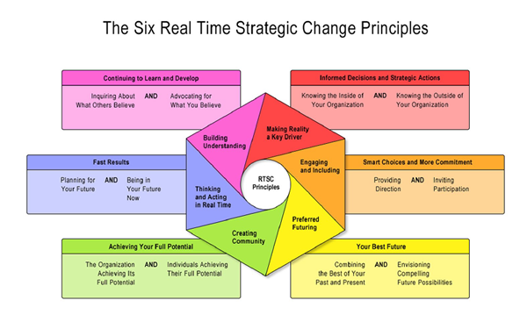
© 2013 by Polarity Partnerships, LLC and Robert (Jake) Jacobs. Used with permission.

Principle 1: Making Reality a Key Driver
Greater Purpose (Why is this important?): Informed Decisions and Strategic Actions
Key polarity to manage: Knowing the inside of your organization AND Knowing the outside of your organization
Key question to ask: Does our plan/project consider the needs and interests of all the appropriate internal and external stakeholders?

Principle 2: Engaging and Including
Greater Purpose (Why is this important?): Smart choices and more commitment
Key polarity to manage: Providing direction AND Inviting participation
Key question to ask: Does our plan/project invite the input and participation of others?

Principle 3: Preferred Futuring
Greater Purpose (Why is this important?): Creating Your best future
Key polarity to manage: Combining the best of your past and present AND Envisioning compelling future possibilities
Key question to ask: Does our plan/project combine the best of what we have with the best of what we want to create?
Principle 4: Creating Community
Greater Purpose (Why is this important?): Achieving your full potential
Key polarity to manage: The organization achieving its full potential AND Individuals achieving their full potential
Key question to ask: Does our plan/project work well for both individual libraries and our collective library system?
Principle 5: Thinking and Acting in Real Time
Greater Purpose (Why is this important?): Getting fast results
Key polarity to manage: Planning for your future (Planning) AND Being in your future now (Implementing)
Key question to ask: Does our plan/project lay out compelling ways to begin realizing our goals right now?
Principle 6: Building Understanding
Greater Purpose (Why is this important?): Continuing to learn and develop
Key polarity to manage: Inquiring about what others believe AND Advocating for what you believe
Key question to ask: Does our plan/project include a way for new and fresh ideas and interest to be incorporated as they arise?
Some additional pairs of design principles:
How might we leverage the benefits of each perspective to realize a thriving New Jersey library community?
- Focusing on our vision AND Focusing on current reality
- Tradition (continuity) AND Innovation (change)
- Collaboration AND Competition (How might we collaborate to compete and compete to collaborate?)
- Building relationships AND Getting results
- Continuous improvement AND Breakthrough innovation

Appendix 2: Additional Project Ideas

Here are some additional ideas for projects created by participants in the LLNJ strategic planning process. Start by inviting a group of interested staff, customers, businesses and community leaders to a conversation to explore the opportunities. You can use the Project Plan template to help guide your conversation.

- Aggregate purchasing power: Set up a pilot process for all types of libraries to aggregate their buying power. Establish key rules for joining the system that achieve other statewide goals.
- Bring your own tech-sharing space: Project to support the creation and delivery of cross-platform users of technology for kids/students/people bringing their own technology to the learning, personal development or community development space.
- Broadband-intensive services: Research, identify, develop, pilot and expand new services that are possible with very high speed broadband that fit with library capacities/resources/service model.
- Build library apps: Create spaces for young people together to build new apps that bring libraries, services and resources more easily to mobile devices. Link to crowdfunding, create contests, etc.
- Caring, responsible adults: Libraries do a lot for youth (teens) that help them develop into caring responsible adults -- tap into juvenile justice money to help provide programs. Queens Public Library did this and got a youth worker to staff after school hours. Also, work with ex-offenders - help them become productive positive forces in the community; job training, etc. Have them work with troubled youth, additional creation of library advocates.
- Community opportunity center: Provide services to help communities deal with issues which require high level facilitation, interests integration AND cross-boundary knowledge provision, or knowledge intensive support.
- Community project creation center: Develop projects with the community to help people without skills develop new skills.
- Community safety/Urban libraries: Work with community groups, police, halfway houses, parole officers to develop strategies for achieving high levels of community safety.
- Creating Community Conversations: Initiative to place library in a position to be an effective change agent in the community. Facilitation training for staff doing a series of programs. Includes multi-type libraries in the community. Stakeholders - county and city government, chambers of commerce, local emergency management, school districts BOE, cultural community reps, colleges. First topic - emergency management. Other topics to follow. Topics to define subsidiary stakeholders, with core stakeholders present. Measures - ideas and feedback. The library is sought out for solutions and invited to other tables
- Edutainment: Capitalize on star quality of people connected to what libraries do. Host events with not just authors, but thought leaders, give the mid-level thought leaders from TED.ORG, NPR, etc. a voice/platform of people to work with.
- English is only the beginning. Work with cultural/language groups in the community to jointly develop new types of library resources, applications, welcoming spaces that are culturally attuned.
- Expand library pick-up delivery: What else could the current book pickup/delivery service be used for? How might this be funded by another partner?
- Funding models task force: An ongoing project to develop a detailed understanding of funding approaches available to libraries and their partners including taxation, levies, grants, for profit services, venture capital and productivity improvement and to provide increased access to these sources. Here are some things to consider: How might we rethink the relationship between libraries and money? What sources can we tap for revenue that we might not have thought about before? What services might be free and which ones might be for a fee? What services or combination of unique facilities might libraries offer as a national network/brand?
- Growing your business: Public libraries work with local businesses to help them better use websites and social media to grow their business. The library will work with you on a-one-to-one basis to help you craft outreach to potential customers. Measurement is by expansion of customer base and more interaction between libraries and businesses.
- Helping people work/learn across disciplines: Libraries offer a service to help people work/learn together across the boundaries of their disciplines, e.g. writing, art, film production, music, design, marketing, fundraising, display, archiving and research in the pursuit of new knowledge, businesses, social programs, creative works or other projects.
- Information Literacy and Common Core Standards: Create and implement a K-16+ Information Fluency (IF) continuum for all NJ students and residents. Obtain backing and support from the NJ Department of Education and a presence on their web site.
- Integrate Libraries with Transport Network: Every public library meeting state aid requirements will be a stop on NJ Transit routes. Make the library the shelter in all weather. Develop libraries as key critical mass, high traffic destinations.
- Library Tech Coffee Bar: Bring technology to Starbucks, showcasing new devices/technology brought to you by your local library. Use library website to demonstrate the technology...mobile phones, tablets, e-readers. Take it out but invite them in.
- Local delivery for global partners without storefronts/co-location of services: Project to partner with organizations (government, business and community) who have no/limited local presence, but who could benefit from partnering with libraries and making use of their advantages - local, IT technology, meeting spaces, research capacity, makerspace lending, learning support etc. Develop relationships with majors such as Google, Amazon, Apple etc. to identify projects and activities that benefit both NJ libraries and these organizations.
- Local entrepreneurship/economic development center: Partnerships with state, county, national agencies for specific service provision. Provide facilities for supporting new social and for-profit venture creation, including business plans, new opportunity trend research, cross-discipline research, proposal/application/regulatory documentation writing, job application, up-skilling, link between business and education providers,
- Local publishing support: Service to support local writing and publishing of printed as well as e-books, including partnerships with literary agents, editors, and talent exchanges e.g. illustrators, cover designers, e-marketers.
- Meeting room spaces for all community activities: Provide support services including facilitation, record keeping, research etc. Share community center concept with other libraries and community organizations. Make sure we have parking.
- New skills for wise knowledge facilitation: This project would examine the structure and skills of the library workforce in relation to new services and determine what skills are needed in order to be 1) Trusted partners helping people make sense of a complex world, 2) Content curators, mentors, co-creators, 3) Cross-boundary facilitators and 4) Role models for how to bridge multiple knowledge spaces. This might be done in collaboration with library education institutions, as well as consultants and thought leaders in the industry.
- Serving specialized communities: Language specialization, e.g. Bengali, building up collections, or specialized professional communities.
- Serving the differently abled: Project to develop innovative standards, practices and specific recommendations for a statewide initiative to better serve the differently abled. Project would address issues of ergonomics, access to facilities, etc. and information and materials offered, including electronic media and tools.
- Serving underserved communities: Develop a suite of projects or programs that can be implemented to support the underserved communities (No Netflix, No Internet, No jobs, lots of spare time, lots of boredom, 25 percent below poverty level, 40 percent who do not graduate from HS) to begin the process of helping people build skills for mid-level jobs.
- TechKnowEXPO: Technology demos...no one under 50 allowed. Appeals to boomers and seniors. Develop the project with AARP.
- Technology showcases: Develop and promote the best models for developing traffic around new technology (maker spaces, e-books, e-readers, specialized apps and software) including "appy hours", or apps of value in education. Publish/promote regular Top Ten Lists, e.g. the top ten tech gadgets your library can offer/use and how.
- The College Next Door: Offering college classes in the local library in communities where there is no transportation to the college campus.
- The Three Minute Library: Adapting libraries service delivery to those with short attention spans. This problem impacts all strata of society. Success? Increase library use by new customers.
- Top Ten Lists: Maintain a top ten tech gadgets list your library should use and how as a regular feature on every library website.
- Training in skills for Wise Knowledge Facilitation: Based on the findings from Project No. 24, this project would offer training in areas critical to success in the “new normal”, including leadership, facilitation, project management, fundraising, business development, partnering and process design.
- Tutorial center for remote colleges and universities: Provide outreach service for student support for universities for a fee, including local tutorial cluster meetings, internet access.

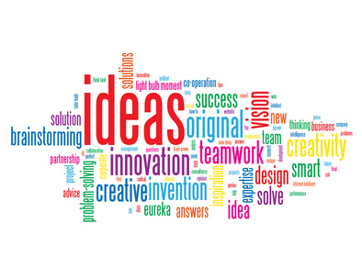

Appendix 3: Participants in the Strategic Planning Process

Thanks to everyone who participated in the planning process!
Leadership

Cheryl O’Connor, Executive Director, LibraryLinkNJ, Chair
Mary Chute, State Librarian, New Jersey State Library
Peggy Cadigan, Associate State Librarian, New Jersey State Library
Joanne Roukens, Assistant Director, LibraryLinkNJ

Facilitators

John Findlay, Maverick & Boutique
Abby Straus, Maverick & Boutique

Statewide Strategic Planning Committee

Douglas Baldwin, Piscataway Public Library
Susan Briant, Haddonfield Public Library
Leslie Burger, Princeton Public Library
Kay Cassell, Rutgers University, School of Communication & Information
Anne Ciliberti, William Paterson University Library
Ann DeRenzis, Phillipsburg Free Public Library
Roberta Bronson Fitzpatrick, George F. Smith Library, Rutgers Biomedical and Health Sciences
Ann Hoang, New Jersey Institute of Technology Library
Susan Kaplan, Sayreville Public Library
Joann Lustig, Mathematica Policy Research Library
Mary Mallery, Montclair State University Library
Pat Massey, South Plainfield High School Information Center
Susan O'Neal, Middletown Township Public Library
Bill Paullin, NJLA Public Policy Committee
Taras Pavlovsky, The College of New Jersey Library
Deb Poillon, Cape May County Library
Pat Regenberg, Overlook Medical Center Library, Summit
Pat Tumulty, New Jersey Library Association
Dee Venuto, Rancocas Valley Regional High School Library
Robert White, Bergen County Cooperative Library System
Anne Wodnick, Gloucester County Library System

LibraryLinkNJ Executive Board

Marian Bauman, Neptune Township Public Library
Ruth Bogan, PALS Plus
Candice Brown, Clifton Public Library
Ingrid Bruck, formerly Long Branch Free Public Library
Janice Cooper, Northern Valley Regional High School at Old Tappan
Heather Craven, County College of Morris Library
Jane L. Crocker, Gloucester County College Library
James Keehbler, Piscataway Public Library
Robert Lackie, Rider University Library
Mary Lewis, Kawameeh Middle School, Union
Kimberly Paone, Matawan-Aberdeen Public Library
Lynn Pascale, Collingswood Middle/High School Library
Carolyn Ryan Reed, East Orange Public Library
Kathy Schalk-Greene, Mount Laurel Library
Margaret Shapiro, New Jersey Library Trustee Association
Rick Vande Wende, Lay Representative

Contributors (conversations, meetings, workshops, task forces, discussions, conference calls)

Galena Adair, Kinnelon Public Library
Jessica Adler, LibraryLinkNJ
Theresa Agostinelli, Monroe Township Public Library
Alexandria Arnold, Long Hill Township Public Library
Marlene Z. Asselta, Southern New Jersey Development Council
Brian Auger, Somerset County Library System
Carolyn Aversano, Mercer County Library
Stephanie Bakos, Berkeley Heights Public Library
Maria Baratta, New Jersey Talking Book & Braille Center
Linda Baum, library user & advocate, Middletown
Ralph Bingham, Gloucester County Library System
Norma Blake, former New Jersey State Librarian
Karen Brodsky, Bernardsville Public Library
Peter Bromberg, Princeton Public Library
Sophie Brookover, LibraryLinkNJ
Linda Caffrey, Twin Rivers Library
George J. Carfagno, AICP/PP
Mun-Hwa Chen, Somerset County Library System
Mary Faith Chmiel, formerly Red Bank Public Library
Deborah Cohen, Jefferson Township High School Library
Cynthia Coulter, Hudson County Community College Library
Cindy Czesak, Paterson Public Library
Linda Devlin, Camden County Library System
Phebe Dickson, Rutgers University Student
Chris Duffy, Somerset Medical Center
Marguerite Dugas, Ocean County Library
Carol Feltes, The Rockefeller University
Cathi Finnen, Ocean County Library
Randall Gabrielan, historian, writer, Middletown Township
Joseph Gasparro, Montville Township Public Library
Marianne Gaunt, Rutgers University Libraries
Karen George, Atlantic County Library System
Rosary Gilheany, Retired Library Director
Thomas Gilheany, Library user
Irene Goldberg, Monroe Township Public Library
Wilma Grey, Newark Public Library
Susan Heinis, LSTA Advisory Council and NJASL
Christine Hill, Willingboro Public Library
Claire Houghton-Kiel, Passaic County Technical Institute
Marilyn Kahn, Eastern School of Acupuncture & Traditional Medicine Library
Sheri Kaminski, B.A. Slotkin Memorial Library Kennedy Health System
Lisa Katz, Cherry Hill Public Library
Christine King, Willingboro Public Library
Anne Krautheim, Borough of Totowa Public Library
Michelle Louden, Monroe Township Public Library
Mi-Sun Lyu, LibraryLinkNJ
Allen McGinley, Piscataway Public Library
Robert Mackes, Health Sciences Library Association of New Jersey
Laverne Mann, Cherry Hill Public Library
Marna Elliott, Somerset County Library System
Mary Jane McNally, Ridge High School Library
Judy Macaluso, Ocean County Library
Christopher Malony, Ocean City Free Public Library
Elisabeth Marrapodi, Trinitas Regional Medical Center Library
Laurie Matassa, Jackson Liberty High School Library
Patrica May, St. Joseph’s Regional Medical Center, Paterson
Elaine Mayweather, Barsky Memorial Library at Kennedy Health System
Elisabeth Marrapodi, Trinitas Regional Medical Center Library
Kathleen Moeller-Peiffer, New Jersey State Library
Carol Moroz, Manchester Township High School
Dana Nicklas, Burlington County Library
Daniel O’Connor, Rutgers University, School of Communication & Information
Malakia Oglesby, Asbury Park Public Library
Eileen Palmer, Libraries of Middlesex Automation Consortium
Virginia Papandrea, Red Bank Public Library
Connie Paul, formerly Central Jersey Regional Library Cooperative
Susan Permahos, Summit Free Public Library
Susan Pifher, Somerset County Library System
Michael Plumley, East Orange Public Library
Tamar Pritchard, New Jersey Attorney General’s Library
Susan Quinn, Ocean County Library
Maryann Ralph, East Brunswick Public Library
Patricia Reusing, Saint Barnabas Medical Center Library
Alyssa Rosen, Middletown Township Public Library
Gail Rosenberg, formerly INFOLINK Regional Library Cooperative
Victoria Rosch, New Jersey State Library
Scherelene Schatz, New Jersey State Library
Claire Schmieder, I Need A Library Job, INALJ.com
Ken Sheinbaum, Monmouth County Library
Eleanor Silverman, St. Joseph’s Regional Medical Center, Paterson
Helen Snowden, Gloucester County Library System
Melissa Spatucci, Elizabeth School District
Sherry Spier, Cinnaminson School District
Jackie Spritzer, New Jersey Center for the Book
Sheri Stein, JP Stevens High School Library, Edison
Renee Swartz, New Jersey Center for the Book
Madeline Taylor, St. Joseph’s Regional Medical Center, Paterson
Brian Tervo, St. Joseph’s Regional Medical Center, Paterson
Monica Teixeira, Monroe Township Public Library
Karen Thomas, Raritan Valley Community College
Mark Titus, Hunterdon County Library
Jody Treadway, Wayne Public Library
Betty J. Turock, Rutgers University, School of Communication & Information
Susan Van Alstyne, Berkeley College Library
Tom Vranesch, Franklin Lakes School District
Gloria Urban, Vineland Public Library
Leah Wagner, Monroe Township Public Library
Menno Wiebe
Nicole Williams, Rochelle Public Library
Catherine Wolverton, Englewood Public Library
Nancy Zaccagnino, Kinnelon Public Library

Our thanks as well to the 520 participants in the LibraryLinkNJ membership survey and the 457 students who shared their thoughts about how to make libraries more awesome.

Let’s hear it for libraries!

