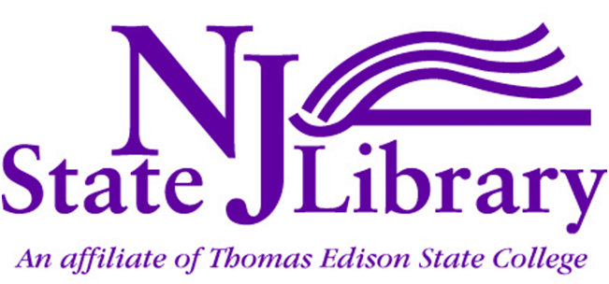
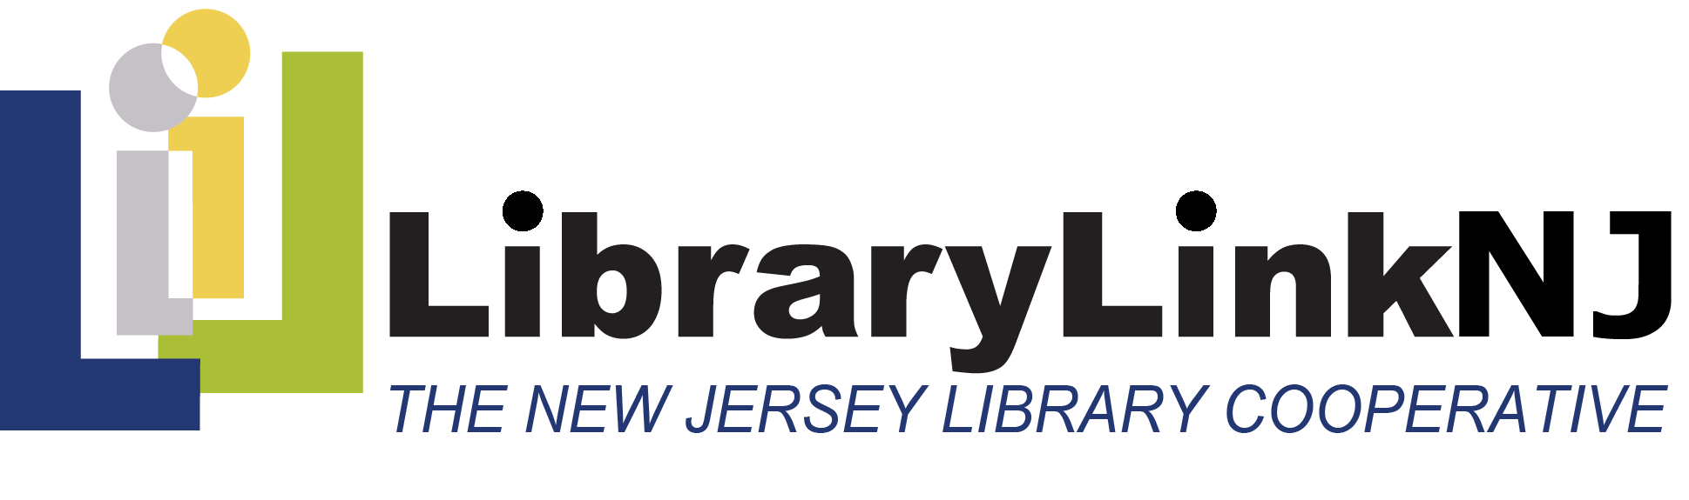
Statewide Strategic Plan
For the Future of Libraries in New Jersey
Executive Summary

July 2013
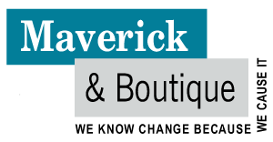
Prepared by John Findlay & Abby Straus
Maverick & Boutique
www.maverickandboutique.com
Copyright Notice
Except where otherwise noted, content in this document is licensed under a Creative Commons Attribution 3.0 License. Readers are invited to distribute, remix, tweak and build upon this work, even commercially, as long as they credit The New Jersey State Library and LibraryLinkNJ for the original creation. To learn more visit http://creativecommons.org/licenses/by/3.0/
Contents
Executive Summary 1
Participants in the Strategic Planning Process 2

Executive Summary

This strategic plan to guide the future of New Jersey’s 2000+ public, school, academic and special libraries was developed through a process of public engagement by representatives of the library community and stakeholders during 2012-2013. The plan is a collaborative effort between the membership of LibraryLinkNJ (LLNJ), The New Jersey Library Cooperative and the New Jersey State Library (NJSL).
Our vision
We envision every library in New Jersey as a thriving, vibrant hub of its community. We envision the people of libraries—librarians, staff, boards, customers and all library stakeholders—as happy, fulfilled and collaborating productively to realize our shared goals.
Our future role
In a world of growing complexity, uncertainty and change, libraries and librarians have much to offer the communities we serve. We see our roles as:
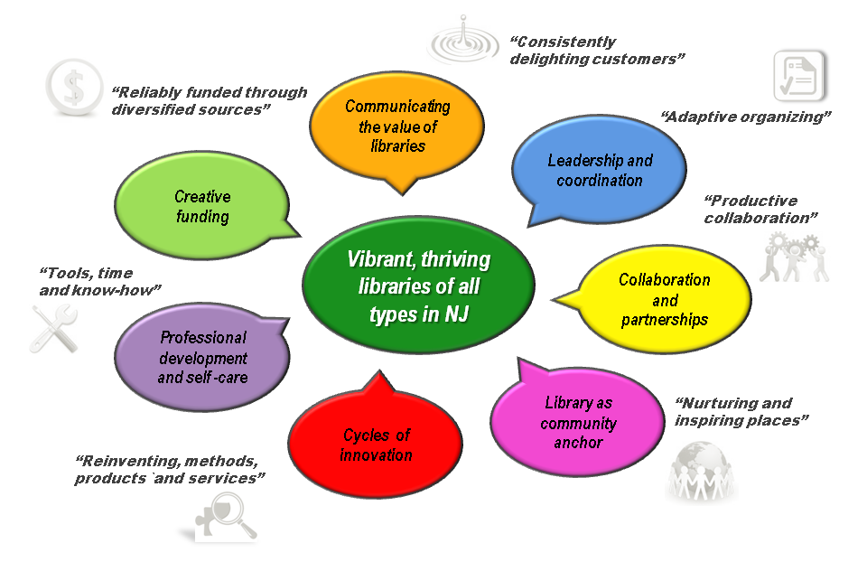
Libraries as the heart of our communities: Libraries play an increasing role as a place for people to collaborate and exchange ideas and to gain access to information, knowledge, tools and methods. In a partnership with our customers we will help build more robust, vibrant communities, incubate new businesses, develop new skills for 21st century work and life and be a safe haven in times of crisis.
Librarians as wise knowledge facilitators: Librarians will increasingly help people make sense of and navigate a world that is ever more complex, rapidly changing and uncertain. We will become role models for how to bridge and leverage new knowledge spaces in a multiplicity of roles: trusted, responsive partners, guides and content curators and publishers, teachers, advocates and cross-boundary facilitators.
The Trends
The New Jersey library community identified numerous local, national and global trends which have major impacts on libraries, the services we provide and the way we engage with our stakeholders. The most important of these trends are:
- 24/7 always-on world
- Blend of high-tech and past-tech
- Budget cuts with changing priorities, e.g. retirement and health bubble
- Content shift from text/print to multimedia/electronic
- Dissolving boundaries in terms of connectivity and yet more divisions between disciplines
- Emergence of social deserts, people want meaning-making time together.
- Explosion in availability of tools such as iPhones that do “everything”
- Focus is scattered: Shorter attention spans
- Growing demand for access to physical tools, computers, machines, apps
- Growing demand for skills for working across boundaries
- Growing democratization of apps, machines and Internet
- Growing diversity of disciplines, skill sets, cultures
- Growing number of have-nots lacking skills and access to 21st century work and world
- Increasingly shorter waves of change demands regular personal reinvention
- Instant gratification; anticipatory awareness of customer needs/interests
- On-line access to content, multi-function tools & people anywhere
- Shift from content/information curation to knowledge creation and implementation
- The Internet of things

The process
The strategic planning process began in November 2012 and concluded in June 2013 with the publication of this report.
The “living plan” process comprised the following activities:
- A Kick-off meeting: to decide the process and who to involve.
- Research and Briefing Notes to inform the process and challenge our thinking.
- An Advisory Committee Workshop to canvas ideas about the future of libraries in the context of the trends, identify customer and stakeholder needs and interests, understand what value libraries have to offer and the resources and skills we have and need, consider new ways to deal with competitors and possible collaborators and explore new sources of funding.
- A series of Community Workshops to expand on the issues considered by the advisory committee and generate ideas for projects and programs we can undertake.
- A First Iteration of the Strategic Plan including an environmental scan, preferred future position, stakeholder interests and dynamic capacities resources analysis and project and program concepts.
- Supplementary Inputs to the Plan include targeted interviews with thought leaders, a statewide survey of librarians and a schools survey.
- Synthesis into seven Strategic Focus Areas each with 6-7 project concepts
- On-line Task Force Workshops to create very detailed Project Plans and goal, strategy and measures of success statements.
- A Draft Strategic Plan Review by the Advisory Committee.
- Preparation of the Strategic Plan in three formats, a slide show, a report and a website.
The entire process can be viewed at:
https://www.mindmeister.com/237766551/llnj-strategic-planning-process
Strategic Principles
The strategic plan is based on six core principles that are a balance between the contrary forces that shape the emerging world in which we live and work. We seek to:
- Serve New Jersey’s library community as a whole and serve individual libraries, their staff and communities.
- Honor our tradition as an institution and innovate to stay relevant and add value.
- Be visionary and be grounded in current reality.
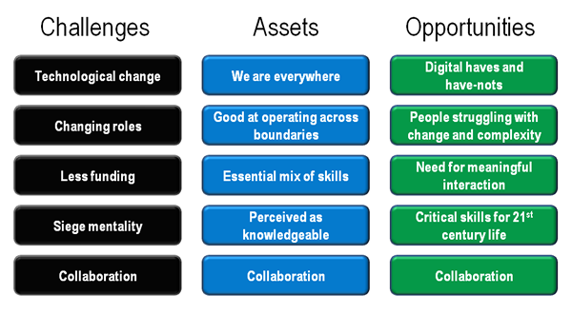
- Advocate for what we believe and inquire about what others believe.
- Conserve and work with existing resources and develop new, creative funding streams.
- Provide structure and be flexible to accommodate change.
Strategic analysis
A strategic analysis of the key factors having an impact on New Jersey’s libraries reveals not only a variety of pressing challenges, but also a host of opportunities for capitalizing on our existing assets and for developing new skills and services to meet the needs of 21st Century citizens.
For example, libraries have, or are well-positioned to acquire, the capacities for success an emerging economy that is based on the wise application of knowledge.
These capacities include:
- Essential mix of skills: The required education, research, relationships, technology and other skills critical to the 21st Century work and life.
- Working across boundaries: This is an essential skill in a complex ever changing world. We are able to operate in both the virtual and the real-world.
- Safe haven: We are seen as a portal and a safe haven for those who do not have access to the 21st century skills and tools.
- Perceived as knowledgeable: Our clients expect/think librarians know or have access to everything and anything.
- Collaboration: We have the skills to collaborate well with each other and our stakeholders.
- We are everywhere: In communities, schools, universities, community colleges, corporations and on-line.
However, libraries do face a number of critical challenges, none of which are insurmountable provided we take the kinds of actions that have been developed during the planning process. These challenges include:
- Technological change: Keeping abreast of technological change, the new skills required and new business models.
- Less funding: Higher demand, means doing more with less, especially to respond to change.
- Siege mentality: We see ourselves as under attack.
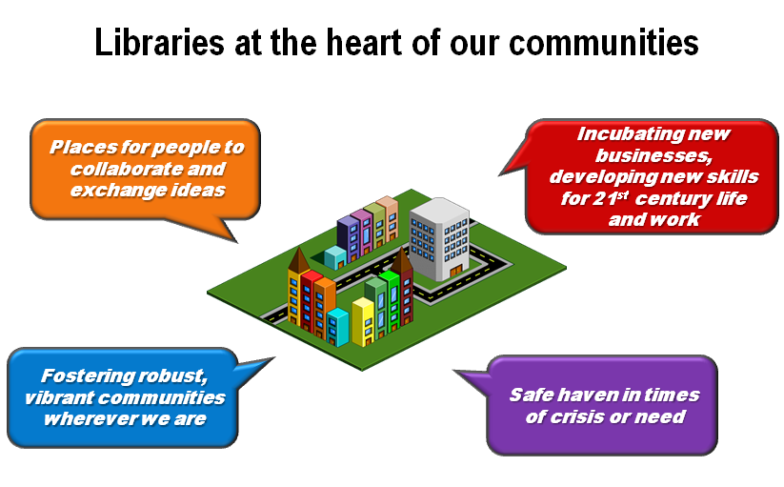
- Undervalued by some political leaders: They think Google and the Internet have all the answers.
- Role change: A shift in roles from content & knowledge curators to creators and facilitators.
- Barriers to change: Some rules and systems are unfriendly to customers’ new needs, e.g., No talking, no eating.
- Collaboration: We know how to collaborate but need and want to do it better and more frequently.
Arising from the intersection of the trends, challenges and capacities are major opportunities. It is vital that libraries and librarians capitalize upon these to more effectively meet our needs and those of our stakeholders. These include:
- People and communities struggling with change and complexity: accelerating change that has become permanent.
- Digital have and have-nots: Growing digital divide between access have and have-nots.
- People who desire meaningful interaction: As a response to living too long in cyberspace or having become socially isolated. Many of us now want more meaningful face-to-face opportunities to meet, work, learn and create together.
- Critical skills for 21st century life: A growing gulf between the skills required for living and working in the 21st century. Libraries becoming the go-to place for becoming re-employed and reengaged.
- Collaboration: Libraries are in the right place at the right time to work with our stakeholders to help people work across or live more successfully in multiple worlds.
The Seven Strategic Goals
The LLNJ community identified seven goal areas on which to focus in order to implement the strategic plan. They are numbered in this plan for convenience and are all of equal importance. The goal areas and accompanying strategies are as follows:
Goal 1: Communicating the Value of Libraries- Our libraries offer a consistent brand promise through which we delight our customers and anticipate their evolving needs. All stakeholders appreciate the value of the libraries in their world, and participate actively in joining and belonging to the brand.
The strategies to achieve this goal are:
- Strategic positioning: Position ourselves as co-creators of new ways to help people improve their quality of life, learn, develop and participate more fully in society.
- Develop a branding strategy: Create and deliver a comprehensive branding strategy for NJ libraries.
- Monitor awareness: Track public and political awareness through usage measurements, surveys, and event attendance.
- Advocacy: Create a statewide advocacy and collaborative relationships group to help libraries of all types better communicate and deliver on the brand.
- Future planning processes: Involve political, community and business leaders in implementing this plan and future planning processes.
Goal 2: Leadership and Coordination- Our libraries are led, organized and managed so that we are able to rapidly adapt our methods, systems, and offerings in anticipation of the emerging needs and interests of customers, funders, partners, suppliers, staff and other stakeholders.
The strategies to achieve this goal are:
- Efficiency and effectiveness: Provide a service to undertake reviews of the efficiency and effectiveness of library service delivery to identify opportunities for improvement.
- Learn from each other: Establish forums that enable the staff of libraries to regularly meet and share best practices in funding, service delivery, advocacy, innovation and leadership.
- Distributed leadership: Develop the capacity among library leaders to work with each other and their stakeholders in the most productive ways.
- Alignment with stakeholder interests: All libraries in New Jersey that are publicly funded will prepare a strategic plan in collaboration with key internal and external stakeholders.
The NJSL “SWAT Team of Library Transformers”
Goal 3: Collaboration and Partnerships- We collaborate productively with each other and with our stakeholders, internally, between libraries and library systems, across functions and disciplines, with our funders, customers, competitors, government and legislators.
The strategies to achieve this goal are:
- Promote collaboration: Create incentives for and reward collaboration.
- Develop cross-boundary skills: Develop and offer cross-boundary collaboration tools and skills for librarians, staff and stakeholders.
- Resource sharing: Promote collaborative resource-sharing models between libraries and stakeholders.
- Events: Facilitate opportunities for networking, collaboration and creativity amongst library colleagues, to learn from each other’s successes.
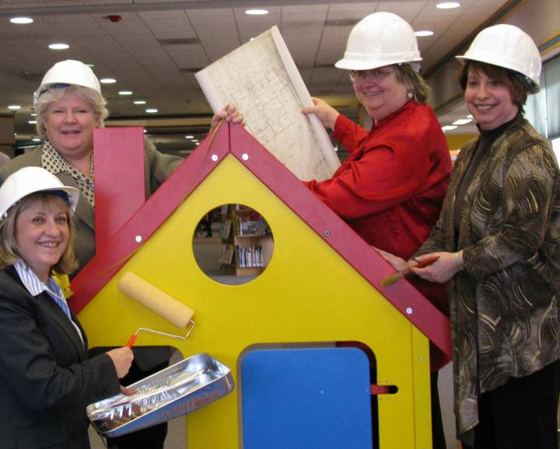
- New partnerships: Promote libraries as trusted partners for business, community, education and government.
Goal 4: Library as Community Anchor-Libraries are safe, nurturing and inspiring places for people to meet, work, learn, grow and exchange ideas together.
The strategies to achieve this goal are:
- Create hubs of activity: Work with municipalities and cities to plan the development of "villages" around libraries including the co-location of dining, consulting, education, personal development, recreation and communication storefronts.
- Meet new needs: Develop programs and services to address changing user and community needs, including new citizens and the differently-abled.
- Offer services for others: Become the local agencies of business, education (especially higher education) health and government services.
- Safe haven: Build the capacity for libraries to be the go-to place for information and help in emergencies.
- Non-users: Engage with people who don’t use libraries to see how we might enroll them and meet their needs.
Goal 5: Cycles of Innovation- We reinvent our methods, models, products and services to keep pace with the “new normal” of transformational social and technological change.
The strategies to achieve this goal are:
- Pilot projects: Design, pilot and replicate innovative projects in all library types that align with emerging customer and partner needs.
- Balance with traditional models: Maintain an appropriate balance between new and traditional services for which libraries are widely valued.
- Guidelines and certification: Provide guidelines for libraries for appropriate technology, skills and services and to help late adopters to more quickly take up new models of service delivery.
- Commit % of funds: Devote a percentage of resources to innovation to stay current.
- Reward innovation: Celebrate success with opportunities to replicate the results elsewhere. Allow failure as a learning experience.
Goal 6: Professional Development and Self Care- We reinvent our methods, models products and services to keep pace with the “new normal” of transformational social and technological change.
The strategies to achieve this goal are:
- New skills: Examine the structure and skills of the library workforce in relation to new services.
- Cross-training: Offer training in areas critical to success in the “new normal”, including leadership, facilitation, project management, fundraising, business development, partnering and process design.
- Collaborate with educational institutions: Ensure that librarians receive the training they need for high performance and career satisfaction in the future.
- Time to learn: Designate time for informal networking, brainstorming and learning from each other.
- Self-care: Provide opportunities for library staff to take care of themselves through stress reduction, coaching, improvements to the workplace and fun.
Goal 7: Creative Funding Sources- We are reliably funded through diversified sources including federal, state and foundation grants, business partnerships, seed funding and entrepreneurial activities. We work closely with political leaders to maintain or grow funding from traditional sources.
The strategies to achieve this goal are:
- Efficiency and effectiveness: Develop more efficient ways of delivering services. Shift the resources to new projects that have strong customer or stakeholder support and those that reflect the most promising practices.
- Value-add: Generate new revenue from adding value to jointly-created and delivered services.
- Grants: Pursue state, federal and foundation grants as both a revenue source and a service.
- Specialized partnerships: Develop partnerships around issues facing key government, business and community groups, e.g. school readiness, workforce development and enterprise incubators.
- Revitalize existing funding: Work with political leaders to identify gaps in service delivery for new projects that underpin traditional funding.
Next Steps
The strategic plan provides opportunities for all librarians and all types of libraries to participate in the implementation of the plan. These options comprise:
Lead or join a task force: to collaborate with other librarians in New Jersey to create a future of our choosing with the support of key stakeholders
Choose to implement one of 33 ready-made projects: you can start today in collaboration with your community, customers or political leaders.
Develop one of 33 project ideas: and start a planning process with your own staff and in partnership with your local community, school, business or university.
Secure new funding using some of 8 strategies: for existing and new projects and programs including federal, state and foundation grants, LLNJ and State Library seed funding, sponsorships, new political commitments and partnerships with suppliers, government agencies and community groups.
Libraries create their own version of the strategic plan: using key elements of the LLNJ strategic plan.
Design and deliver new professional development programs: for your staff and boards in advocacy, project management and partnering that will enable libraries to achieve their goals.
Develop and offer a new state-wide service: by finding the talents in your library e.g. grant writing that could be offered through other libraries on an exchange-of-value basis.

Our Strategic Planning Process
The "Living Plan" approach to strategic planning adopted by LLNJ/NJSL is designed to be an iterative process of planning and implementation that can be continued by libraries and our stakeholders throughout New Jersey. We use the process to synthesize our creativity, passions and expertise and to collectively create our desired future one step at a time.
There are many ways to make use of this plan. Key elements of the plan, including goals and strategies, can easily be incorporated into individual library strategic plans. Individuals can join task forces to implement specific projects, and libraries can also choose to undertake a similar strategic planning process, but at a local scale.
1. Kick-off meeting
The process began with a meeting to discuss and finalize the process, decide who we want to invite and what we expect to achieve by the end of the project. The process began in the LLNJ offices on October 9, 2012, followed by the official kick-off meeting with the Statewide Strategic Planning Committee on the afternoon of October 25.
2. Research and Briefing Notes
Desktop research was undertaken to prepare briefing notes to inform the strategic planning process, especially to provide inputs to the series of workshops. This information included trend data on emerging technologies, changes in the role of libraries, shifts in patterns of knowledge management and knowledge creation, as well as relevant financial and population statistics. Thought provoking challenges from thought leaders about future scenarios were derived from journal articles, meta-studies and presentations on TED.
3. Advisory Committee Workshop
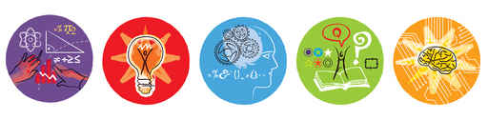
A workshop was conducted with the leadership of LLNJ to canvass the widest possible range of issues as early in the process as possible. The issues were explored using sequences of rich questions including:
- Our role: What are the roles of libraries and librarians in a world that is ever more complex, and where many more people are involved in the creation, dissemination, remixing, categorization and publishing of works (film, books, research, learning resources, etc.)? What is important to keep that we have done in the past? What is our new work/activity?
- Our brand/identity: What are we known for? How will our citizens regard libraries and librarians in the mid-21st century? For what will we be recognized and valued? How will we help people, where are they located? How do we interact with our community?
- The context: What are the major trends in the world of libraries and librarians? What might we borrow from other industries/sectors, e.g. hospitality, publishing, communications? Where are libraries/or the new functions of libraries needed where they do not exist already?
- Our customers and other stakeholders: Who uses libraries now? What are our customers’ needs and do we serve them well? Who might use libraries in the future? How might we engage more people/new groups of people in becoming part of the NJ library community? What other stakeholders are important to our future and why?
- The value of libraries: How is the value of libraries perceived and by whom? How are they perceived as entities that embrace the future? If not, how might we change that? What value/perceived value might we add so that libraries become known as a great thing to fund?
- Competition: Who are the competitors to libraries? Where do we compete where can’t be successful? How and where might we compete where we have a strategic advantage? How might we collaborate with competitors to offer higher overall value?
- Governance, leadership and influence: How can we play a leadership role in the fields of knowledge management, knowledge creation and the wise application of knowledge? What are the gaps in society/business where we can make a difference or be influential?
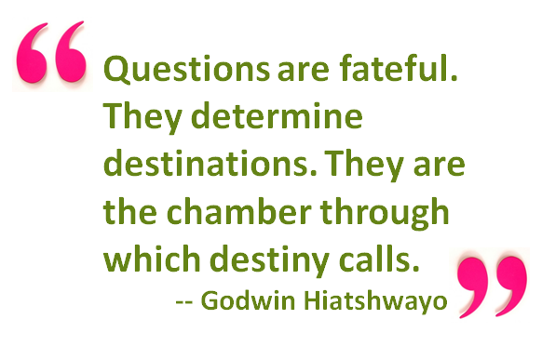
- Structures and processes: How should we structure/organize and co-ordinate our activities across New Jersey so that we integrate the interests of our member organizations and their communities, customers and stakeholders? How might we apply economies of scale to take advantage of resources? What activities require local/custom/just-in-time services and how might we best deliver these?
- Professional development: What new skills/capacities will librarians and their staff need and what old skills do we want to maintain or further develop in order to perform our new role(s)?
- Resources, technologies and methods: What kinds of buildings, equipment, processes and methods will we expect in the library of the mid-21st century? Describe a day in the life of the "library", virtual, physical or otherwise?
- Sources of funding: How will our work be funded? Who will want to pay for our services/support our work, and why will they want/need to do this? What will be free and why?
- What new sources of funding might we tap? How might we expand on or manage existing sources of funding more effectively?
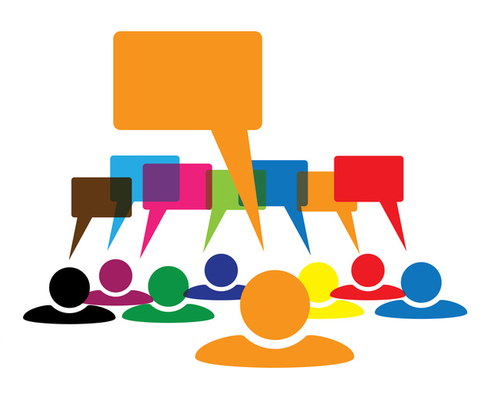
- Choice trilogy: What are we doing well that we want to KEEP? What is an obstacle or barrier to our success that we might ABANDON? What new activities or revised activities are we drawn to INVENT/REINVENT?
- Envisioning the future: Craft a definition of “library” for Wikipedia in 2020. Be sure to include librarians/other library people, who uses libraries and how, as well as their structure, physical and/or virtual.
- Projects: What is a project we need to start today in New Jersey to create or further develop our new or enhanced services, systems, roles, methods, processes, governance models, funding mechanisms etc.?
- Measure of success: How will we know when we are successful? What will we have achieved and how will we be able to measure it? E.g. Number of new library users and positive experience satisfaction reports. Number of people trained. Number of documents published.
After each workshop, the results were published on an interactive, web-based mind map that enables LLNJ and the broader community to see and track the progress of the plan.
4. Community workshops
A series of public workshops was held throughout New Jersey – in Hammonton, Monroe and Paterson - to give librarians and other stakeholders an opportunity to participate and contribute their thinking to the plan.
5. First Iteration of the Strategic Plan
An initial version of the plan, in the form of a narrative framework, was developed early in the process to act as a reference point. It combined the initial research and the advisory committee deliberations, including:
- Environmental scan: The major trends and emerging issues
- Preferred future: The main goals; what we should be striving to achieve so we either align with the emerging future or take an active role in creating it
- Stakeholder interests: The major stakeholders and their interests and how their relationships with libraries and librarians may possibly evolve
- Dynamic capacities analysis: What activities should we keep? What should we abandon? What should we invent or reinvent?
- Dynamic resources analysis: What roles do we need to play? What tools/technologies/methods and resources do we need to have or continue to use/enhance? What are the rules of interaction with our stakeholders?
- Projects/Programs: A list of projects or programs and tentative measures we need to put in place so that a) the activities are aligned with the emerging preferred future, b) the stakeholders’ evolving interests are met or surpassed, c) the changes we need to make to our organization or system (keep, abandon, reinvent) are in place and d) the new roles we need to play in relation to our stakeholders are all identified and understood
- Measures: Initial list of possible indicators/measures of success

6. Supplementary Inputs to the Plan
A series of non-workshop activities were also undertaken to include a broad spectrum of opinions to enrich the planning process:
- Targeted interview were conducted with 12 domain experts and key leaders/influencers in the library community with a deep understanding of New Jersey libraries in a national/international context.
- A survey sought opinions from the LLNJ network unable to participate in the workshops, to which 520 responded.
- A survey of school students’ opinions about the future of libraries elicited 457 responses.

7. Synthesis into Strategic Focus Areas
The workshop outputs were consolidated/synthesized into a set of seven themes/strategic focus areas, each exemplified by 6-7 project concepts.
8. On-line Task Force Workshops to Create Project Plans
Thirty six people volunteered to join task forces to create detailed project plans and generate goal and strategy statements and measures of success for each of the seven strategic focus areas. Participants worked in groups using telephone conferencing and Google Docs.
The goal statement format was:

- Goals (What)
- Strategies (How)
- Measures of Success (How will we know when we’ve succeeded)
The project plan format was:
- Project Title (4-5 words)
- Project Description (25 -100 words)
- Governance: Roles and responsibilities, who will own the project
- Objectives: What will the project achieve?
- Stakeholders: Which stakeholders and their interests will be served by the project? Who will make use of the product/service and how, who will be the suppliers?
- Time frame(s) for development, implementation etc.
- Estimated cost range and sources of funding
- Actions/activities (in detail)
- Measures of success (benefits, measurable, clear, simple, actionable)
- Professional development required
- Resources, technological or facilities requirements
- Integration with other projects/programs
9. Draft Strategic Plan Review
The advisory committee met to review the project plans, the stakeholder interests analysis, as well as the goals, strategies and measures of success, and to further refine them. This process involved reviewing all of the information collected during the process, as well as the tentative goal statements and project plans and synthesizing the concepts to a new and higher level of integrated order.
10. Strategic Plan Preparation
The formal strategic plan was developed by analyzing the contributions of all of the participants and the analysis by the advisory committee, and drawing these together into an environmental scan, a vision statement for New Jersey libraries and librarians, seven strategic goals and a selection of projects to operationalize the plan consisting of:
- A slide presentation or “haiku” version of the plan, which was presented at the New Jersey Library Association conference in Atlantic City, on June 5, 2013.
- This report, which is a formal strategic plan.
- The entire strategic plan and process, step-by-step, complete with briefing notes, workshop outputs, the early project plan framework, project plans, slide presentations and survey results located at: https://www.mindmeister.com/237766551/llnj-strategic-planning-process.

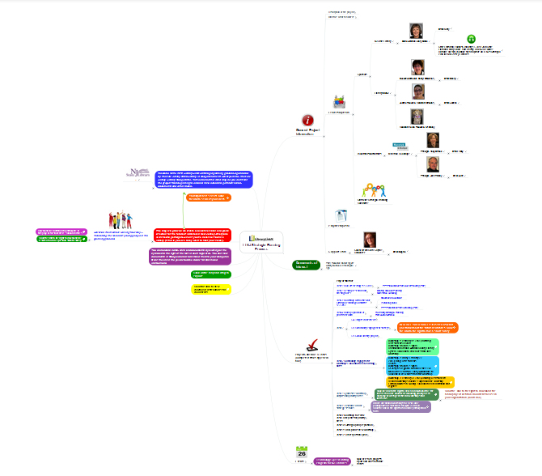
NJSL/LLNJ Interactive
Strategic Planning Mind Map

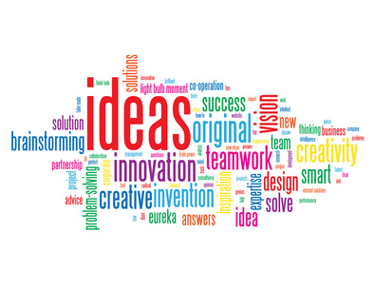

Participants in the Strategic Planning Process

Thanks to everyone who participated in the planning process!
Leadership

Cheryl O’Connor, Executive Director, LibraryLinkNJ, Chair
Mary Chute, State Librarian, New Jersey State Library
Peggy Cadigan, Associate State Librarian, New Jersey State Library
Joanne Roukens, Assistant Director, LibraryLinkNJ

Facilitators

John Findlay, Maverick & Boutique
Abby Straus, Maverick & Boutique

Statewide Strategic Planning Committee

Douglas Baldwin, Piscataway Public Library
Susan Briant, Haddonfield Public Library
Leslie Burger, Princeton Public Library
Kay Cassell, Rutgers University, School of Communication & Information
Anne Ciliberti, William Paterson University Library
Ann DeRenzis, Phillipsburg Free Public Library
Roberta Bronson Fitzpatrick, George F. Smith Library, Rutgers Biomedical and Health Sciences
Ann Hoang, New Jersey Institute of Technology Library
Susan Kaplan, Sayreville Public Library
Joann Lustig, Mathematica Policy Research Library
Mary Mallery, Montclair State University Library
Pat Massey, South Plainfield High School Information Center
Susan O'Neal, Middletown Township Public Library
Bill Paullin, NJLA Public Policy Committee
Taras Pavlovsky, The College of New Jersey Library
Deb Poillon, Cape May County Library
Pat Regenberg, Overlook Medical Center Library, Summit
Pat Tumulty, New Jersey Library Association
Dee Venuto, Rancocas Valley Regional High School Library
Robert White, Bergen County Cooperative Library System
Anne Wodnick, Gloucester County Library System

LibraryLinkNJ Executive Board

Marian Bauman, Neptune Township Public Library
Ruth Bogan, PALS Plus
Candice Brown, Clifton Public Library
Ingrid Bruck, formerly Long Branch Free Public Library
Janice Cooper, Northern Valley Regional High School at Old Tappan
Heather Craven, County College of Morris Library
Jane L. Crocker, Gloucester County College Library
James Keehbler, Piscataway Public Library
Robert Lackie, Rider University Library
Mary Lewis, Kawameeh Middle School, Union
Kimberly Paone, Matawan-Aberdeen Public Library
Lynn Pascale, Collingswood Middle/High School Library
Carolyn Ryan Reed, East Orange Public Library
Kathy Schalk-Greene, Mount Laurel Library
Margaret Shapiro, New Jersey Library Trustee Association
Rick Vande Wende, Lay Representative

Contributors (conversations, meetings, workshops, task forces, discussions, conference calls)

Galena Adair, Kinnelon Public Library
Jessica Adler, LibraryLinkNJ
Theresa Agostinelli, Monroe Township Public Library
Alexandria Arnold, Long Hill Township Public Library
Marlene Z. Asselta, Southern New Jersey Development Council
Brian Auger, Somerset County Library System
Carolyn Aversano, Mercer County Library
Stephanie Bakos, Berkeley Heights Public Library
Maria Baratta, New Jersey Talking Book & Braille Center
Linda Baum, library user & advocate, Middletown
Ralph Bingham, Gloucester County Library System
Norma Blake, former New Jersey State Librarian
Karen Brodsky, Bernardsville Public Library
Peter Bromberg, Princeton Public Library
Sophie Brookover, LibraryLinkNJ
Linda Caffrey, Twin Rivers Library
George J. Carfagno, AICP/PP
Mun-Hwa Chen, Somerset County Library System
Mary Faith Chmiel, formerly Red Bank Public Library
Deborah Cohen, Jefferson Township High School Library
Cynthia Coulter, Hudson County Community College Library
Cindy Czesak, Paterson Public Library
Linda Devlin, Camden County Library System
Phebe Dickson, Rutgers University Student
Chris Duffy, Somerset Medical Center
Marguerite Dugas, Ocean County Library
Carol Feltes, The Rockefeller University
Cathi Finnen, Ocean County Library
Randall Gabrielan, historian, writer, Middletown Township
Joseph Gasparro, Montville Township Public Library
Marianne Gaunt, Rutgers University Libraries
Karen George, Atlantic County Library System
Rosary Gilheany, Retired Library Director
Thomas Gilheany, Library user
Irene Goldberg, Monroe Township Public Library
Wilma Grey, Newark Public Library
Susan Heinis, LSTA Advisory Council and NJASL
Christine Hill, Willingboro Public Library
Claire Houghton-Kiel, Passaic County Technical Institute
Marilyn Kahn, Eastern School of Acupuncture & Traditional Medicine Library
Sheri Kaminski, B.A. Slotkin Memorial Library Kennedy Health System
Lisa Katz, Cherry Hill Public Library
Christine King, Willingboro Public Library
Anne Krautheim, Borough of Totowa Public Library
Michelle Louden, Monroe Township Public Library
Mi-Sun Lyu, LibraryLinkNJ
Allen McGinley, Piscataway Public Library
Robert Mackes, Health Sciences Library Association of New Jersey
Laverne Mann, Cherry Hill Public Library
Marna Elliott, Somerset County Library System
Mary Jane McNally, Ridge High School Library
Judy Macaluso, Ocean County Library
Christopher Malony, Ocean City Free Public Library
Elisabeth Marrapodi, Trinitas Regional Medical Center Library
Laurie Matassa, Jackson Liberty High School Library
Patrica May, St. Joseph’s Regional Medical Center, Paterson
Elaine Mayweather, Barsky Memorial Library at Kennedy Health System
Elisabeth Marrapodi, Trinitas Regional Medical Center Library
Kathleen Moeller-Peiffer, New Jersey State Library
Carol Moroz, Manchester Township High School
Dana Nicklas, Burlington County Library
Daniel O’Connor, Rutgers University, School of Communication & Information
Malakia Oglesby, Asbury Park Public Library
Eileen Palmer, Libraries of Middlesex Automation Consortium
Virginia Papandrea, Red Bank Public Library
Connie Paul, formerly Central Jersey Regional Library Cooperative
Susan Permahos, Summit Free Public Library
Susan Pifher, Somerset County Library System
Michael Plumley, East Orange Public Library
Tamar Pritchard, New Jersey Attorney General’s Library
Susan Quinn, Ocean County Library
Maryann Ralph, East Brunswick Public Library
Patricia Reusing, Saint Barnabas Medical Center Library
Alyssa Rosen, Middletown Township Public Library
Gail Rosenberg, formerly INFOLINK Regional Library Cooperative
Victoria Rosch, New Jersey State Library
Scherelene Schatz, New Jersey State Library
Claire Schmieder, I Need A Library Job, INALJ.com
Ken Sheinbaum, Monmouth County Library
Eleanor Silverman, St. Joseph’s Regional Medical Center, Paterson
Helen Snowden, Gloucester County Library System
Melissa Spatucci, Elizabeth School District
Sherry Spier, Cinnaminson School District
Jackie Spritzer, New Jersey Center for the Book
Sheri Stein, JP Stevens High School Library, Edison
Renee Swartz, New Jersey Center for the Book
Madeline Taylor, St. Joseph’s Regional Medical Center, Paterson
Brian Tervo, St. Joseph’s Regional Medical Center, Paterson
Monica Teixeira, Monroe Township Public Library
Karen Thomas, Raritan Valley Community College
Mark Titus, Hunterdon County Library
Jody Treadway, Wayne Public Library
Betty J. Turock, Rutgers University, School of Communication & Information
Susan Van Alstyne, Berkeley College Library
Tom Vranesch, Franklin Lakes School District
Gloria Urban, Vineland Public Library
Leah Wagner, Monroe Township Public Library
Menno Wiebe
Nicole Williams, Rochelle Public Library
Catherine Wolverton, Englewood Public Library
Nancy Zaccagnino, Kinnelon Public Library

Our thanks as well to the 520 participants in the LibraryLinkNJ membership survey and the 457 students who shared their thoughts about how to make libraries more awesome.

Let’s hear it for libraries!

