Need to share information? Maybe it is an announcement for a meeting or a flyer for an event? Create a Smore – the free online flyer. Here is a sample: (you can click to go to the live flyer)
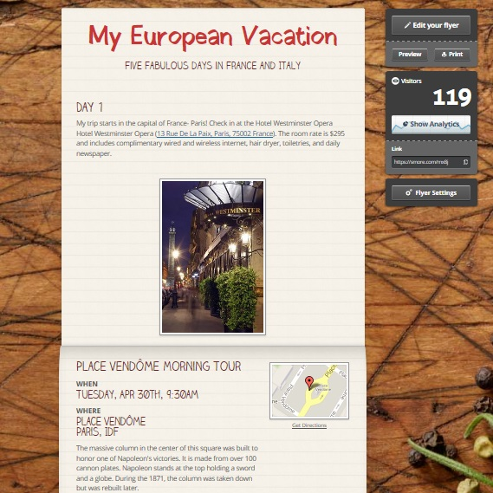
From this sample, you can see Smore will display text, links, images, event information as well as google maps. This was a sample I created for a seventh grade teacher. His assignment was a travel brochure using Publisher. That worked well in school but did not meet the needs of the students who needed time to work on the project at home. Since Smore is web-based, the students can access it anywhere.

To get started, create a free account. It does request an email address but there is no verification email. Select . You can start with a blank form or use one of their templates:
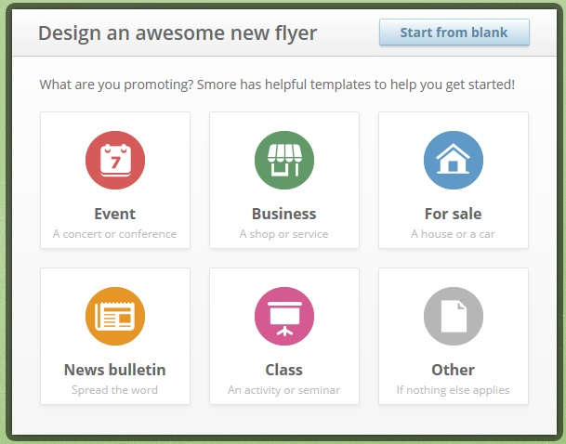

They are populated with most of the features you will need. But you have complete flexibility- you can add or subtract features to your flyer.
Start out with a title and then begin to add content. Mouse over the panel you want to edit.
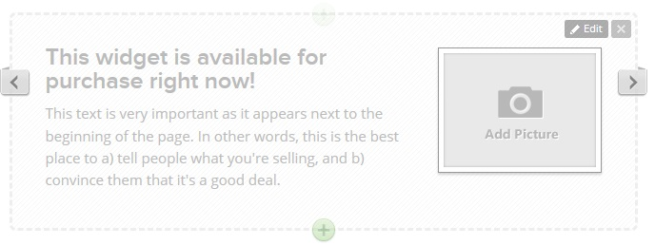
Click on the edit feature to get started. Since there is no spell check, I usually type in a word processing program, check the spelling, and then cut and paste the text into the Smore. There are some formatting options in Smore:
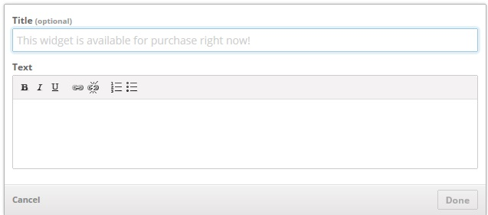
You can change the emphasis, insert links, or change to a bullet format.
To add a photo, just click on the Add Picture icon- you can then upload an image. The arrows on the sides will show layout options. Your wo.rk saves automatically
If you want to add more options, click on the + (or add from the bottom of the screen)- then you will these options: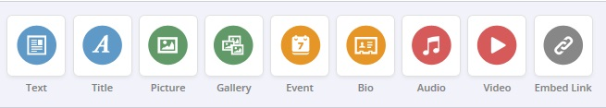
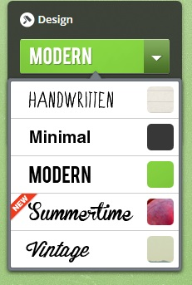
Once your content is complete, you can modify the appearance. There are four major design themes- this is the general feel of your flyer:

You can then make a few other choices with background, color, and font.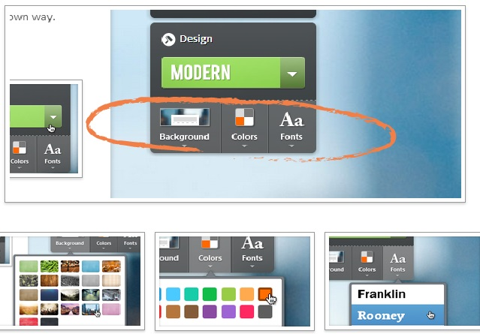
Now you are ready to share. Select Done Editing. You will now have options on how to share you flyer.
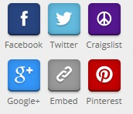
The embed option provide both the link and the code. Printing is also an option- but unless you have a color printer, I would not recommend it. There are also privacy settings. For students in school, I select the Private option- but there are several public options as well. (You will notice when you login, you will see public smores.)
I have only used their free product but they do offer (for a fee) and Education account.

To recap, with Smore, you can
- Create your own online flyer.
- Have students create their own Smore as part of a project (you do need an email to generate an account but there is no verification. I usually create a class account and allow each student to create their Smore.
Smore has a Help section on their site. You can follow them on Twitter or Facebook.

